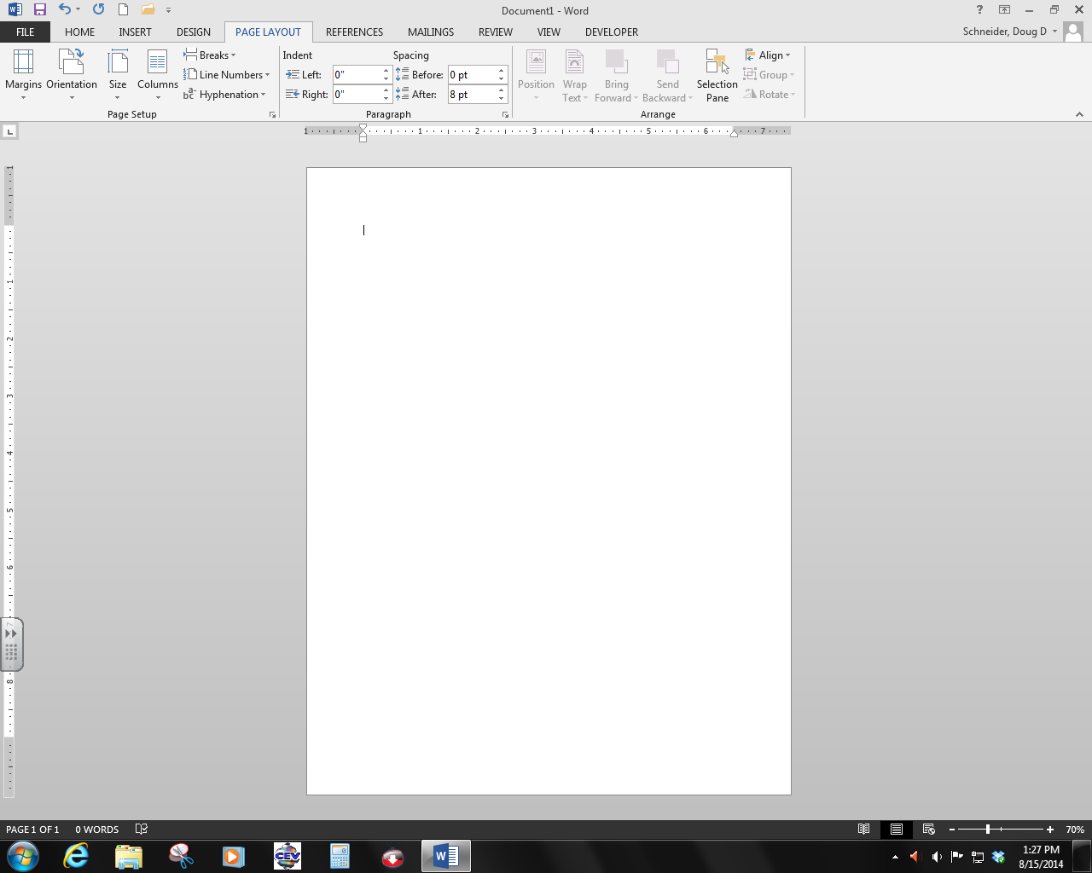

4. This called the what?________________________

2. These are called what?_____________

1. This is the button that allows you to save, open, print, etc. and takes you to the backstage view?___________________

9. This is called the what?________________

12. This is called the what that allows you to customize your window?____________________________________

11. What type of window is the entire program?

__________________

8. This is called the what?_____________________

10. This is called the what?__________________

3. This called the what?_____________

7. The Arrow changes to a what when it is placed in the document?_____________________

5. The blinking line is called a what?_____________________

6. What type of window is this where you can type text in it?_______________________

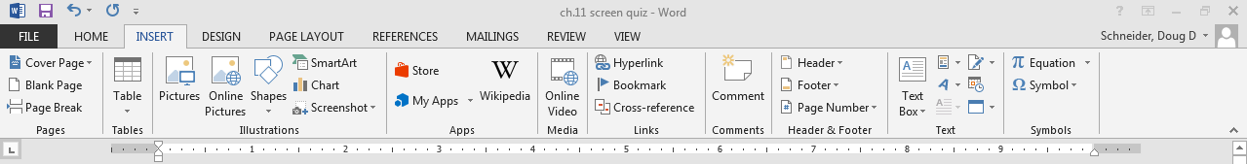

13. What button is this called?________________

16. This is called the what?________________

14. What button is this called?________________

15. What button is this called?________________

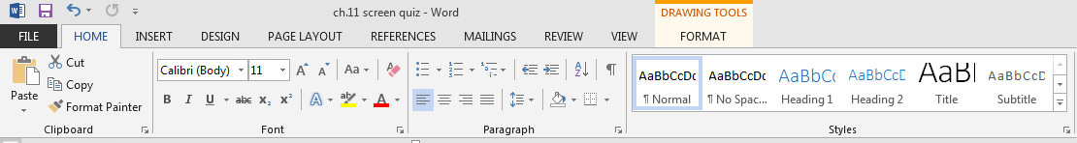

18. What is the name of this button that gives you more options?________________

17. What are these sections called?__________________