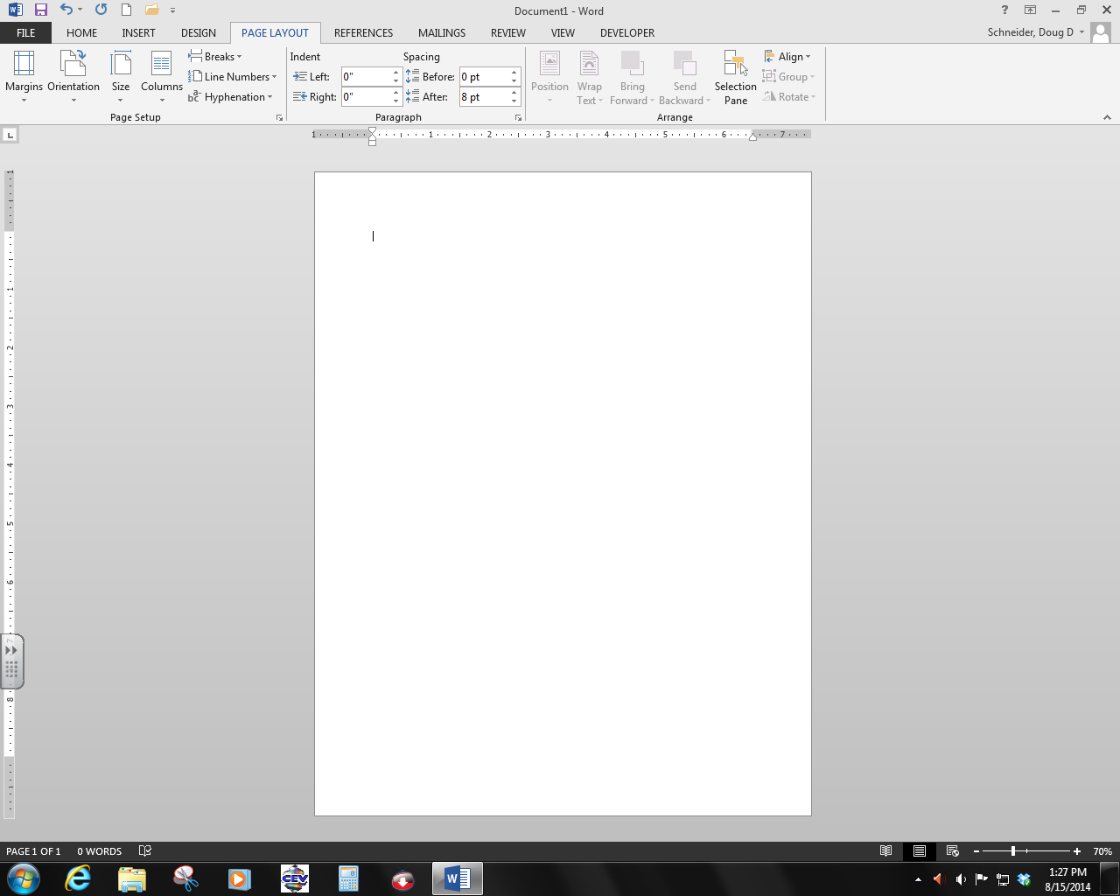

4. This called the what?__**title** **bar**_

2. These are called what?__**tabs**___________

1. This is the button that allows you to save, open, print, etc. and takes you to the backstage view?__**File_**________________

9. This is called the what?__**task** **bar**_

12. This is called the what that allows you to customize your window?____**quick** **access** **toolbar**________________________________

8. This is called the what?___**status** **bar**_________

10. This is called the what?__**Start**________________

3. This called the what?_**Ribbon**____________

7. The Arrow changes to a what when it is placed in the document?_______**I-Beam**_______

5. The blinking line is called a what?___**insertion** **point**________

6. What type of window is this where you can type text in it?__**Document** **Window**____

11. What type of window is the entire program?

_**Application** **window**_________________

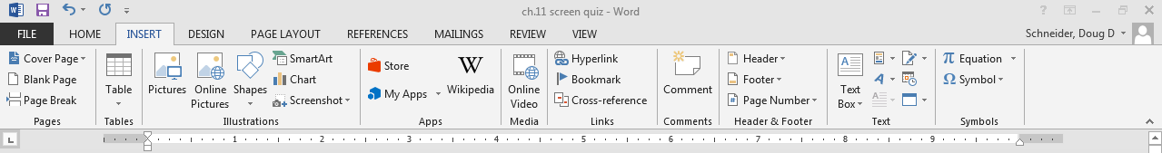

13. What button is this called?__**minimize**______________

16. This is called the what?__**ruler**______________

14. What button is this called?_restore down/ **maximize**___

15. What button is this called?__**Exit/ Close**__________

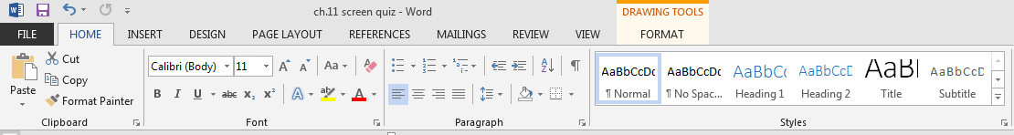

18. What is the name of this button that gives you more options?__**dialogue** **box** **launcher**____________

17. What are these sections called?__**groups**________________