Project 7-1: Creating Elevator Communications
Montgomery, Slade & Parker uses elevator communications for in-house announcements, invitations,
and other employee-relations documents. In each elevator, a durable 8½0 3 140 clear plastic
frame has been installed in which announcements can be inserted and changed on a regular basis.
Create a draft document for approval that recognizes employee award winners and invites employees
to a reception to honor these award winners.
GET READY. LAUNCH Word if it is not already running.

1. OPEN Congratulations from the data fi les for this lesson.
2. SAVE the document as 7-1 Congratulations Reception in the lesson folder on your flash
drive.
3. On the Design tab, in the Page Background group, click the Page Color menu. In the
Theme Colors section, select Olive Green, Accent 3, Lighter 80 % .
4. Click the Page Borders button. In the Borders and Shading dialog box, click Shadow in
the Setting section. Click the Width menu and choose 3 pt. In the Color section, select
Olive Green, Accent 3, Darker 50% . Click OK to apply the changes to the whole
document.
5. Launch the Page Setup dialog box and click the Layout tab to change the Vertical
Alignment to Center .
6. Select Congratulations! Change the font color to Olive Green, Accent 3, Darker 50% to
match the page border.
7. Click the Watermark button in the Page Background group on the Insert tab and select
Custom Watermark . The Printed Watermark dialog box opens.
8. Select the Text watermark option and then click the drop-down arrow next to Text .
Select Draft .
9. Customize the watermark by changing the color to dark red.
10. SAVE the document in the lesson folder on your flash drive, and then CLOSE the file.

Project 7-2: Page Formatting & Inserting Objects
- Open up the file Bandwidth and Utilization from the data files.
- Save this file as “Bandwidth Formatting”.
- Change the theme to “Wood Type”.
- Change the Style to “Lines (Simple)”.
- Select the title “Bandwidth and Utilization”, and place a shadow border, orange accent 1 darker 50%, 2 ¼ pt. width, and apply it to the paragraph.
- Center the title “Bandwidth and Utilization”. Change the size to 24 point.
- Insert a Copyright sign next to Utilization (in the title).
- Make the symbol superscript.
- Select the Numbered list and format them so they are a solid circle bullet.
- Select the 1st Paragraph under the title “Bandwidth and Utilization” starting with “In addition to…apply”, and format it with 2 columns.
- Click on the blank line below your last bullet, and insert the Excel document “file associations” into this document that you are working on. (You cannot minimize this document and search for it. It must be inserted using the Insert tab.)
- After inserting the file, center the object horizontally on the page.
- Click on the blank line after the last paragraph at the end of the document, and insert a simple quote text box.
- Select the text “The storage and distribution…prohibited” sentence and drag and drop it in the text box.
- Change the size of the text box to Height 1.8” and Width to 1.3”.
- Format the color of the text in the text box to white.
- Move the Text box so that it is directly below the last Paragraph (See image on next sheet for placement.)
- Change the Page color to Tan, Background 2 Darker 10%
- Insert a Custom Text Watermark. The text should read “FILES”, arial black font, color is dark red, semi-transparent should be checked, and the layout needs to be diagonal.
- Press CTRL + Home on the keyboard to go to the top of the document.
- Insert a Shadow Page Border, orange accent 1 darker 50%, 6 pt. width, and apply it to this section- First Page only.
- Insert a header with your first & last name, Project name, and class period. Right Align.
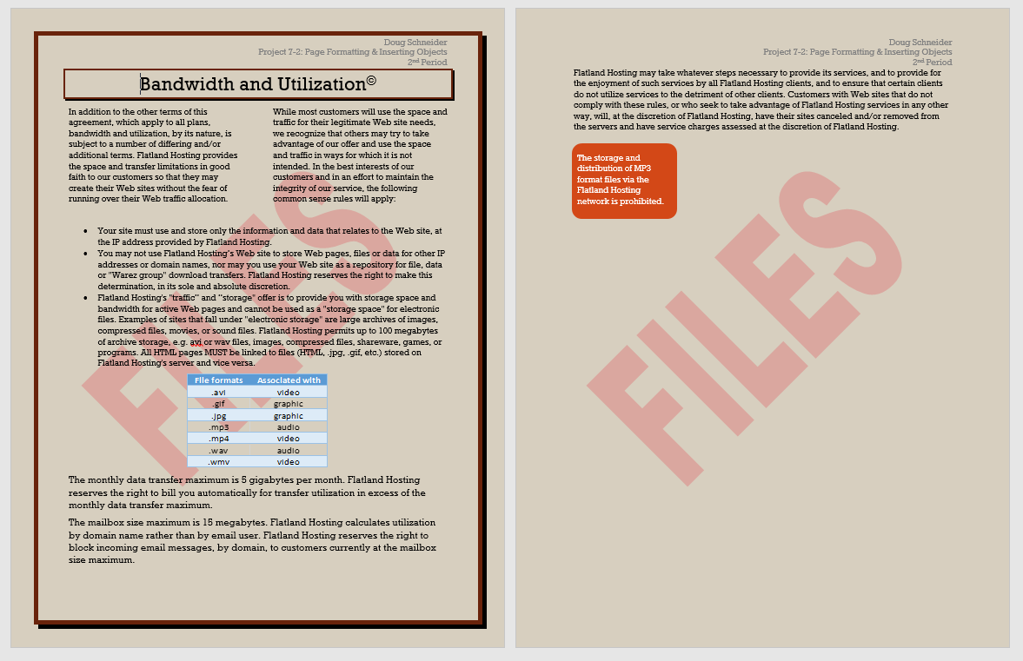
- Save this document and Raise your hand so the teacher and check your project on the computer.

