Project 8-1: House for Sale
In your position at Tech Terrace Real Estate, you were asked by the new home owners if a picture could be taken of them with their new home. The picture turned out so well that you asked them if Tech Terrace Real Estate could use this picture in a flyer for an advertisement. Your task is to create a new flyer that will be used for marketing.
GET READY . LAUNCH Word if it is not already running.

1. OPEN a blank document.
2. SAVE the document as 8-1 Marketing Flyer in the lesson folder on your fl ash drive.
3. Key the following information and change the font size to 18 pt.
4. Look at who just purchase d their new dream home. Tech Terrace Real Estate agents can
assist you in finding your next home or dream home. We’ll take care of all the necessary
details for you and show you quality homes just like we did for our last clients.
5. Press Enter twice.
6. Click the Pictures button from the Illustrations group on the Insert tab.
7. Locate the lesson folder and insert the Realtor with Couple outside House image; then
click Insert .
8. Resize the image height to 3.4” .
9. In the Picture Styles group, convert the picture to the SmartArt graphic Picture Accent
Process . In the placeholder, key We love our new home!
10. Click the More button in the SmartArt Styles group and select Metallic Scene from the
3-D group.
11. In the SmartArt Styles group, click the Change Colors button then select Colored Fill –
Accent 6 from the Accent 6 group.
12. Center the document vertically on the page.
13. SAVE the document in the lesson folder on your flash drive then CLOSE the fi le.

Project 8-3: House for Sale Flyer
You need to make some additional changes to the flyer completed in Project 8-1.
GET READY . LAUNCH Word if it is not already running.

1. OPEN the 8-1 Marketing Flyer you completed for Project 8-1.
2. SAVE the document as 8-3 House Keys in the lesson folder on your flash drive.
3. Under the first paragraph, add a new paragraph and key Are you ready for us to hand
over the keys to your new home?
4. Select the SmartArt graphic, and replace it with a new image, Handing Over House
Keys .
5. Select the Reflected Bevel, Black style from the Picture Styles group to apply a style to
the image.
6. Change the border and apply the Orange, Accent 2, Darker 25% .
7. Change the Picture Effects and select Slope from the Bevel group. Adjust the height
to 2.7” .
8. Apply the Square style to wrap text only to the right .
9. SAVE the document in the lesson folder on your flash drive then CLOSE the fi le.
PAUSE. LEAVE Word open for the next project.

Project 8-4: Creating a Chart
In this exercise, you will create a 3-D pie chart to reflect quarterly sales.
GET READY . LAUNCH Word if it is not already running.
1. OPEN a blank document.
2. SAVE the document as 8-4 Expense Report in the lesson folder on your flash drive.
3. Insert the Pie chart from Figure 8-43 into your document and format as shown.
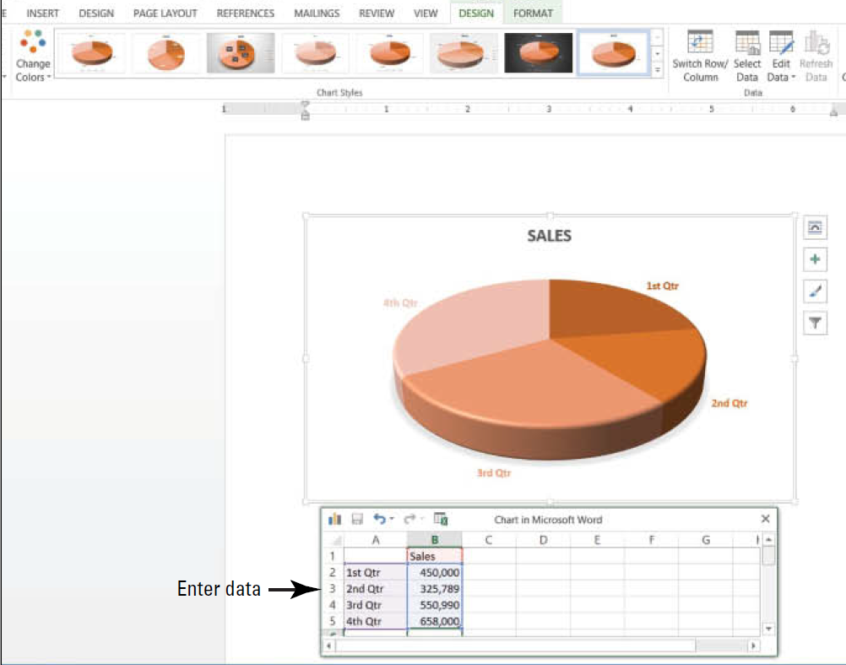
4. Enter the data (see Figure 8-43).
5. Insert a custom watermark and apply the image, Real Estate Folder with Data .
6. SAVE the document in the lesson folder on your flash drive then CLOSE the fi le.
PAUSE. LEAVE Word open for the next project.

