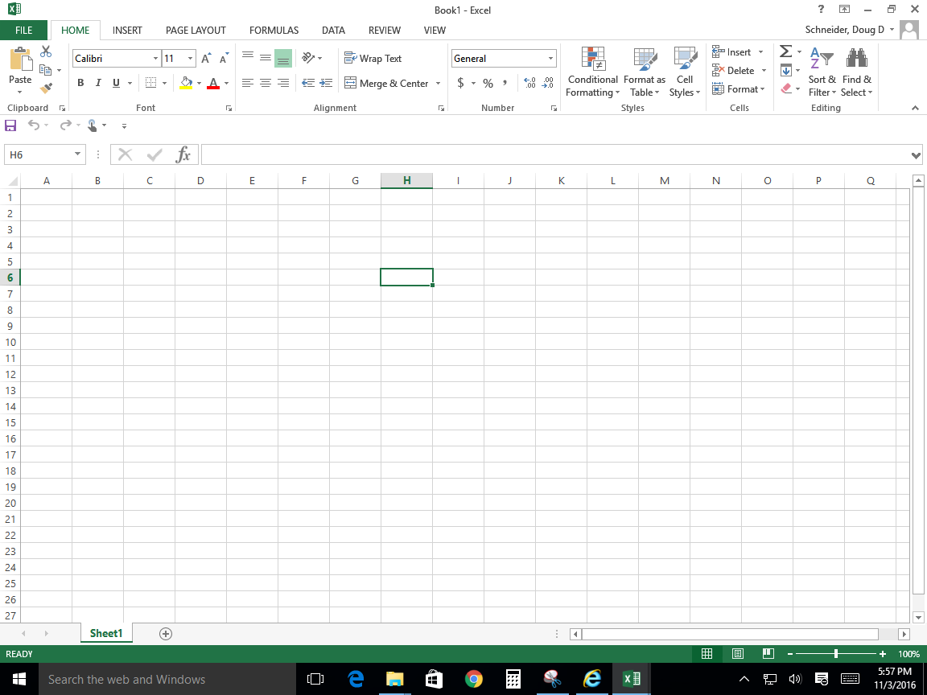

9. What do you have to click to get to the backstage view?

_________________________

Name:______________________________________________

3.



6.

4.

2.

10.

8.

7.

5.