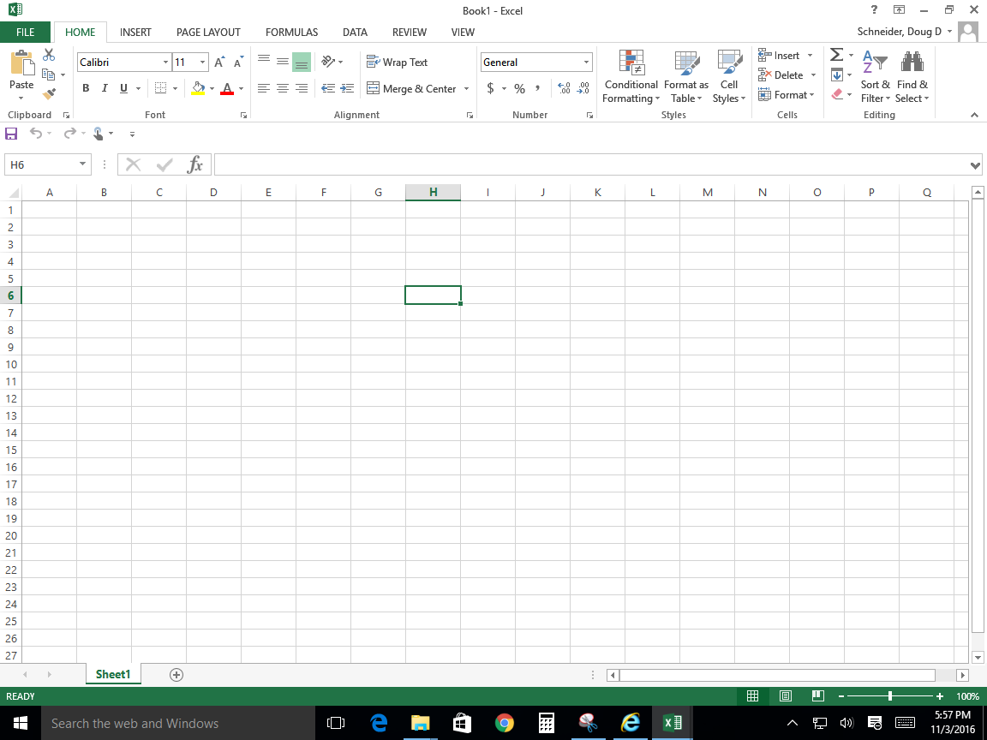

9. What do you have to click to get to the backstage view?

**___FILE____**

Name:______________________________________________

3. Groups

1. Tabs

6. Formula Bar

4. Name Box

2. Workbook

10. Worksheet

8. Column

7. Active Cell

5. Row