- What does the help button look like? Circle it

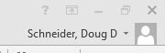
- What button on the keyboard do you have to hit in order to get key tips above your ribbons?____________________________
- What does the show/ hide button look like? Circle it
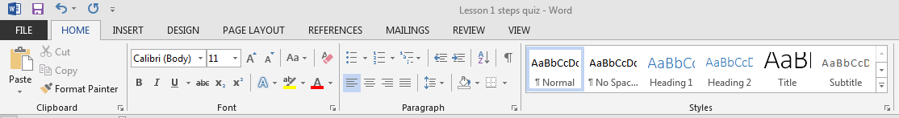
- Under the font group, what button do you have to hit in order to get more buttons for the Font group? Circle it
- Where do you go to move the quick access toolbar below the ribbon? Circle it

- How do you get a mini-toolbar to pop up?____________________________________________

- How do you hide white space at the top of the document?____________________________________________________

- How many letters must you type before Auto-complete will pick the word?____________________

- What type of letter is this?_____________________________
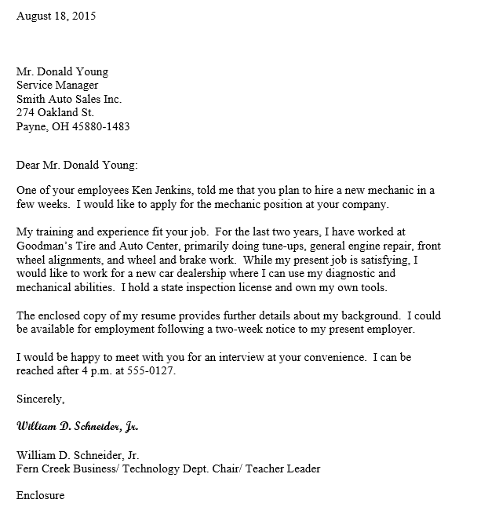
- What type of letter has no punctuation after the Salutation or closing?_____________________

- What type of letter has a colon after the salutation and a comma after the closing?________________

- Where do you go to Save as a Previous document? Circle it
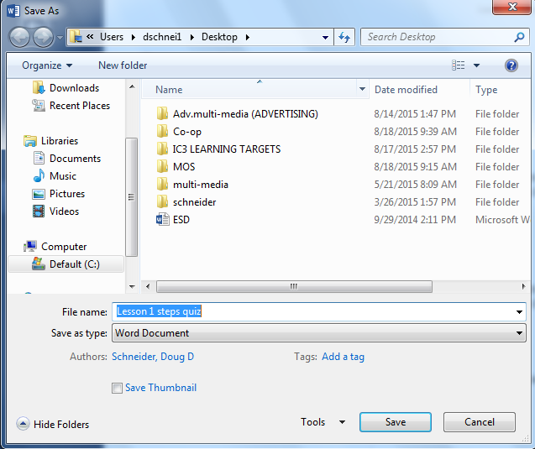

- What view is this an example of?__________________________________ 