- What does the help button look like? Circle it

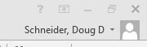
- What button on the keyboard do you have to hit in order to get key tips above your ribbons?____________________________
- What does the show/ hide button look like? Circle it
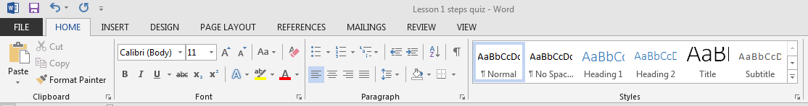
- Under the font group, what button do you have to hit in order to get more buttons for the Font group? Circle it
- Where do you go to move the quick access toolbar below the ribbon? Circle it

