Step by Step 1: Start Excel
  - GET READY. To complete this exercise, make sure your computer is running and Microsoft Excel is installed. Then, perform the following steps:
  - If the Windows desktop is displayed, click the Start charm in the bottom left corner of the Windows 8 screen.
  - Right-click in a blank area of the screen and click All apps.
  - In the list of applications under Microsoft Office 2013, click Excel 2013.
  - A window opens to recent Excel files you've opened and examples of templates you can use (see Figure 1-2).
  - Click Blank workbook. A blank workbook opens, and the worksheet named Sheet1 will be displayed as shown previously.
- PAUSE. LEAVE the workbook open for the next exercise.

Step by Step 2: Start Excel

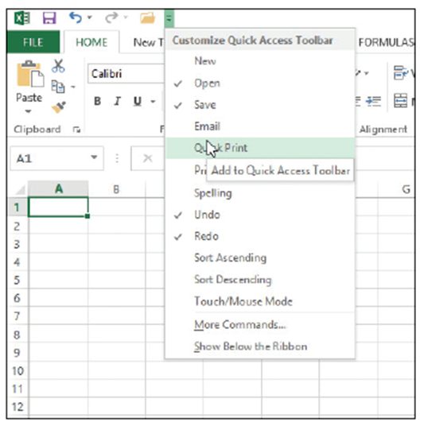
  - GET READY. USE the blank workbook you opened in the previous exercise to perform these steps:
  - Point to each icon on the Quick Access Toolbar and read the description that appears as a ScreenTip.
  - Click the drop-down arrow at the
right side of the Quick Access Tool
bar. From the drop-down list,
select Open. The Open icon is
added to the Quick Access
Toolbar. Click the down arrow
again and select Quick Print
from the drop-down list
as shown at right.
  - Next, right-click anywhere on the Quick Access Toolbar, and then select Show Quick Access Toolbar Below the Ribbon.
  - Right-click the HOME tab and click Collapse the Ribbon. Now, only the tabs remain on display, increasing the workspace area.
  - Right-click the HOME tab again and choose Collapse the Ribbon to uncheck the option and make the ribbon commands visible again.
  - Click the drop-down arrow on the right side of the Quick Access Toolbar to produce a menu of options. Click Show Above the Ribbon from the pop-up menu.
  - Right-click the Open command, and select Remove from Quick Access Toolbar.
  - Click the drop-down arrow on the right side of the Quick Access Toolbar and click Quick Print to remove the checkmark from the menu and thus remove the Quick Print icon from the Quick Access Toolbar.
- PAUSE. LEAVE the workbook open for the next exercise.

Step by Step 3: Navigate the Ribbon
  - GET READY. LAUNCH Excel if necessary and open any workbook.
- Click the HOME tab to make it active and click cell A1. Your ribbon should look similar to the one shown below.
- In the Alignment group, click the Dialog Box Launcher to display the Alignment tab in the Format Cells dialog box.
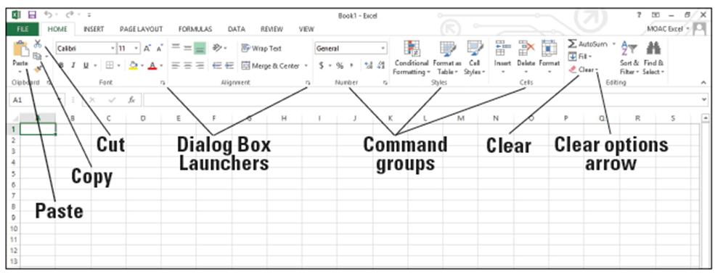
- Click the Cancel button to close the dialog box.

- Click the INSERT tab. Your screen should now look similar to Figure 1-6. Commands on the INSERT tab enable you to add charts and illustrations and perform other functions that add items to enhance your Excel worksheets.
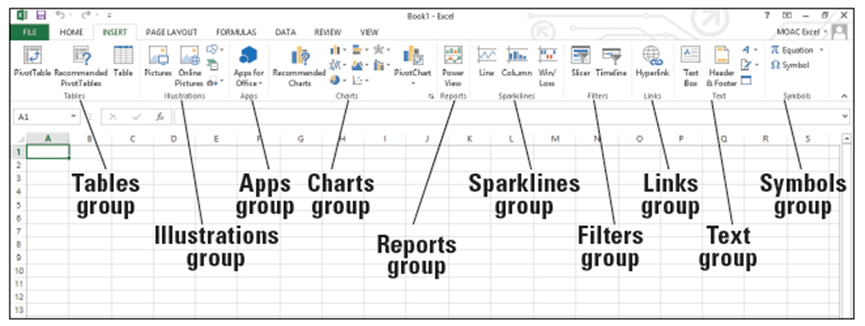
- Click the HOME tab.
- Press and release the Alt key to display onscreen Keytips that show keyboard shortcuts for certain commands (below).
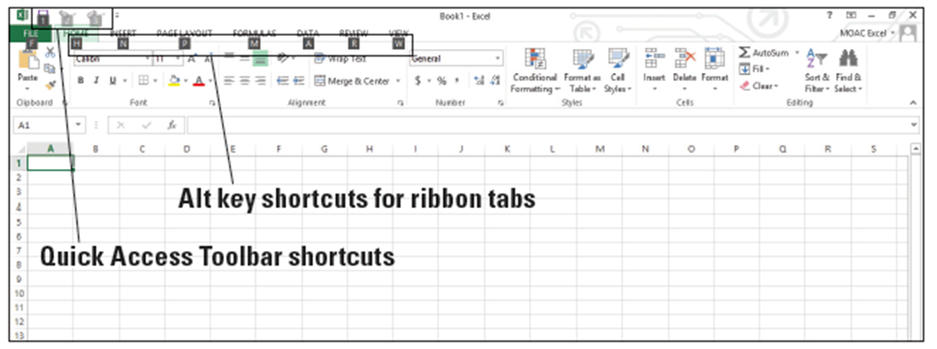
- Type W to display the VIEW tab and then type Q to display the Zoom dialog box.
- Click Cancel or press Esc to close the Zoom dialog box.
- Press Alt + H to return to the HOME tab.
- Press Alt to turn off the Keytips.
- In the Editing group, click the Clear arrow to display the Clear options.
- Press Esc to turn off the options.
- PAUSE. CLOSE Excel.
Step by Step 4: Office Backstage
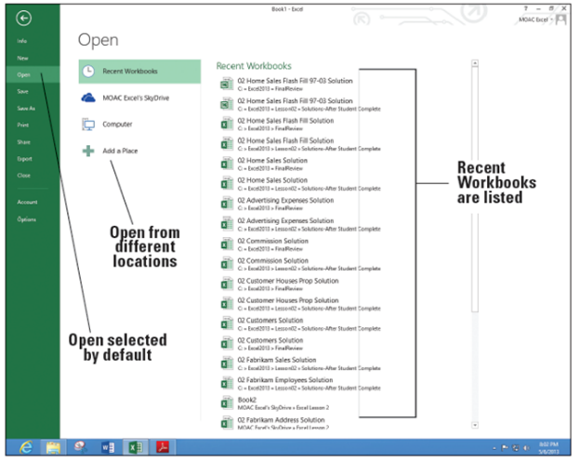
  - GET READY. You should not have Excel running for this exercise.
  - LAUNCH Excel and click Blank workbook to start a new workbook. Notice that Book1
displays in the title bar at the top of the screen.
  - Click the FILE tab. This opens Backstage view (see right).
  - Notice that the Excel Backstage view and Excel icon on the taskbar is green. The Office suite has customized colors to designate which application you are using.
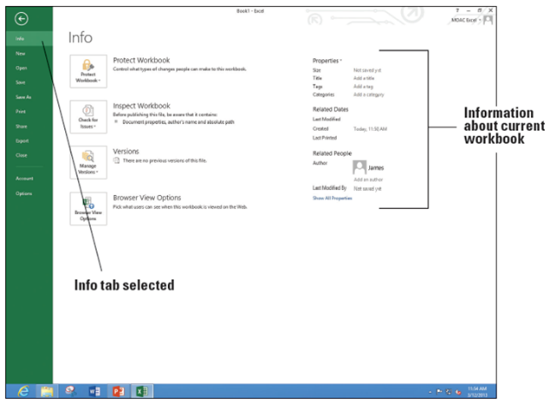
  - The commands are on the left pane of the screen. Click Info and the right pane changes (above).
- PAUSE. CLOSE Excel for the next exercise.

Step by Step 5: Use the Microsoft Office FILE Tab and Backstage View

  - GET READY. LAUNCH Excel and open a new blank workbook.
  - Click the FILE tab to open Backstage view.
  - Click Close in the left pane. Your worksheet disappears, but Excel remains open.
  - Click the FILE tab again, and then click New. The right pane shows the available options, which are the same as when you launch Excel.
  - Click Blank workbook. A new blank workbook is opened.
- PAUSE. CLOSE Excel.

Step by Step 6: Change Excel’s View
  - GET READY. LAUNCH Excel and start a new workbook.
  - If necessary, click the HOME tab to activate it.
  - Select cell A1 to make it active. Then type 456 and press Tab.
  - In the lower-right corner of the Font group, click the Dialog Box Launcher arrow. The Format Cells dialog box shown in Figure 1-10 opens. In most cases, your default font in Excel will be Calibri, 11 point, without bold or italics.
  - Notice that the Font tab of the dialog box is active. Scroll down in the Font list, click Arial, and then click OK.
  - Cell B1 should now be the active cell in your worksheet. Type 456 in this cell, and then press Tab. Notice the difference in size and appearance between this number and the one you entered in cell A1.
  - Click the VIEW tab.
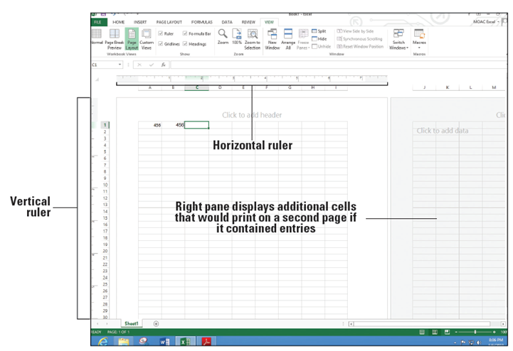
  - In the Workbook Views group, click Page Layout. Your worksheet should look like the figure below. In this view, you can see the margins, where pages break, and you can add a header or footer.
  - In the Workbook Views group, click Normal to return the worksheet to the view that no longer shows rulers, headers, footers, or page breaks.
- PAUSE. LEAVE the workbook open for the next exercise.
Step by Step 7: Split the Window

  - GET READY. USE the worksheet you left open in the previous exercise or type 456 in cells A1 and B1 in a new workbook.
  - Click cell F1 to make it active.
  - On the VIEW tab, click Split. Notice that the screen is split vertically in two different panes.
  - In the horizontal scroll bar of the right pane, hold down the right arrow until you see cell AA1. Notice that you can still see cells A1 and B1 in the left pane.
  - Click Split again. The screen is no longer split.
  - Click in cell A17 and click Split. The screen is split horizontally in two different panes.
  - Click Split again. The screen is no longer split.
  - Click in cell F14 and click Split. The screen is split into four panes this time.
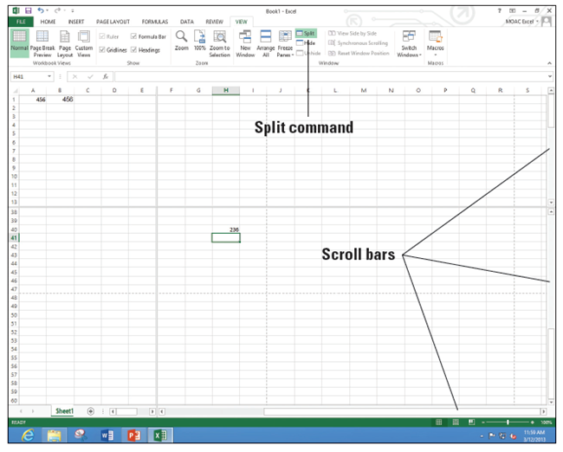
  - Choose the lower right quadrant by clicking any cell in that pane, and then scroll down to display row 40.
  - Type 236 in cell H40 and press Enter. The data you entered in cells A1 and B1 should be visible along with what you just entered in cell H40
(right).
  - Click Split to remove the split. The data in cell H40 is no longer visible.
- PAUSE. LEAVE the workbook open to use in the next exercise.

Step by Step 8: Open a New Window

  - GET READY. USE the worksheet you left open in the previous exercise or type 456 in cells A1 and B1and 236 in cell H40 in a new workbook.
  - Press Ctrl + Home to make A1 the active cell.
  - With the VIEW tab active, in the Window group, click New Window. A new window titled Book1:2 opens. If you have opened a different number of new workbooks, your title bar might show a different book number. The colon and then 2 (:2) indicates that there are two windows of the same workbook open.
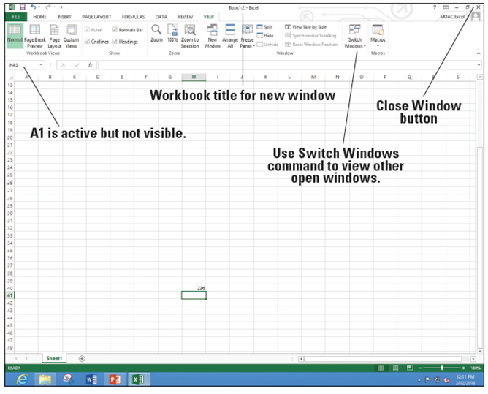
  - Scroll down in the window until cell H40 is visible (right). Although cell A1 is not visible, it is still the active cell. It is important to note that you have opened a new view of the active worksheet—not a new worksheet.
  - Click Switch Windows. A drop-down list of all open windows appears. Book 1:2 is checked, which indicates that it is the active window.
  - Click Book 1:1. You now see the original view of the worksheet with cell A1 active.
  - Click Switch Windows and make Book1:2 active.
  - Click the Close Window button (in the upper-right corner of the workbook window) to close Book1:2. The window closes, and Book1 in the title bar tells you that you are now looking at the only open view of the workbook.
  - Click the FILE tab and then click Close.
  - When asked if you want to save the changes in Book1, click Don’t Save.
- PAUSE. LEAVE Excel open for the next exercise.

Step by Step 9: Open an Existing Workbook
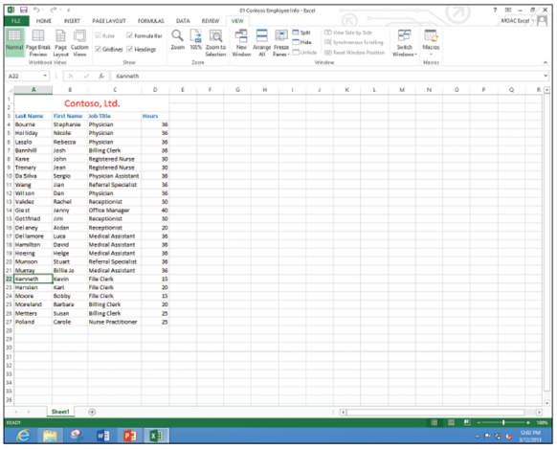
  - GET READY. In this exercise, you use commands on the FILE tab to find and open an existing workbook.
  - In Excel, click the FILE tab and click Open. Documents you recently created or edited appear in the right pane, in the Recent Workbooks area.
  - Click Computer and then click Browse.
  - In the Open dialog box, choose the location for the WileyPLUS files.
  - Select 01 Contoso Employee Info
from the listed files, and then
click Open. The file opens as shown
at right, with the workbook name
displayed in the
title bar.
  - Click the FILE tab, and then click Close to close the Employee workbook.
- PAUSE. LEAVE Excel open for the next exercise.

Step by Step 10: Navigate a Worksheet
  - GET READY. Click the FILE tab, and then click Open. In the Recent Workbooks area, click 01 Contoso Employee Info or go to the class folder and open this file.
  - Press Ctrl + End to move to the end of the document (cell D27).
  - Press Ctrl + Home to move to the beginning of the document (cell A1).
  - Click in the Name Box, type A3, and press Enter to make the cell active.
  - Press Ctrl + Down Arrow to go to the last row of data (cell A27).
  - Press Ctrl + Right Arrow. Cell D27, the last column in the range of data, becomes the active cell.
  - Press Ctrl + Down Arrow. The last possible row in the worksheet displays.
  - Press Ctrl + Home.
  - Press Scroll Lock. Then press the Right Arrow key. This moves the active column one column to the right, and the whole worksheet moves.
  - Use the vertical scroll bar to navigate from the beginning to the end of the data.
  - If your mouse has a wheel button, roll the wheel button forward and back to quickly scroll through the worksheet.
- PAUSE. Press Scroll Lock again to turn it off. LEAVE the workbook open for the next exercise.
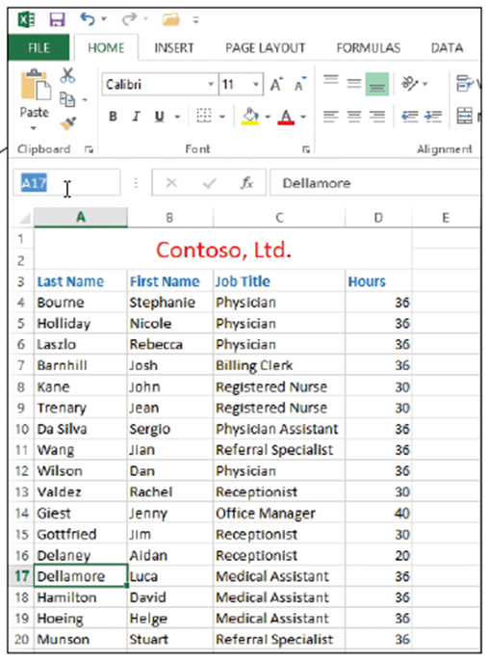
Step by Step 11: Navigate Data with the Go To Command
  - USE the 01 Contoso Employee Info workbook from the previous exercise.
  - Select cell A17.
  - In the Name Box to the left of the formula bar, select cell A17, as indicated t right.
  - Delete A17, type MedAssts, and press Enter.
  - Select cell M11.
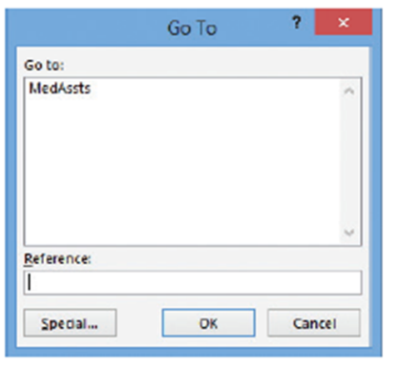
  - Click Find & Select in the
Editing group of the HOME
tab. Click Go To in the menu.
The Go To dialog box appears
(right).
  - In the Go to list, click MedAssts, then click OK.
  - Cell A17 becomes the active cell.Click Find & Select again, and then click Go To Special in the menu. The Go To Special dialog box appears (see Figure 1-18).
  - In the Go To Special dialog box, click Last cell.
  - Click OK. Cell D27 becomes the active cell. The last cell is the lower rightmost cell in the worksheet with contents or formatting.
- CLOSE the workbook and do not save. LEAVE Excel open for the next exercise.

