Step by Step 1: Use the SUMIF Function
- GET READY. LAUNCH Excel.
  - OPEN the 10 Fabrikam Sales file for this lesson.
  - Select C20. Click the FORMULAS tab and in the Function Library group, click Math & Trig. Scroll down the list and click on SUMIF. The Function Arguments dialog box opens with text boxes for the arguments, a description of the formula, and a description of each of the arguments when you are in each text box.
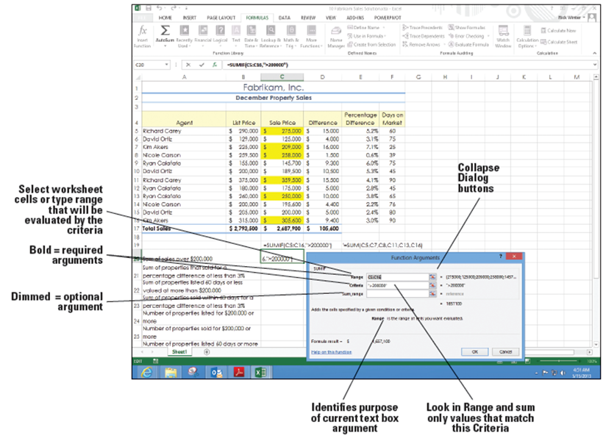
  - In the Function Arguments dialog box, click the Collapse Dialog button for the Range argument. This allows you to see more of the worksheet. Select the cell range C5:C16. Press Enter. By doing this, you apply the cell range that the formula will use in the calculation.
  - In the Criteria
box, type
>200000 and
press Tab. The
figure at right
shows that the
Sum_range text
box is not bold.
This means that
this range is
optional. If you
leave the
Sum_range blank, Excel sums the cells you enter in the Range box. You now applied your criteria to sum all values that are greater than $200,000.
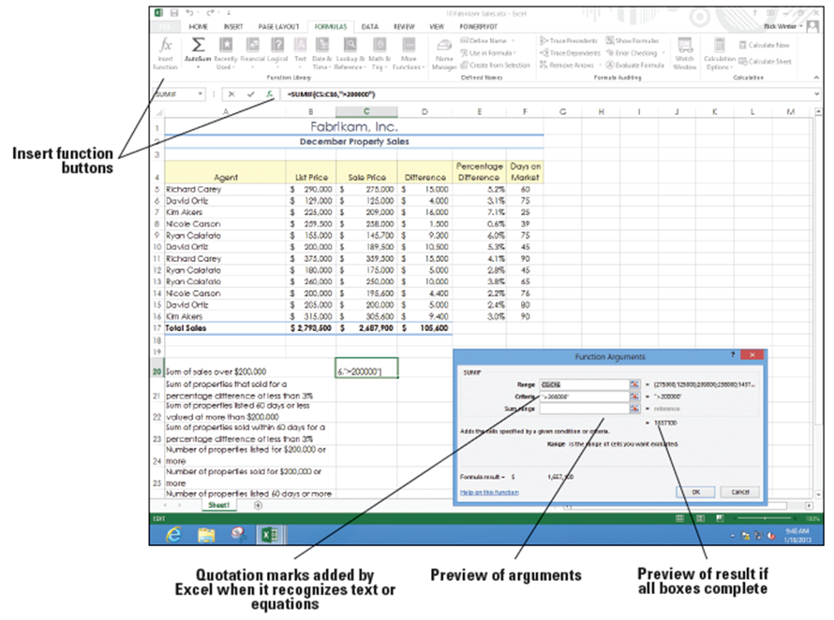
  - Click OK to accept the
changes and close the
dialog box. You see that
$1,657,100 of
Fabrikam’s December
revenue came from
properties valued in
excess of $200,000.
  - If for some reason you
need to edit the formula,
select the cell that
contains the function,
and on the FORMULAS
tab, or in the Formula Bar, click the Insert Function button to return to the Function Arguments box (above).
  - Click OK or press Esc if you have no changes.
  - Select cell C21, and in the Function Library group, click Recently Used, and then click SUMIF to once again open the Function Arguments dialog box. The insertion point should be in the Range box.
  - In the Range field, select cells E5:E16. The selected range is automatically entered into the text box. Press Tab.
  - In the Criteria box, type <3% and press Tab. You enter the criteria to look at column E and find values less than 3%.
- In the Sum_range field, select cells C5:C16. The formula in C21 is different that the formula in C20. In C21, the criteria range is different than the sum range. In C20, the criteria range and the sum range are the same. In C21, SUMIF checks for values in column E that are less than 3% (E8 is the first one) and finds the value in the same row and column C (C8 in this case) and adds this to the total. Click OK to accept your changes and close the dialog box. Excel returns a value of $1,134,200.
- Click the FILE tab and select Save As.
- SAVE the workbook as 10 Fabrikam Sales Solution.
- PAUSE. LEAVE the workbook open for the next exercise.
Step by Step 2: Use the SUMIFS Function
- GET READY. USE the workbook from the previous exercise.
  - Click cell C22. On the FORMULAS tab, in the Function Library group, click Insert Function.
  - In the Search for a Function box, type SUMIFS, and then click Go. SUMIFS is highlighted in the Function box.
  - Click OK to accept the function.
  - In the Function Arguments dialog box, select cells C5:C16 in the Sum_range box. This adds your cell range to the argument of the formula.
  - In the Criteria_range1 box, select cells F5:F16. In the Criteria1 box, type <=60. This specifies that you want to calculate only those values that are less than or equal to 60. When you move to the next text box, notice that Excel places quotation marks around your criteria. It applies these marks to let itself know that this is a criterion and not a calculated value.
  - In the Criteria_range2 box, select cells C5:C16. You are now choosing your second cell range.
  - In the Criteria2 box, type >200000. Click OK. You now applied a second criterion that will calculate values greater than 200,000. Excel calculates your formula, returning a value of $742,000.
  - Select C23 and click Recently Used in the Function Library group.
  - Select SUMIFS. In the Sum_range box, select C5:C16.
  - In the Criteria_range1 box, select cells F5:F16. Type <=60 in the Criteria1 box.

  - In the Criteria_range2 box, select cells E5:E16. Type <3% in the Criteria2 box and press Tab. To see all arguments, scroll back to the top of the dialog box. The Function Arguments dialog box should look like the figure below. 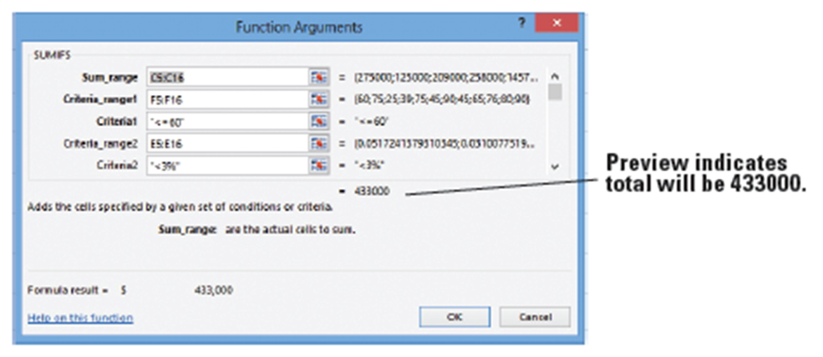
- Click OK. After applying this formula, Excel returns a value of $433,000.
- SAVE the workbook.
- PAUSE. LEAVE the workbook open for the next exercise.
- The formulas you use in this exercise analyze the data on two criteria. You can continue to add up to 127 criteria on which data can be evaluated.
- Because the order of arguments is different in SUMIF and SUMIFS, if you want to copy and edit these similar functions, be sure to put the arguments in the correct order (first, second, third, and so on).
Step by Step 3: Use the COUNTIF Function
- GET READY. USE the workbook from the previous exercise.
  - Select C24. In the Function Library group, click More Functions, select Statistical, and click COUNTIF.
  - In the Function Arguments dialog box, in the Range box, select cells B5:B16.
  - In the Criteria box, type >=200000 and press Tab. Preview the result and click OK. You set your criteria of values greater than or equal to $200,000. Excel returns a value of 9.
  - Select C25 and in the Function Library group, click Recently Used.
- Select COUNTIF. In the Functions Arguments box, in the Range box, select cells C5:C16.
- In the Criteria box, type >=200000 and press Tab. Preview the result and click OK. Excel returns a value of 7 when the formula is applied to the cell.
- SAVE the workbook.
- PAUSE. LEAVE the workbook open for the next exercise.
Step by Step 4: Use the COUNTIFS Function
- GET READY. USE the workbook from the previous exercise.
  - Select C26. Click Insert Function in the Function Library group.
  - In the Search for a function box, type COUNTIFS and then click Go. COUNTIFS is highlighted in the Function box.
  - Click OK to accept the function and close the dialog box.
  - In the Function Arguments dialog box, in the Criteria_range1 box, type F5:F16. You selected your first range for calculation.

  - In the Criteria1 box, type >=60 and press Tab. The descriptions and tips for each argument box in the Function Arguments dialog box are replaced with the value when you navigate to the next argument box (see below). The formula result is also displayed, enabling you to review and make corrections if an error message occurs or an unexpected result is returned. You now set your first criterion. Excel shows the calculation up to this step as a value of 8.
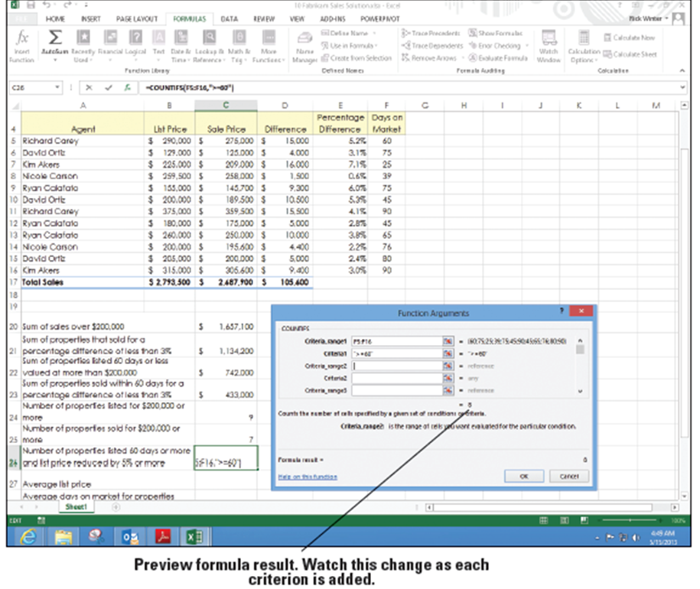
- In the Criteria_range2 box, select cells E5:E16. You selected your second range to be calculated.
- In the Criteria2 box, type >=5% and press Tab to preview. Click OK. Excel returns a value of 2.
- SAVE the workbook.
- PAUSE. LEAVE the workbook open for the next exercise.
- A cell in the range you identify in the Function Arguments box is counted only if all of the corresponding criteria you specified are TRUE or that cell.
- If a criterion refers to an empty cell, COUNTIFS treats it as a 0 value.
Step by Step 5: Use the AVERAGEIF Function
- GET READY. USE the workbook from the previous exercise.
  - Select C27 and in the Function Library group, click More Functions. Select Statistical and click AVERAGE.
  - In the Number1 box, type B5:B16 and click OK. A mathematical average for this range is returned.
  - Select C28 and in the Function Library group, click Insert Function.
  - Select AVERAGEIF from the function list or use the function search box to locate and accept the AVERAGEIF function. The Function Arguments dialog box opens.
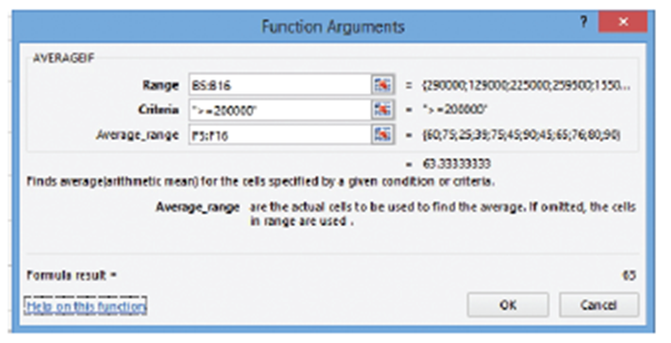
  - In the Function Arguments dialog box, in the Range box, select cells B5:B16.
  - In the Criteria box, type >=200000.
  - In the Average_range
box, select F5:F16
and press Tab to
preview the formula.
In the preview, Excel
returns a value of
63.33 (right).
  - Click OK to close the dialog box.
  - SAVE the workbook.
- PAUSE. LEAVE the workbook open for the next exercise.
Step by Step 6: Use the AVERAGEIFS Function
- GET READY. USE the workbook from the previous exercise.
  - Click cell C29. Click Insert Function in the Function Library group.
  - Type AVERAGEIFS in the Search for a function box and click Go. AVERAGEIFS is highlighted in the Function box.
  - Click OK to accept the function and close the dialog box.
  - In the Function Arguments dialog box, select cells F5:F16 in the Average_range box. Press Tab.
  - In the Criteria_range1 box, select cells B5:B16 and press Tab. You selected your first criteria range.
- In the Criteria1 box, type <200000. You set your first criteria.
- In the Criteria_range2 box, select cells E5:E16 and press Tab. You have selected your second criteria range.
- In the Criteria2 box, type <=5% and press Tab. Click OK. Excel returns a value of 60.
- SAVE the 10 Fabrikam Sales Solution workbook, and then close it.
- PAUSE. LEAVE Excel open for the next exercise.
Step by Step 7: Use the VLOOKUP Function
- GET READY. LAUNCH Excel if it is not already open.
  - OPEN the 10 Fabrikam Bonus data file for this lesson.
  - With the Performance sheet active, select cells A15:C20 in the worksheet. Click the FORMULAS tab, and then click Define Name in the Defined Names group. The New Name dialog box opens.
  - In the New Name dialog box, in the Name box, type Bonus. Click OK to close the dialog box. You defined the range name.
  - Click cell E5, in the Function Library group, click Lookup & Reference, and select VLOOKUP.
  - In the Lookup_value text box, type B5 and press Tab. The insertion point moves to the Table_array box.
  - In the Table_array box, click the Collapse Dialog button. In the Defined Names group, click Use in Formula and select Bonus. Press Enter and Tab. The insertion point moves to the next text box.
  - In the Col_index_num box, type 2, which is the column containing the individual bonus amounts. Press Tab.
  - In the Range_lookup box, type True, which means that VLOOKUP can check for the nearest value that does not go over the number in the first column; the same bonus is paid for a range of years, so you enter True in the Range_lookup box so that a value will be returned for all agents. The Function Arguments dialog box should look similar to the one shown on the next slide. Click OK. Excel returns a value of 2.5%.
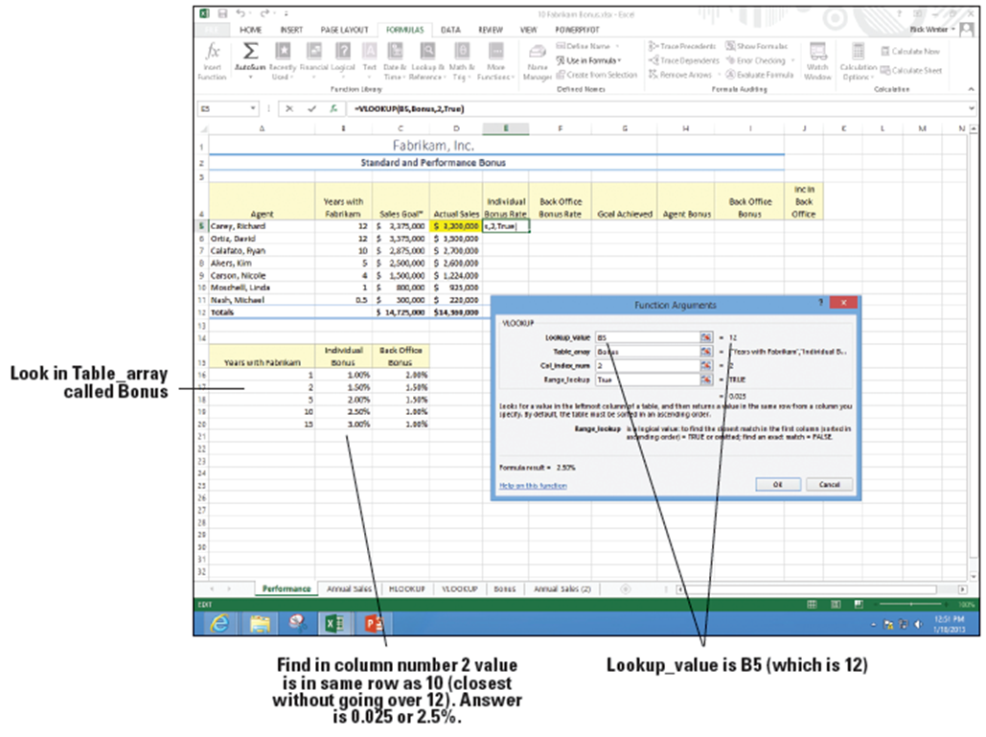
- Using the fill handle in cell E5, copy the formula to the range E6:E11. This calculates bonus rates for the other sales agents. The #N/A error message appears in cell E11 because a value is not available for agents who have been employed for less than one year. (Agents become eligible for a bonus only after a full year of service.) You change this error message in another exercise.
- Click in cell F5 and type =VLOOKUP(B5,Bonus,3). Notice that the ScreenTip gives you information and help as you go. This looks up values in the third column of the Bonus range. Press Enter.
- Copy the formula from F5 to the range F6:F11.
- SAVE the workbook as 10 Fabrikam Bonus Solution.
- PAUSE. LEAVE the workbook open for the next exercise
Step by Step 8: Use the HLOOKUP Function
- GET READY. USE the workbook from the previous exercise.
  - Click on the Standards worksheet tab to move to the Standards worksheet.
  - Click cell F11, click Lookup & Reference in the Function Library group, and select HLOOKUP.
  - In the Lookup_value text box, type E11. This is the cell you will change and the box previews to Feet because that is what is currently typed in cell E11.
  - In the Table_array text box, type A1:D7. This will be the range of cells you will look in.
  - In the Row_index_num, type D11+1. This currently evaluates to 3. If you just do the number of beds that is in D11, you don't come down enough rows because of the labels in the first row of the Table_array. The number of beds is actually one row more than the number of beds because the labels (Beds, CO2, Exits, and Feet) count as the first row and row 2 is for 1 bed.
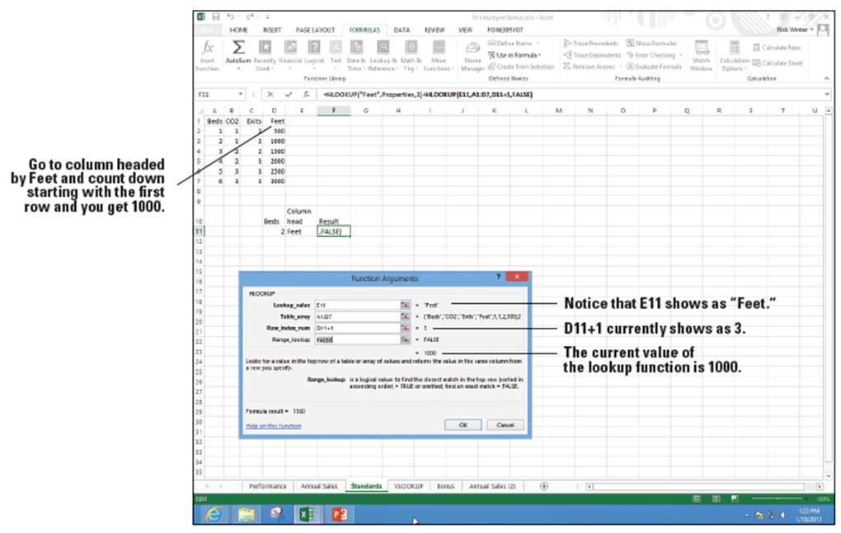
  - In Range_lookup,
type FALSE because
you want an exact
match.
The screen should look
like the figure at
right. Click OK. In the following steps, you will change the
values in D11 and H11 and see what happens when there are different values and when there is not an exact match.
- In cell D11, type 5 and notice that the result in F11 changes to 2500.
- In cell E11, type CO2 and notice that the result changes to the result for the CO2 column for 5 beds, which is 3.
- Click cell D11, and then type 7. Notice that you get a #REF! error because the table goes up only to five beds.
- In cell D11, type 1. Cell F11 displays a result of 1.
- SAVE the workbook.
- PAUSE. LEAVE the workbook open for the next exercise.
Step by Step 9: Use the IF Function
- GET READY. USE the workbook from the previous exercise.
  - Click the Performance worksheet tab to make it the active worksheet.
  - In the Function Library group, select G5. Click Logical and click IF. The Function Arguments dialog box opens.
  - In the Logical_test box, type D5>=C5. This component of the formula determines whether the agent has met his or her sales goal.
  - In the Value_if_true box, type Yes. This is the value returned if the agent met his or her goal.
  - In the Value_if_false box, type No and click OK.
  - With G5 still selected, use the fill handle to copy the formula to G6:G12. Excel returns the result that three agents earned the performance award by displaying Yes in the cells (see below).
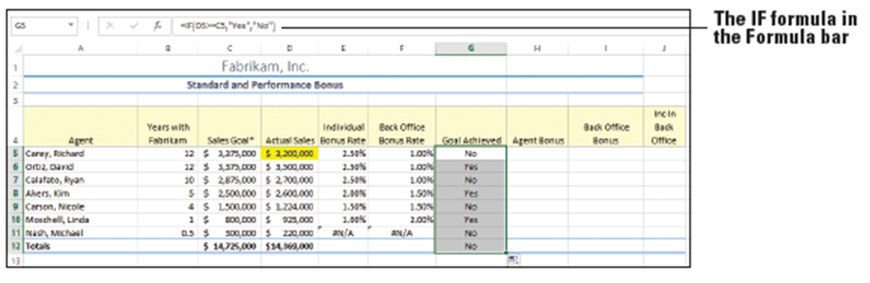
  - Click the Auto Fill Options button in the bottom right corner of the range and choose Fill Without Formatting.

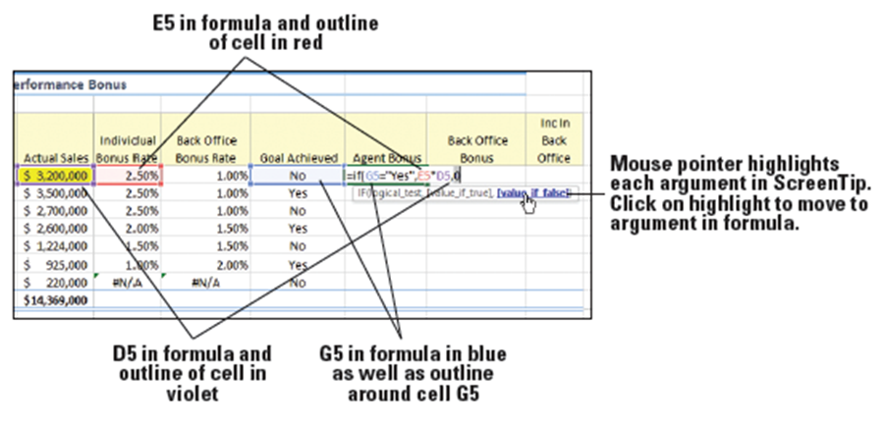
  - In cell H5, type =IF(G5="Yes",E5*D5,0. Before you complete the formula, notice the ScreenTip, the cells selected, and the colors (below). Move the mouse pointer to each of the arguments and they become a hyperlink. E5 is the individual bonus rate and D5 is the actual sales. The bonus is the rate times the sales.
  - Press Enter to finish the formula.
  - Use the fill handle in H5 to copy the formula from cell H6 to cell H11.
  - In I5, type =IF($G$12="Yes",F5*D5,0), and then press Enter.
  - Use the fill handle in I5 to copy the formula from cell I6 to cell I11. Notice that Richard Carey, the Senior Partner, did not receive an Agent Bonus and there was no bonus for Back Office.

  - The final pending sale of $700,000 of the year came through. In D5, type $3,900,000. Notice that H5 and the amounts in column I go from 0 to bonuses (below).
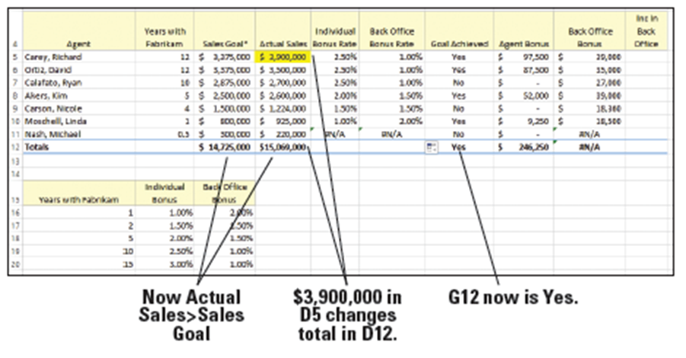
  - SAVE the workbook.
- PAUSE. LEAVE the workbook open for the next exercise.

Step by Step 10: Use the AND Function
- GET READY. USE the workbook from the previous exercise.
  - Click the Annual Sales worksheet tab. Click the FORMULAS tab if necessary.
  - Click cell B6. In the Function Library group, click Logical and click the AND option. The Function Arguments dialog box opens with the insertion point in the Logical1 box.
  - Click cell B3, type <=, select cell B16, and press Enter. This argument represents the first condition: Did actual sales equal or exceed the sales goal? Because this is the first year, only one logical test is entered.
  - Select cell C6, click the Recently Used button, and click AND. In the Logical1 box, type C3<=C16. This is the same as the condition in Step 3 (sales exceed or equals sales goal).
  - In the Logical2 box, type C16>=B16*1.05 and press Tab. The preview of formula returns True, which means that both conditions in the formula have been met. The AND function arguments are illustrated ibelow.
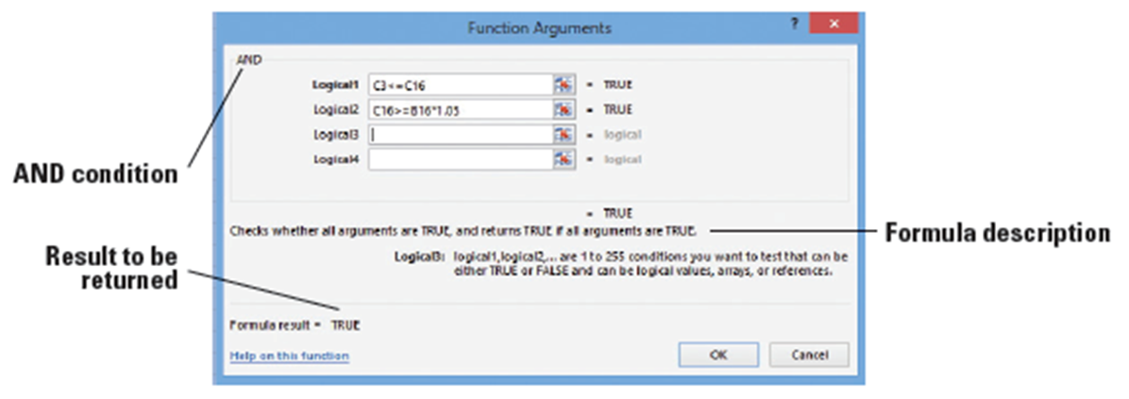
  - Click OK to complete the formula.
  - Select cell C6 and copy the formula to D6:F6 (below).
  - SAVE the workbook.
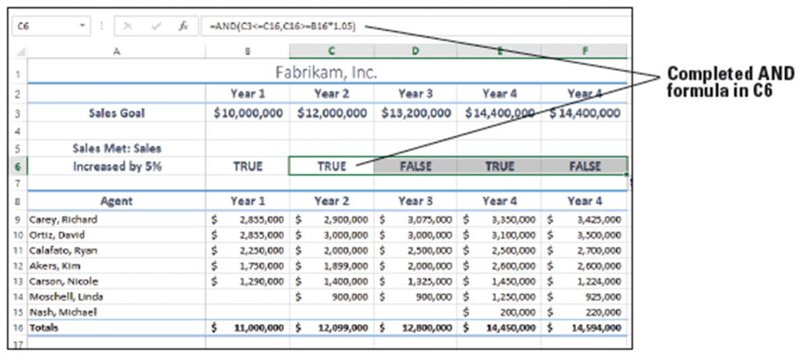
- PAUSE. LEAVE the workbook open for the next exercise.
Step by Step 11: Use the OR Function
- GET READY. USE the workbook from the previous exercise.
  - Click on the Performance worksheet tab to activate this worksheet. Select J5 and click Logical in the Function Library group.
  - Click OR. The Function Arguments dialog box opens. You create a formula that answers the following question: Has Carey worked with the company for less than 4 years?
  - In the Logical1 box, type B5<4 and press Tab.
  - In the Logical2 box, type G5="No" and press Tab. This argument answers the second question: Did Carey not achieve the sales goal? Each of the arguments evaluates to false and so the entire function evaluates to false.
  - Click OK to close the dialog box.
  - Select cell J5 and copy the formula to J6 through J11.
  - Cell J7 is the first in the column that returns a True value. To see each of the arguments, click cell J7 and then click the Insert Function button and you return to the Function Arguments dialog box (below).
  - Click OK to close the dialog box and return to the workbook.
  - SAVE the workbook.
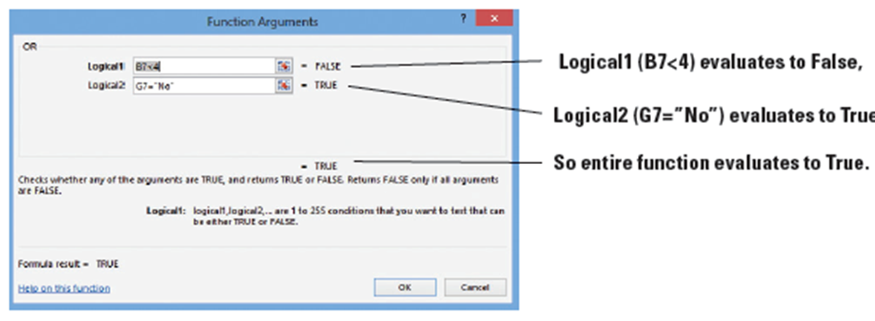
  - PAUSE. LEAVE the workbook open for the next exercise.
Step by Step 12: Use the NOT Function
- GET READY. USE the workbook from the previous exercise. The Performance worksheet should still be active.
  - Copy cell J4 to cell K4 and edit the label to say Not In Back Office.
  - In the Function Library group, click the Logical button.
  - Select NOT from the list of logical formulas.
  - In the Function Arguments dialog box, type J5 and press Enter.
  - Copy cell K5 to cells K6 through K11. Notice that the values in K5 through K11 are the opposite of the values in column J.
  - SAVE the workbook.
- PAUSE. LEAVE the workbook open for the next exercise.
Step by Step 13: Use the IFERROR Function
- GET READY. USE the workbook from the previous exercise and make sure the Performance worksheet is active.
  - Select cell E11 and click to place the insertion point after the = in the formula bar to edit the formula. You add the IFERROR formula to correct the formula error that gave the #N/A result in a previous exercise.
  - Type IFERROR( before VLOOKUP. Leave the existing formula intact. Press End to take you to the end of the formula.

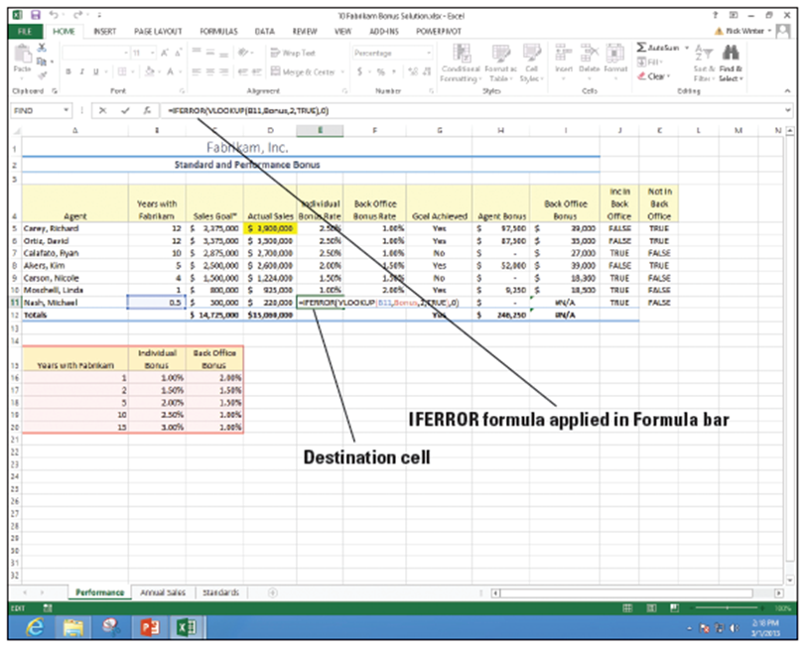
  - At the end of the original formula, type ,0). As shown below, the complete formula is =IFERROR(VLOOKUP(B11,Bonus,2,True),0). Be sure
to include the
closing paren-
thesis and the
preceding
comma or Excel
returns an error
that the formula
is incorrect.
  - Press Enter. The #N/A error message is replaced by 0. If you select cell E11 and click the Insert Function button next to the formula bar, the original VLOOKUP formula appears in the Value box (first argument) in the IFERROR formula. As illustrated below, that argument returned a #N/A error. The Value_if_error box contains the 0 that replaces the error message.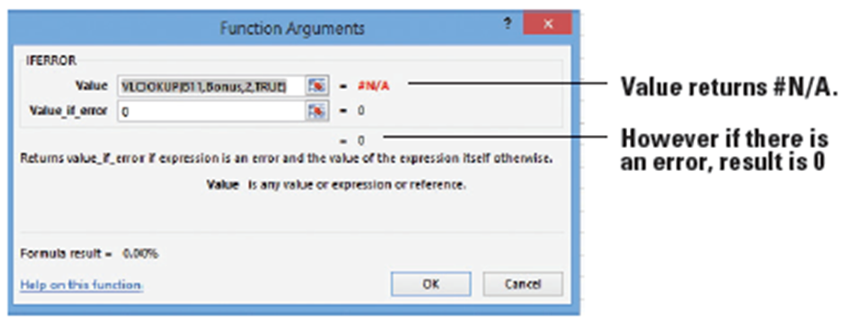
  - Click cell F11 and edit the formula to include the IFERROR function =IFERROR(VLOOKUP(B11,Bonus,3),0).

  - Copy the formulas in E11:F11 to E5 through F10. The workbook doesn’t look like it changes, but you should verify that this worked by changing B6 to 0 (as shown below).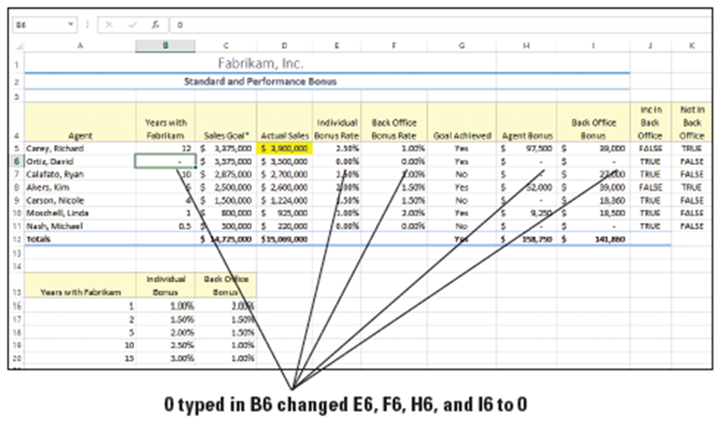
- Click Undo to reverse the change to cell B6 and return the worksheet to the proper values.
- SAVE the 10 Fabrikam Bonus Solution workbook again.
- PAUSE. CLOSE the workbook and LEAVE Excel open for the next exercise.
- IFERROR recognizes and evaluates the following errors: #N/A, #VALUE!, #REF!, #DIV/0!, #NUM!, #NAME?, or #NULL!. In this exercise, you replace the #N/A error message with 0”.
Step by Step 14: Convert Text to Columns
- LAUNCH Excel if necessary.

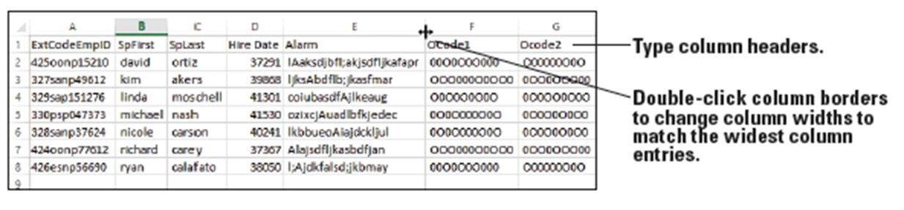
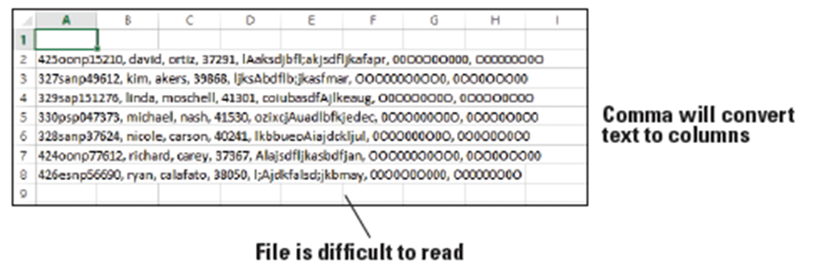
  - Open the 10 Fabrikam Alarm Codes workbook. The figure below shows what the file looks like before you convert the rows to column. The figure (below) shows the same data after the conversion.
  - Select cells A2:A8. Click the DATA tab and click Text to Columns in the Data Tools group.
  - The Convert Text to Columns Wizard opens with Delimited selected as the default, because Excel recognizes that the data in the selected range is separated with commas. Click Next to move to the next step in the wizard.
  - Select Comma as the delimiter. If other delimiters are checked, deselect them
  - Click Next, and then click Finish.
  - Data is separated into seven columns. To help identify the columns, type the text in row 1 and increase the column widths so you can see the cell contents.
  - SAVE the workbook as 10 Fabrikam Alarm Codes Solution.
- PAUSE. LEAVE the workbook open for the next exercise.

Step by Step 15: Use the LEFT Function
- GET READY. USE the workbook from the previous exercise.
  - Click cell H1, type Ext, and in I1, type Floor to label the columns.
  - Select cell H2.
  - Click the FORMULAS tab. In the Function Library group, click Text and choose LEFT. The Function Arguments dialog box opens.
  - In the Text box, click A2 and press Tab.
  - In the Num_chars box, type 3 and press Tab. The preview of the result shows 425 (see below).
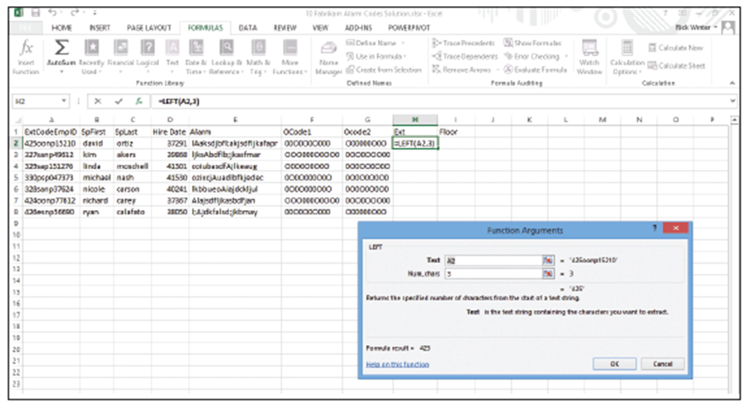
  - Click OK and double-click on the fill handle in the bottom right of cell H2 to copy the formula in H2 from H3 to H8.
- Select cell I2, click the Recently Used button, and select LEFT.
- In the Text box type A2, press Tab, and in the Num_chars box, type 1. Click OK.
- Copy the formula in I2 from I3 to I8.
- SAVE the workbook.
- PAUSE. LEAVE the workbook open for the next exercise.
Step by Step 16: Use the RIGHT Function
- GET READY. USE the workbook from the previous exercise.
  - Click cell J1, and then type Birthday. In cell K1, type EmpID to label the columns.
  - Select cell J2.
  - Click the FORMULAS tab and in the Function Library group, click Text and choose RIGHT. The Function Arguments dialog box opens.
  - In the Text box, click E2 and press Tab.
  - In the Num_chars box, type 3 and press Tab. The preview of the result shows apr.
  - Click OK and copy the formula in J2 from J3 to J8.
  - Select cell K2, type =RIGHT(A2,5), and press Enter.
  - Copy the formula in K2 from K3 to K8.
  - SAVE the workbook.
- PAUSE. LEAVE the workbook open for the next exercise.
Step by Step 17: Use the Mid Function
- GET READY. USE the workbook from the previous exercise.
  - Click cell L1, and then type empcat1, and in cell M1, type empcat2 to label the columns.
  - Select cell L2.
  - Click the FORMULAS tab and in the Function Library group, click Text and choose MID. The Function Arguments dialog box opens.
  - In the Text box, click A2 and press Tab.
  - The starting point of the empcat1 value is the fourth character of (425oonp15210), so type a 4 in the Start_num text box.
  - In the Num_chars box, type 2. The preview of the result shows oo.
  - Click OK and copy the formula in L2 from L3 to L8.
  - Select cell M2, and type =MID(A2,6,2), and press Enter.
- Copy the formula in M2 from M3 to M8.
- SAVE the workbook. The worksheet should look like the figure below.
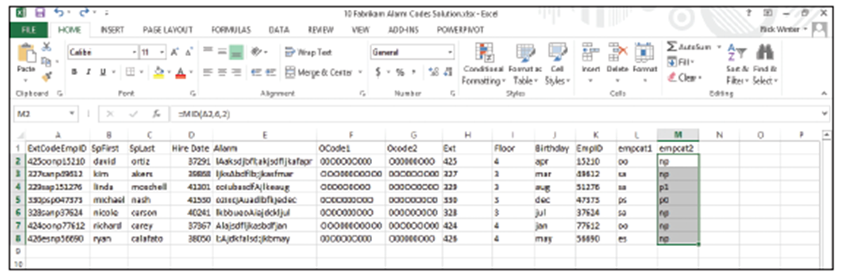
- PAUSE. LEAVE the workbook open for the next exercise.
Step by Step 18: Use the TRIM Function
- GET READY. USE the workbook from the previous exercise.
  - Click cell N1, type first, and in cell O1, type last to label the columns.
  - Click cell N2.
  - Click the FORMULAS tab and in the Function Library group, click Text and choose TRIM. The Function Arguments dialog box opens.
  - In the Text box, click B2. If you look closely, you see that the original value of cell B2 is “david” with a space before the first name.
  - Click OK and copy the formula in N2 from N3 to N8.
  - Select cell O2, type =TRIM(C2), and press Enter.
- Copy the formula in O2 from O3 to O8.
- SAVE the workbook. The results of the next few exercises appear in the figure below.
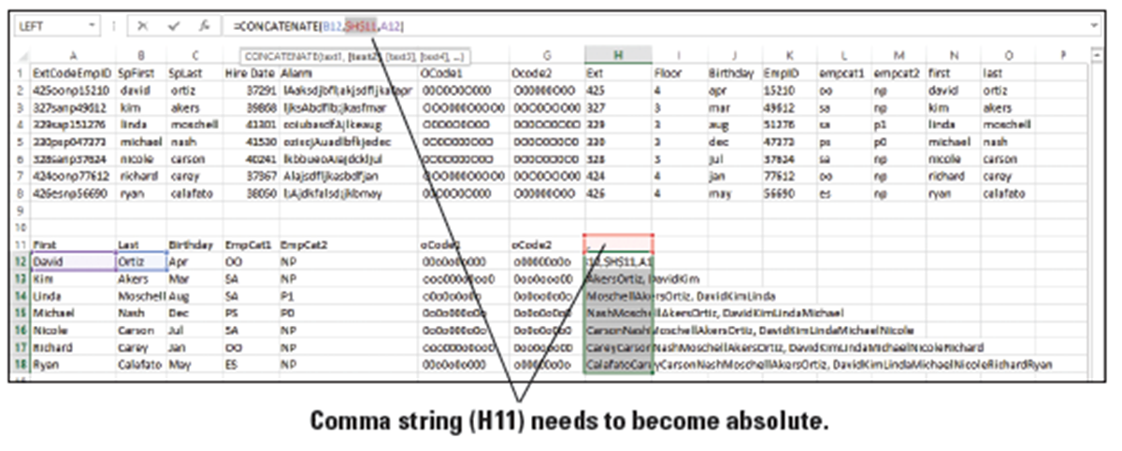
- PAUSE. LEAVE the workbook open for the next exercise.
Step by Step 19: Use the PROPER Function
- GET READY. USE the workbook from the previous exercise.
  - Click cell A11, and then type First. In cell B11, type Last, and in cell C11, type Birthday to label the columns.
  - Select cell A12.
  - Click the FORMULAS tab and in the Function Library group, click Text and choose PROPER. The Function Arguments dialog box opens.
  - In the Text box, click N2. You see that david is converted to David.
  - Click OK and copy the formula in A12 from A12 through B18 (both First and Last name columns).
  - Select cell C12, type =PROPER(J2), and press Enter.
  - Copy the formula in C12 from C13 to C18.
  - SAVE the workbook.
Step by Step 20: Use the UPPER Function
- GET READY. USE the workbook from the previous exercise.
  - Click cell D11, type EmpCat1, and in cell E11, type EmpCat2 to label the columns.
  - Click cell D12.
  - Click the FORMULAS tab and in the Function Library group, click Text and choose UPPER. The Function Arguments dialog box opens.
  - In the Text box, click L2. You see that oo is converted to OO.
  - Click OK and copy the formula in D12 from D12 through E18 (both EmpCat1 and EmpCat2 columns).
  - SAVE the workbook.
- PAUSE. LEAVE the workbook open for the next exercise.
Step by Step 21: Use the LOWER Function
- GET READY. USE the workbook from the previous exercise.
  - Click cell F11 and type oCode1. In cell G11, type oCode2 to label the columns.
  - Click cell F12.
  - Click the FORMULAS tab and in the Function Library group, click Text and choose LOWER. The Function Arguments dialog box opens.
  - In the Text box, click F2. You see that 00O0O0O000 is converted to 00o0o0o000.
  - Click OK and copy the formula in F12 from cell F12 through G18 (both oCode1 and oCode2 columns).
  - SAVE the workbook.
- PAUSE. LEAVE the workbook open for the next exercise.
Step by Step 22: Use the CONCATENATE Function
- GET READY. USE the workbook from the previous exercise.
  - Click cell H11 and type , (a comma followed by a space), and in cell I11, type First Last to label the columns.
  - Click cell H12.
  - Click the FORMULAS tab and in the Function Library group, click Text and choose CONCATENATE. The Function Arguments dialog box opens.
  - In the Text box, click cell B12 and press Tab. Click cell H11, press Tab, and click A12. In the preview area, you see "Ortiz, David".
  - Click OK and copy the formula in cell H12 from cell H13 through cell H18. The result is an error (see below). Notice that the string gets longer and longer and Ortiz is in every string.
  - Click the cell H12. In the Formula bar, select place your insertion point directly after H11 and press F4 (Absolute). Cell H11 should become $H$11.
  - Press Enter and copy the formula in cell H12 from cell H13 through cell H18 again. This time the formula is copied correctly.
  - Type a ; (a semi-colon followed by a space) in H11, and notice that all values in the column now have semi-colons instead of commas.
- Select cell I12 and type =CONCATENATE(A12," ",B12). Notice that the second argument is a quote, space, and a quote. This separates the first and last names.
- Press Enter and copy the formula in cell I12 from cell I13 through cell I18 again.
- SAVE the workbook.
- PAUSE. LEAVE the workbook open for the next exercise.
Step by Step 23: Use the FIND Function
- GET READY. USE the workbook from the previous exercise.
  - Click cell J11 and type APos, and in cell K11, type bPos to label the columns.
  - Click cell J12.
  - Click the FORMULAS tab and in the Function Library group, click Text and choose FIND. The Function Arguments dialog box opens.
  - In the Find_text box, type A and press Tab. Notice that the preview shows “A” (with quotes) in the row.
- In the Within_text box, click E2. Notice that the result returns a 3 for the function. The first character in the string is a space, the second is an l (lowercase “L”), and the third is a capital A.
- Click OK and copy the formula in cell J11 from cell J12 through cell J18.
- Select cell K12, type =FIND(“b”,E2), and press Enter. In this case, you are looking for a lowercase b—the argument is case sensitive.
- Copy the formula in cell K12 from cell K13 to cell K18.
- SAVE the workbook.
- PAUSE. LEAVE the workbook open for the next exercise.
Step by Step 24: Use the SUBSTITUTE Function
- GET READY. USE the workbook from the previous exercise.
  - Click cell L11 and type S1, and in M11 type Probationary Level to label the columns.
  - Select cell L12.
  - Click the FORMULAS tab and in the Function Library group, click Text and choose SUBSTITUTE. The Function Arguments dialog box opens.
  - In the Text box, click E12 and press Tab.
  - In the Old_text box, type NP. This is a code for employees who are not probationary.
  - In the New_text box, type Non and press Tab. Because the first value is NP, the result of the formula will be Non.
  - Click OK and copy the formula in L11 from L12 through L18.
  - Select cell M12 and type =SUBSTITUTE(L12,"P","Probationary Level ") and press Enter. In this case, you are looking the letter P and changing the string to Probationary Level with a space at the end because a number will follow.
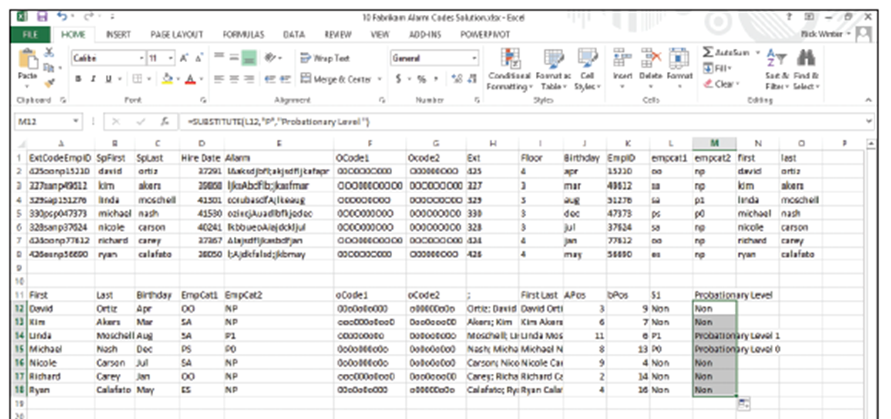
  - Copy the formula in cell M12 from cell M13 to cell M18. See the figure below to see the worksheet values.
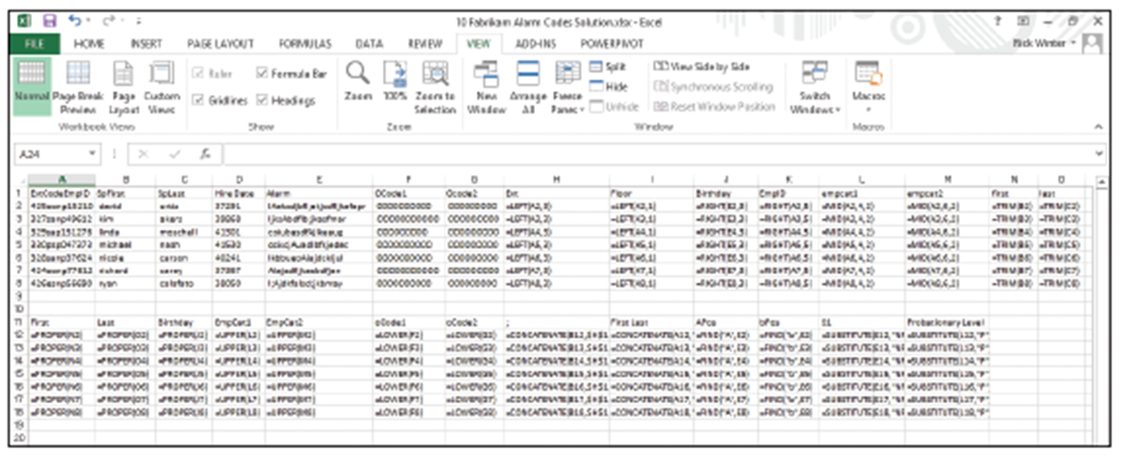
  - Press Ctrl +` to display the formulas, as shown below. Press Ctrl +` again to switch back to the formula results.
  - SAVE the workbook as 10 Fabrikam Alarm Codes Solution again.
- EXIT Excel.
- To use existing text with small changes, you can use the SUBSTITUTE function.
- In the Function Arguments dialog box, Text can be the actual text you want to substitute, or it can be a cell reference.

