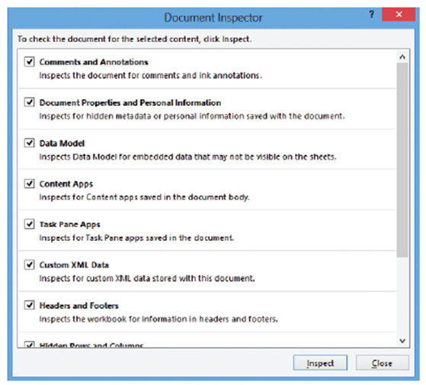
Step by Step 1: Use the Document Inspector
- GET READY. OPEN 11 Contoso Employee IDS from the data files for this lesson.
  - Click the FILE tab, click Save As,
click Browse, and navigate to the
lesson folder. In the File name box,
type 11 Employee ID Doc
Inspect Solution to save a copy
of the workbook. Click the Save
button.
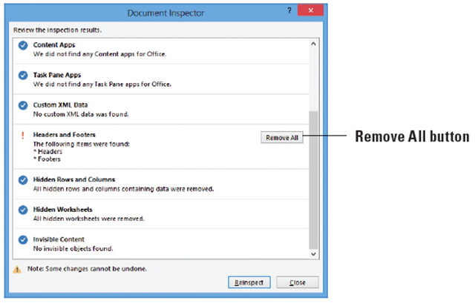
  - Click the FILE tab. Then, with
Info selected, click the Check for
Issues button in the middle pane of the Backstage view. Next, click Inspect Document. The Document Inspector dialog box opens, as shown above.
  - Click Inspect. The Document Inspector changes to include some Remove All buttons.
  - Click Remove All for
Comments and Annotations.
  - Click Remove All three times
for Document Properties and
Personal Information, Hidden
Rows and Columns, and
Hidden Worksheets. Headers
and Footers should be the only hidden item remaining (above).
  - Click the Close button to close the Document Inspector dialog box.
  - SAVE the workbook.
- PAUSE. CLOSE the workbook.
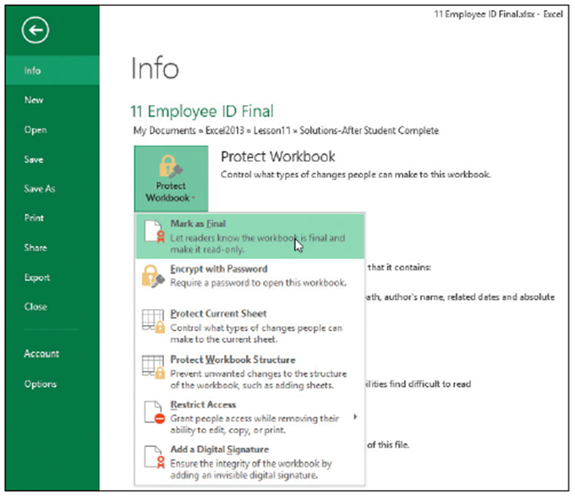
Step by Step 2: Mark a Document as Final
- GET READY. OPEN 11 Contoso Employee IDS.
  - SAVE the workbook as
11 Employee ID Final
Solution.
  - Click the FILE tab and in
Backstage view, click the
Protect Workbook
button. Click Mark as
Final, as shown at right.
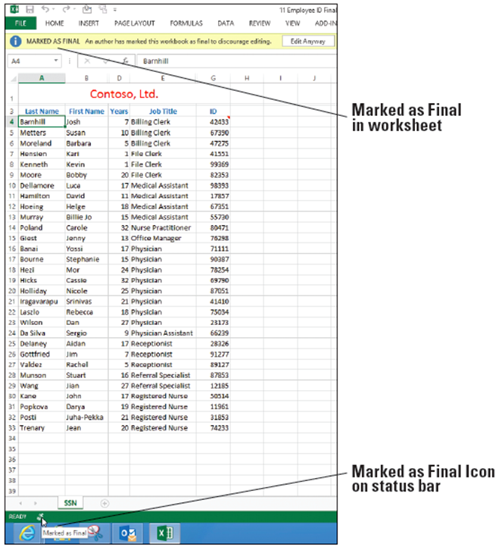
  - The Excel message dialog
box opens indicating that
the workbook will be
marked as final and saved. Click OK.
- An Excel message explains
that the document has been
marked as final. This also
means that the file has
become read-only, meaning
you can’t edit it unless you
click the Edit Anyway button.
Click OK. Notice a Marked
as Final icon appears in the
Status bar (right).
- PAUSE. CLOSE the workbook.
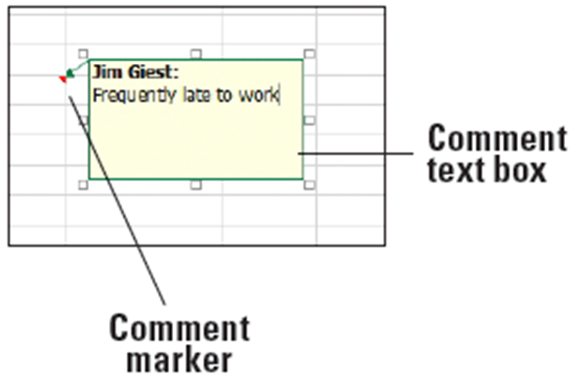
Step by Step 3: Insert a Comment
- GET READY. OPEN the 11 Contoso Personnel Evaluations data file for this lesson.
  - Select cell E11. On the
REVIEW tab in the
Comments group, click
New Comment. The
comment text box opens
for editing.
  - Type Frequently late
to work as shown above.
- Click cell D8. Press Shift + F2 and type Currently completing Masters degree program for additional certification. Click outside the comment box. The box disappears and a red triangle remains in the upper-right corner of the cell the comment was placed in.
- Click cell E4. Click New Comment and type Adjusted hours for family emergency.
- Click cell F10. Click New Comment and type Consider salary increase.
- SAVE the file as 11 Evaluations Solution.
- PAUSE. SAVE the workbook and LEAVE it open for the next exercise.
Step by Step 4: View a Comment
- GET READY. USE the workbook from the previous exercise.
  - Click cell F10 and on the REVIEW tab, in the Comments, group, click Show/Hide Comment. Note that the comment remains visible when you click outside the cell.
  - Click cell E4 and click Show/Hide Comment. Again, the comment remains visible when you click outside the cell.
  - Click cell F10 and click Show/Hide Comment. The comment is hidden.
  - In the Comments group, click Next twice to navigate to the next available comment. The comment in cell E11 is displayed.
  - In the Comments group, click Show All Comments. All comments are displayed.
  - In the Comments group, click Show All Comments again to hide all comments and make sure they are no longer displayed.
- PAUSE. SAVE the workbook and LEAVE it open for the next exercise.
Step by Step 5: Edit a Comment
- GET READY. USE the workbook from the previous exercise.
  - 1. Click cell E11 and move the mouse pointer to the Edit Comment button on the REVIEW tab. The ScreenTip also shows Shift + F2 as an option, as shown below.
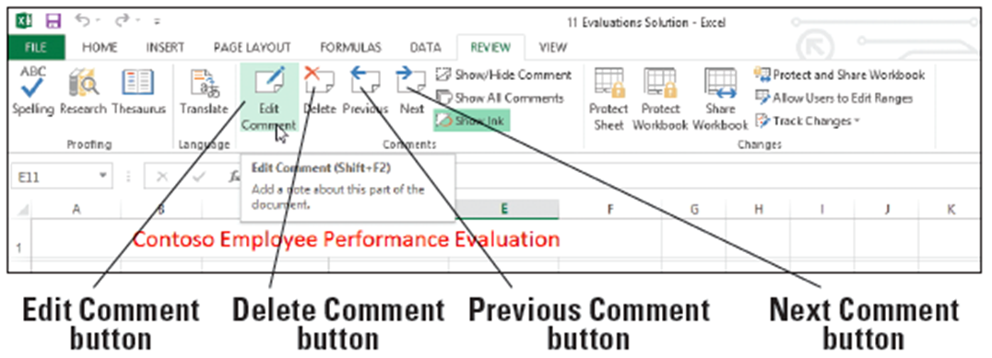
  - Click the Edit Comment button.
  - Following the existing comment text, type a . (period) followed by a space and then Placed on probation. Then click any cell between F4 and D8.
  - Click Next. The comment in D8 is displayed.
  - Select the existing comment text in D8 and type MA completed; can now prescribe medications.
  - Click cell E4 and click Edit Comment.
  - Select the text in the comment attached to E4. On the HOME tab, click Bold.
  - Click cell E11, click the REVIEW tab, and click Edit Comment.
  - Select the name and the comment text. Click the HOME tab and notice that the Fill Color and Font Color options are dimmed. Right-click on the selected text and select Format Comment.
  - In the Format Comment dialog box, click the arrow in the Color box and click Red. Click OK to apply the format and close the dialog box. There is no fill option for the comment box.
- PAUSE. SAVE the workbook and LEAVE it open for the next exercise.
Step by Step 6: Delete a Comment
- GET READY. USE the workbook from the previous exercise.
  - Click cell E4. The comment for this cell is displayed.
  - On the REVIEW tab, in the Comments group, click Delete.
- PAUSE. SAVE the workbook and LEAVE it open for the next exercise.
Step by Step 7: Print Comments in a Workbook
- GET READY. USE the workbook from the previous exercise.
  - On the REVIEW tab, click Show All Comments. Notice that the comments slightly overlap each other.
  - Click the border of the comment box in cell D8. Select the center sizing handle at the bottom of the box and drag upward until the comment in cell E11 is completely visible.
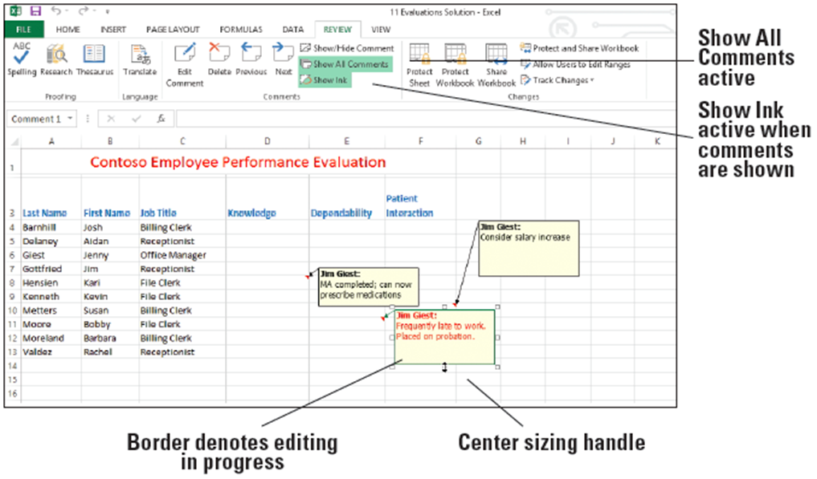
  - Move the
mouse
pointer
until it is a
four-headed
arrow on the
border of the
comment in
cell F10.
Drag the
comment so
it no longer
overlaps the comment in cell E11 (above).
  - Click the PAGE LAYOUT tab, and in the Page Setup group, click Orientation. Click Landscape.
  - In the Page Setup group, click the Page Setup dialog box launcher.
  - On the Sheet tab in the Comments box, click As displayed on sheet.
  - Click Print Preview. The Print Options window in Backstage opens.
  - Click Print. (Ask teacher if they want you to print this page!!!)
  - SAVE and CLOSE the workbook.
- CLOSE Excel.

