Step by Step 1: Select Data to Include in a Chart
- GET READY. LAUNCH Excel.
  - OPEN the 12 4thCoffee Financial History file for this lesson.
  - Select B2:B8 (the 2010 data).
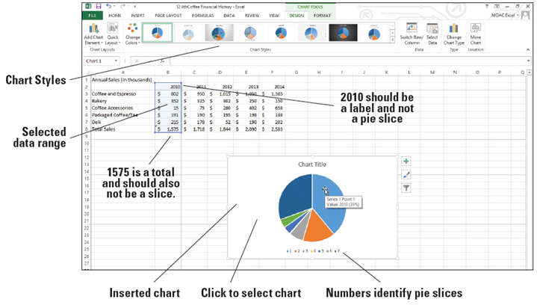
  - Click the INSERT tab, and in the Charts group, click the Pie button. Click the first 2-D Pie chart. A color-coded pie chart with sections identified by number is displayed.
  - Move the mouse pointer
to the largest slice. The
ScreenTip shows Series
1 Point 1 Value: 2010
(39%), as shown at right.
This corresponds to the
label 2010 rather than
actual data.
  - Move to the second largest
slice and you’ll see that the value is 1575, which is the amount for the total. Neither the column label (2010) nor the total sales amount should be included as pie slices.
  - Click in the chart’s white space and press Delete. The chart is now deleted and the CHART TOOLS tab disappears.
  - Select B3:B7, click the INSERT tab, in the Charts group, click Pie, and then click the first 2-D Pie chart. The correct data is displayed, but the chart is difficult to interpret with only numbers to identify the parts of the pie.
  - Click in the chart’s white space and press Delete.
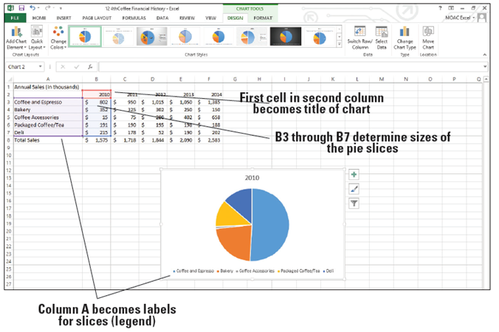
  - Select A2:B7, click the
INSERT tab, and click
Pie in the Charts group.
Click the first 2-D Pie
chart. As illustrated at
right, the data is clearly
identified with a title
and a label for each
colored slice of the pie.
  - Move the mouse pointer to a blank spot within the chart and drag the chart to move it below the data.
  - Click outside of the chart, click FILE, and then click Print. Notice that the Annual Sales data appears with the chart on the page.
  - Press Esc and click on the Chart and choose FILE, Print. Now notice that the chart appears by itself.
  - CREATE a Lesson 12 folder and SAVE the workbook as 12 Charts Solution.
- PAUSE. LEAVE the workbook open for the next exercise.
Step by Step 2: Move a Chart
- GET READY. USE the workbook from the previous exercise.
  - Click in the white space on the chart to select it.
  - On the DESIGN tab, click the Move Chart button.
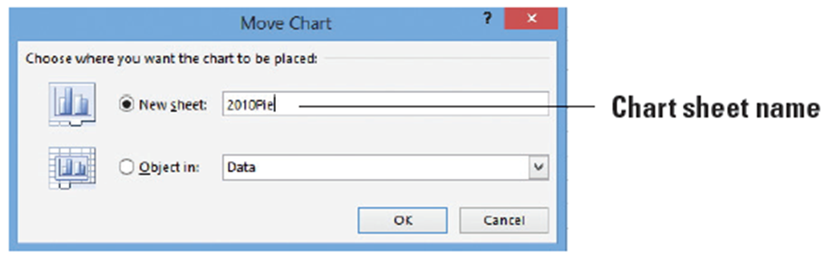
  - In the Move Chart dialog box, click in the New sheet box and type 2010Pie to create the name of your new chart sheet (below).
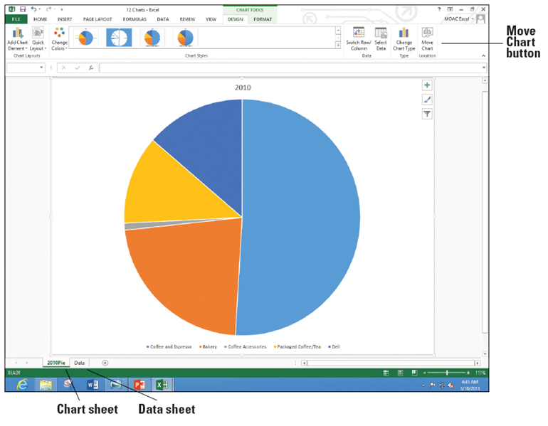
  - Click OK. The chart
becomes a separate
sheet in the work-
book (right).
  - Click on the Data
worksheet tab to
return to the data
portion of the
workbook.
  - SAVE the workbook.
- PAUSE. LEAVE the workbook open for the next exercise.
Step by Step 3: Choose the Right Chart for Your Data
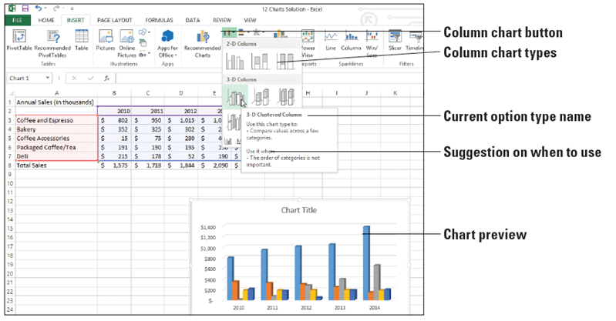
- GET READY. USE the workbook from the previous exercise.
  - Select cells A2:F7.
  - Click the INSERT
tab, and in the
Charts group, click
Column. In the
Column drop-down
list, move to each of
the options. When
you pause on an
option, Excel shows a preview of the chart on the worksheet and a description and tips for the selected chart type. Under 3-D Column, move to the first option. The ScreenTip shows that the type of chart is a 3-D Clustered Column (above).
  - In the drop-down list, click 3-D Clustered Column. The column chart illustrates the sales for each of the revenue categories for the five-year period. The CHART TOOLS tab appears with the DESIGN tab active.
  - Anywhere in a blank area on the chart, click and drag the chart below the worksheet data and position it at the far left.
  - Click outside the column chart to deselect it. Notice that the CHART TOOLS tab disappears.
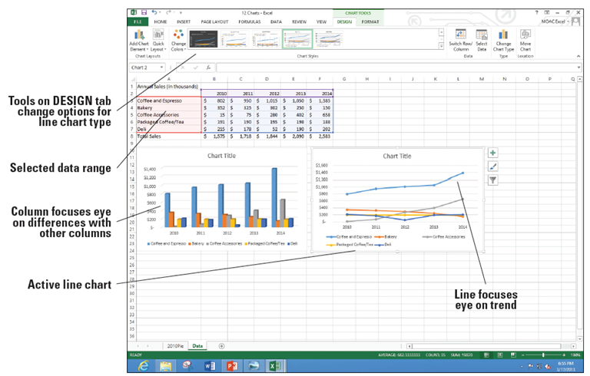
  - Select A2:F7, click
the INSERT tab,
and in the Charts
group, click Line.
In the 2-D Line
group, click the
Line with
Markers option
(first chart in the
second row). Position the line chart next to the column chart. Note that the CHART TOOLS tab is on the ribbon with the DESIGN tab active (above).
  - Click the column chart and click the DESIGN tab.
  - Click the Move Chart button and in the New sheet box, type Column, and then click OK.
  - Click the Data worksheet tab, select the line chart, click the Move Chart button, and in the New sheet box, type Line, and then click OK.
  - SAVE the workbook.
- PAUSE. LEAVE the workbook open for the next exercise.
Step by Step 4: Use Recommended Charts
- GET READY. USE the workbook from the previous exercise.
  - Click the Data worksheet tab.

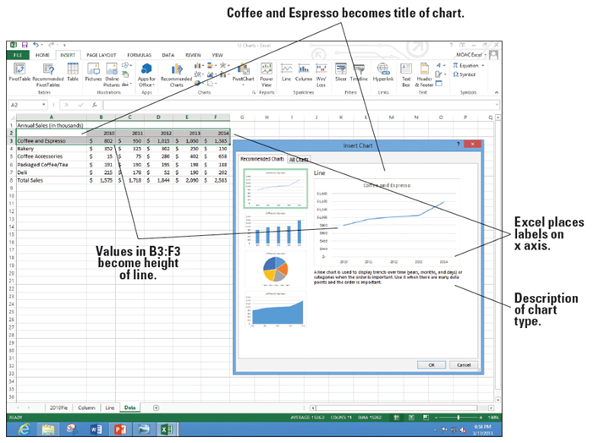
  - Select the Year labels and
Coffee and Espresso cells
A2:F3, click the INSERT
tab, and then click the
Recommended Charts
button. Notice that Excel
recommends four chart
types (right). Excel
explains when you
use each of the charts
underneath the example.
  - Click the other three chart types and read each description. Click the Line chart, and then click OK.
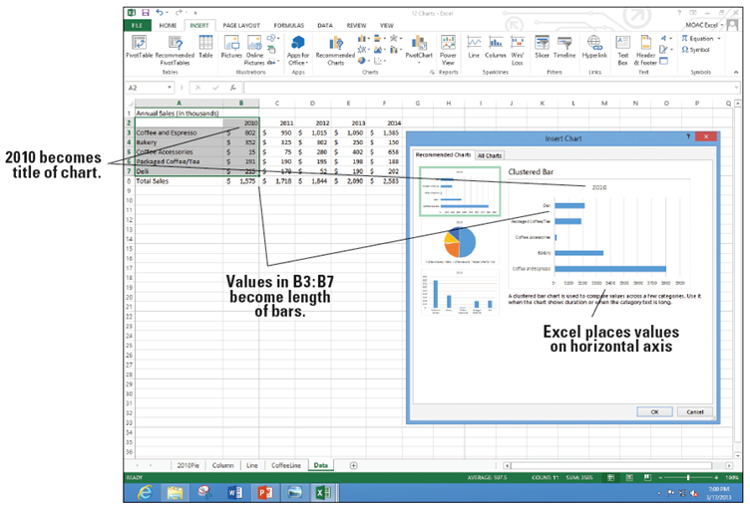
  - Click the Move Chart
button, and in the
New sheet box, type
CoffeeLine, and then
click OK.
  - Click the Data work-
sheet tab, select cells
A2:B7 to include the
labels and data for
2010, and then on the
INSERT tab, click the Recommended Charts button. Notice the three chart types recommended this time (above).
  - Click Cancel. Select A2:F7 and click the Recommended Charts button. Look at each of the suggested choices and scan the description.
Click Cancel.
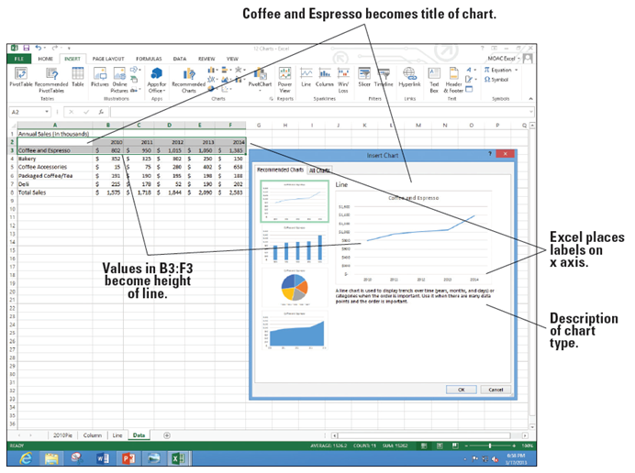
  - Select A8:F8 and click
the Recommended
Charts button. Notice
that the choices are
even different from
the options at right.
Click Cancel.
  - Select A2:F2, hold down Ctrl, and select A8:F8. You do not have to choose adjacent ranges for your data.
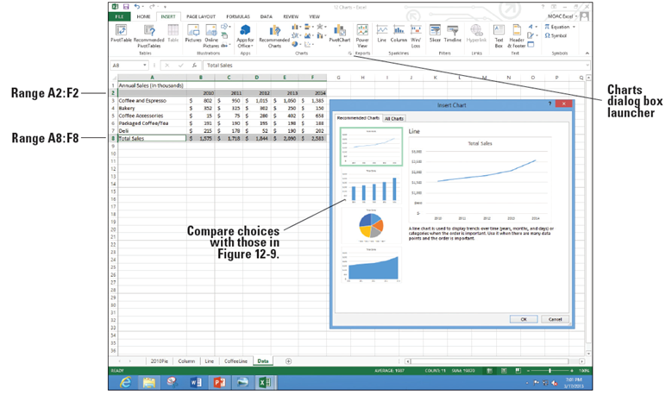
  - Click the Recommended Charts button. Notice that the recommended
choices at right are
the same slide 28
because the first
row includes years
and the second row
includes values.
Click OK.
  - Click the Move Chart button, and in the New sheet box, type TotalLine, and then click OK.
  - SAVE the workbook.
- PAUSE. LEAVE the workbook open for the next exercise.
Step by Step 5: Create a Bar Chart
- GET READY. USE the workbook from the previous exercise.
  - Click the Data worksheet tab.
  - Select cells A2:F7and on the INSERT tab, in the Charts group, click the Bar button.
  - Click the 3-D Clustered Bar subtype. The data is displayed in a clustered bar chart and the DESIGN tab is active on the CHART TOOLS tab.
  - Drag the clustered bar chart on the left below the worksheet data.
  - Select A2:F7. On the INSERT tab, in the Charts group, click the Bar button.
  - Click the 3-D Stacked Bar subtype.
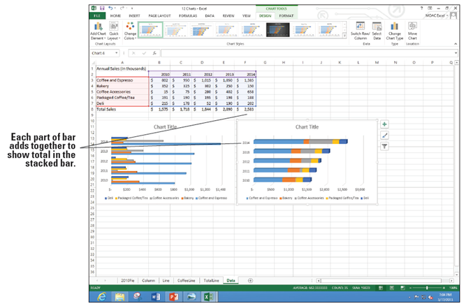
  - Position the stacked
bar graph next to the
3-D bar graph. Your
worksheet should look
like the figure at right.
  - Click the Move Chart
button, and in the New
sheet box, type StackedBar
and click OK.
  - Click the Data work-
sheet tab, click the clustered bar chart, click the Move Chart button, and in the New sheet box, type ClusteredBar, then click OK.
  - SAVE the workbook. PAUSE. LEAVE the workbook open.
Step by Step 6: Format a Chart with a Quick Style
- GET READY. USE the workbook from the previous exercise.
  - Click on the 2010Pie chart tab. If the DESIGN tab is not visible and the buttons
active, click the white space inside the chart boundary and click the DESIGN tab.
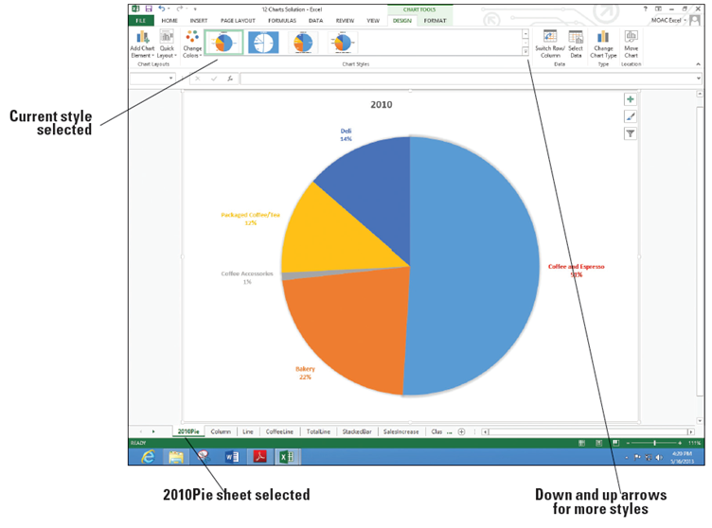
  - One of the Chart
Styles is already
selected. Click each
of the styles until you come to the style shown above with the labels and percentages shown next to each pie slice.
  - Click the Change Colors button and move the mouse pointer over each of the different rows to see the preview of the pie change.
  - Click Color 3 to make the change.
  - SAVE the workbook.
- PAUSE. LEAVE the workbook open for the next exercise.
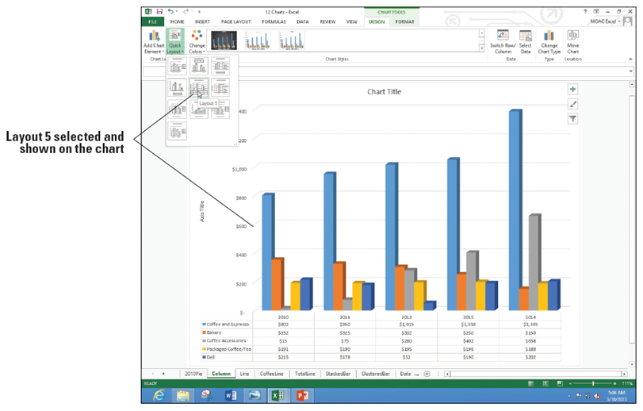
Step by Step 7: Format a Chart with Quick Layout
- GET READY. USE the workbook from the previous exercise.
  - Click on the
Column chart
tab.
  - On the DESIGN tab, click the
Quick Layout button. As you
move to each of the options, the chart changes to preview what the option will look like (right).
  - Click Layout 5. The data table appears under the chart. The years (2010-2014) appear in both the data table and as x-axis labels.
  - SAVE the workbook.
- PAUSE. LEAVE the workbook open for the next exercise.
Step by Step 8: Edit and Add Text on Charts
- GET READY. USE the workbook from the previous exercise.
  - Click the 2010Pie chart tab.
  - Click the 2010 title, move the insertion point to the end of the label and click. Type a space and then type Annual Sales. The text appears in all caps based on the current layout.
  - Select the label text. Click the HOME tab and click the Font dialog box launcher. The Font dialog box appears (below).
  - Click the All Caps check box to uncheck this option. Click OK.
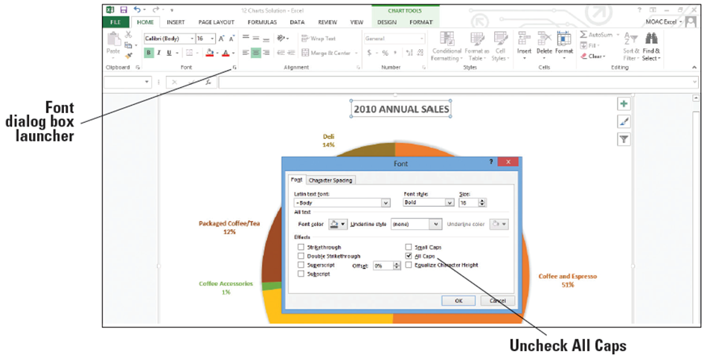
  - Add today’s date in the text box.

- Click on the FORMAT tab and click the Text Box button. Click the bottom left corner of the chart area and type your initials anEdit the chart titles on each of the charts as follows:
Chart | Title | Text
Column | Chart Title | Annual Sales
Column | Axis Title | Thousands
Line | Chart Title | Annual Sales (Thousands)
StackedBar | Chart Title | Annual Sales
ClusteredBar | Chart Title | Annual Sales
- SAVE the workbook.
- PAUSE. LEAVE the workbook open for the next exercise.
Step by Step 9: Format a Data Series
- GET READY. USE the workbook from the previous exercise.
  - Click the 2010Pie chart tab.
  - Click in the largest slice of the pie. You can see data selectors around each of the pie slices.
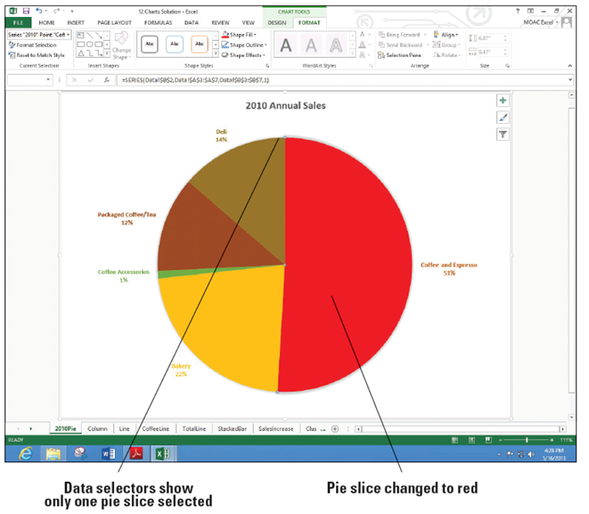
  - Click the FORMAT tab, click the Shape Fill button, and then choose Red in the Standard Colors section. All the slices of the pie change to red. Click Undo. You want to select the largest pie slice instead of all of the pie slices.
  - Click the largest pie slice
again and you should
see data selectors only
on the slice. Click the
Shape Fill button and
choose Red. The Coffee
and Espresso pie slice
changes to Red, as shown
at right.
  - Click the Column
chart tab.
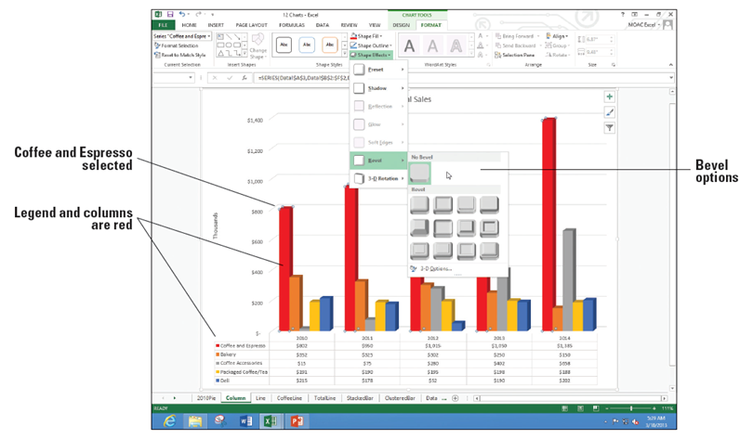
  - Click the tallest bar (Coffee and Espresso). Notice that the five bars have data selectors. Click the Shape Fill button and select Red. All five bars and the legend color for Coffee and Espresso changes to red.
  - Click the Shape
Effects button,
click Bevel and
notice the options
available (right).
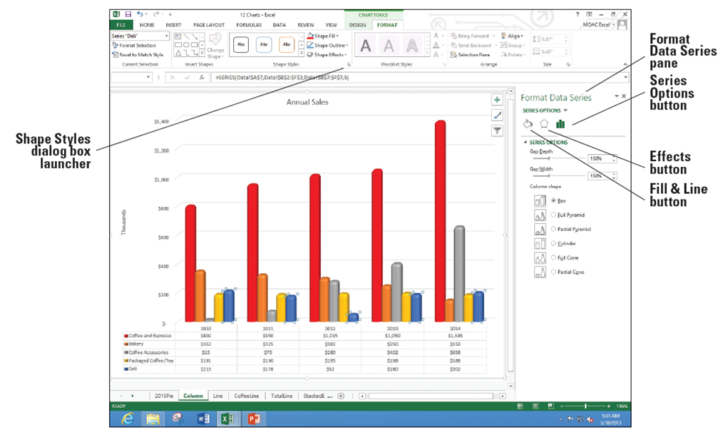
  - Click the first Bevel option (Circle). Repeat this option for each of the data series. The chart now looks like the figure below.
  - Besides the Shape Fill, Shape Outline, and Shape Effects buttons, you can change elements with the Shape Styles dialog box launcher. On the FORMAT tab, in the Shape Styles group, click the Shape Styles Dialog Box Launcher. The Format Data Series pane opens with the Series Options button selected.
  - Click each of the three buttons under the Series Options label and look at the choices. Click one of the Coffee Accessories columns.
  - Click the Fill and Line button, choose FILL, and select Picture or texture fill from the options.
  - Click the Texture drop-down arrow and choose the Brown Marble option.
  - SAVE the workbook.
PAUSE. LEAVE the workbook open for the next exercise.
Step by Step 10: Change the Chart’s Border Line
- GET READY. USE the workbook from the previous exercise.
  - Click the Line chart tab and choose the FORMAT tab.
  - In the Current Selection group, click the arrow in the Chart Elements selection box and click Chart Area. The chart area section on the chart becomes active.
  - Click the More arrow in the Shape Styles group. The Shape Styles gallery opens.
  - Scroll through the outline styles to locate Colored Outline – Blue, Accent 1, as shown below.
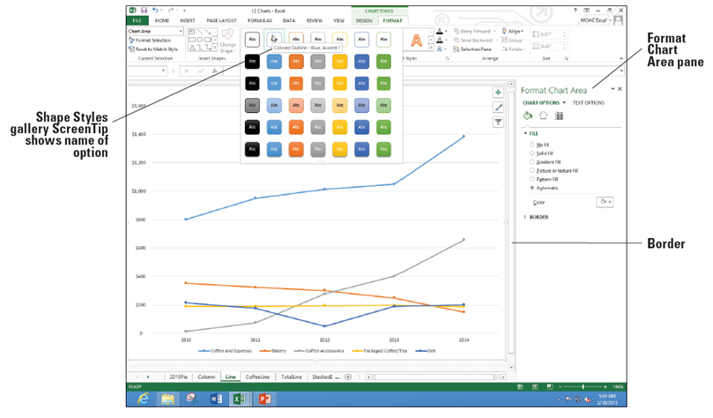
  - Click Colored Outline – Blue, Accent 1. You might not notice a change. This is because the Width of the line may be set so thin you can't see it.
- In the Format Chart Area pane, click the BORDER arrow to expand that section.
- In the Width up arrow, click until you get to 2.5 pt. Now you can see that the chart is outlined with a light blue border.
- Click the Coffee and Espresso line.
- In the Color drop-down, under the LINE section, choose Red.
- SAVE your workbook.
- PAUSE. LEAVE the workbook open for the next exercise.
Step by Step 11: Modify a Chart’s Legend
- GET READY. USE the workbook from the previous exercise.
  - Click the Line chart tab.
  - On the FORMAT tab, click Chart Elements drop-down arrow, and choose Legend.
  - If the Format Legend pane does not appear, click the Shape Styles dialog box launcher.
  - Click the Legend Options button.
  - In the Legend Position section, click Right to move the legend to the right side of the chart.
  - Click the Coffee and Espresso label in the legend.
  - Click the TEXT OPTIONS button to display the menus for the text.
  - In the Fill Color drop-down, choose Red so the text in the legend matches the color (below).
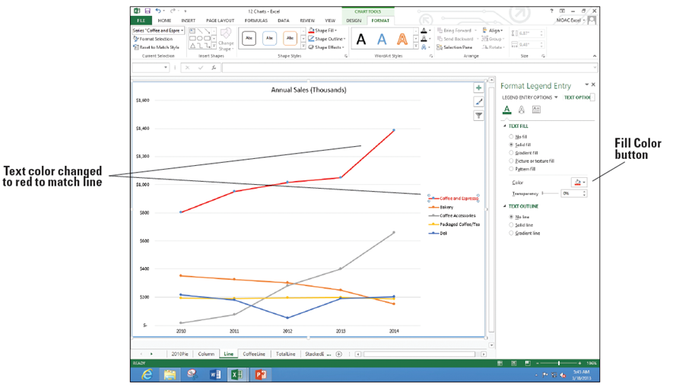
  - Click the 2010Pie chart tab.
  - Click the Coffee and Espresso label twice. If necessary, click the TEXT OPTIONS button and underneath TEXT FILL, click the Color button, and choose Red to change the text color.
  - CLOSE the Format Data Label pane and SAVE the workbook.
- PAUSE. LEAVE the workbook open for the next exercise.
Step by Step 12: Add Elements to a Chart
- GET READY. USE the workbook from the previous exercise.
  - Click the StackedBar chart tab.
  - If necessary, click in a white space of the chart to select the chart and make the buttons in the upper right hand corner appear.
  - Click the CHART ELEMENTS button. A menu appears showing which elements are currently on the chart (checked boxes) and which are not (unchecked boxes). See the figure below.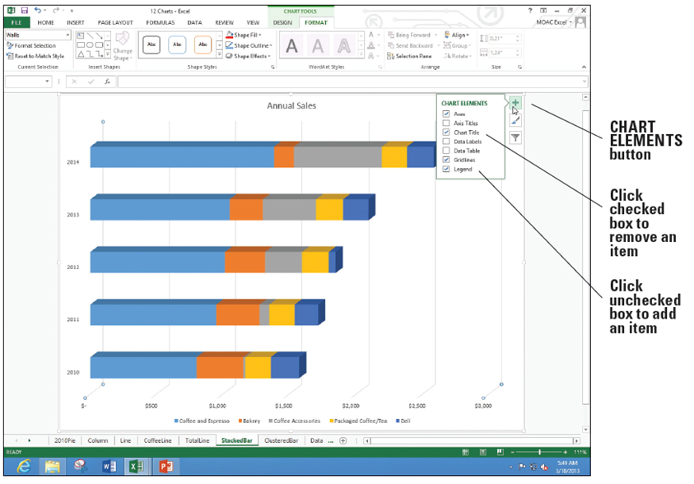
  - Click the Axis Titles box to check the box and add both a vertical and horizontal axis placeholder.
  - The Axis Title on the bottom of the screen has selection indicators to indicate it is selected. Type Thousands and press Enter.
  - Click the TotalLine chart tab, click the CHART ELEMENTS, and select the Axis Titles option. This time the vertical Axis Title is selected. You can click any label placeholder to select it if it is already on a chart. Type Thousands for the vertical title.
  - Repeat the previous step to add a vertical axis title of Thousands for the CoffeeLine chart and the horizontal axis title for the ClusteredBar chart.
  - Click the StackedBar chart tab, click the CHART ELEMENTS, and select the Data Labels option. Labels appear for each of the bars on the chart as shown below.
  - SAVE the workbook.
- PAUSE. LEAVE the workbook open for the next exercise.
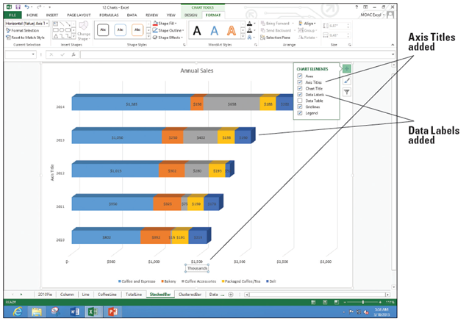

Step by Step 13: Delete Elements from a Chart
- GET READY. USE the workbook from the previous exercise.
  - On the StackedBar chart sheet tab, click the vertical Axis Title and press Delete.

  - Repeat Step 1 to delete the following generic Axis Title labels:
Chart tab | Vertical or Horizontal Axis Title
CoffeeLine | Horizontal
TotalLine | Horizontal
ClusteredBar | Vertical

- Right-click the StackedBar chart tab and select Move or Copy. In the Before sheet list box, Select ClusteredBar, click the Create a copy check box, and then click OK to create another copy of the StackedBar chart.
- Double-click the StackedBar (2) label for the tab and type SalesIncrease for the new name.
- Click the $150 data label for the Bakery in 2014. All data labels for bakery have selection indicators. Press Delete.
- Repeat Step 5 for Coffee Accessories, Packaged Coffee/Tea, and Deli data labels.
- Click the Annual Sales title and type Coffee, Espresso, and Accessories only Consistent Sales Increase. Press Enter.
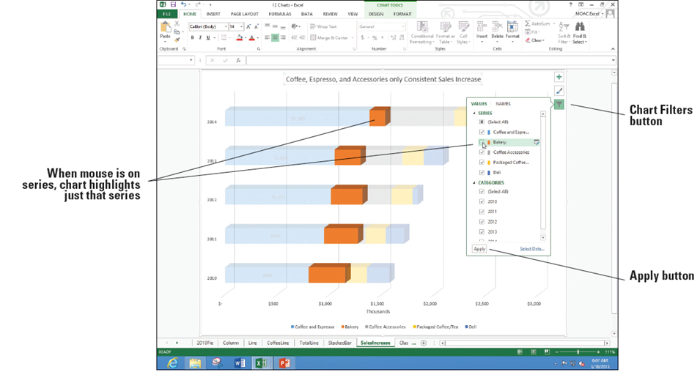
- You can also hide data series. Click the Chart Filters button on the right side of the chart and in the SERIES group, click Bakery to uncheck it (below).
- Repeat step 8 for Packaged Coffee/Tea and Deli and click the Apply button.

- After looking at the chart, you might decide it is better to keep all of the data series. Repeat Steps 8 and 9 to recheck the Bakery, Packaged Coffee, and Deli.
- SAVE the workbook.
- PAUSE. LEAVE the workbook open for the next exercise.
Step by Step 14: Add Additional Data Series
- GET READY. USE the workbook from the previous exercise.
  - Right-click the Data worksheet tab, select Move or Copy, scroll to the bottom of the Before sheet list, and select (move to end). Click the Create a copy checkbox and click OK. Double-click the Data (2) tab, type DataExp, and then press Enter.
  - Select A2:F7, click the INSERT tab, click the Insert Column Chart button, and then under 2-D Column, click the Clustered Column option.
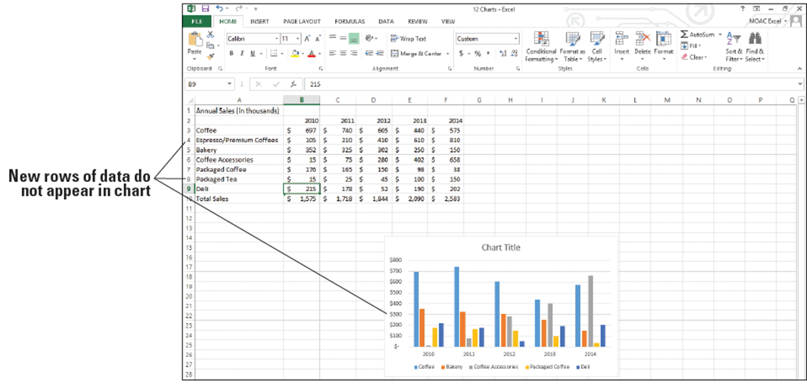
  - Insert rows below Coffee and Espresso and Packaged Coffee/Tea. Edit the labels and values as shown below.

  - Right-click in a blank area of the chart, and choose Select Data. The Select Data Source dialog box opens (below).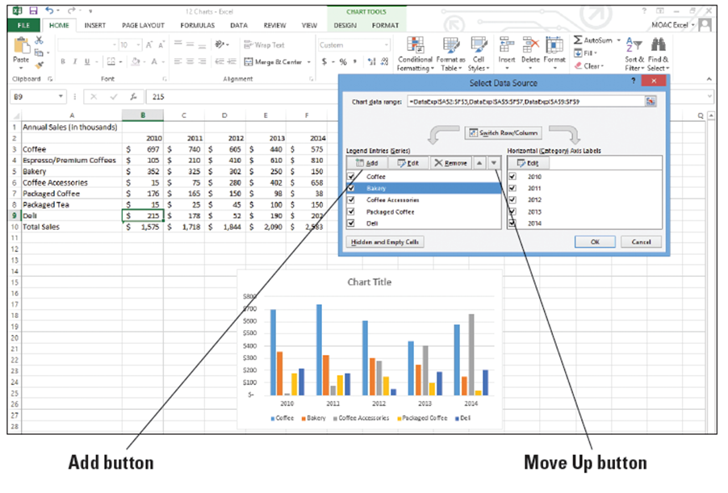
  - Click the Add button and in the Series name box, click cell A4. In the Series values box, delete the entry and drag on the worksheet to select cells B4:F4. The Edit Series dialog box looks like the figure below.
  - Click OK, then click the Move Up button multiple times to move the Espresso/Premium Coffees label below Coffee.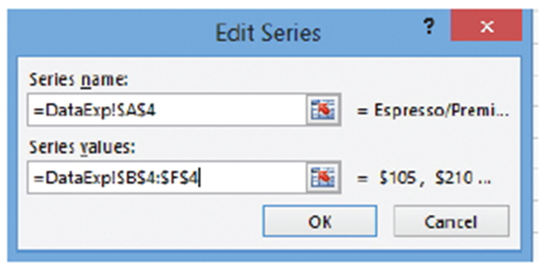

  - Repeat Steps 4 and 5 with Packaged Tea in A8 and the data in B8:F8 so the label is below Packaged Coffee. Click OK to accept the changes and return to the sheet.
  - SAVE the workbook.
- PAUSE. LEAVE the workbook open for the next exercise.
Step by Step 15: Resize a Chart
- GET READY. USE the workbook from the previous exercise. The DataExp sheet should be selected.
  - Move the mouse to the white space to the left of the chart title. The mouse is a black four-headed arrow. Drag to move the chart to the left edge of the sheet and below row 11.
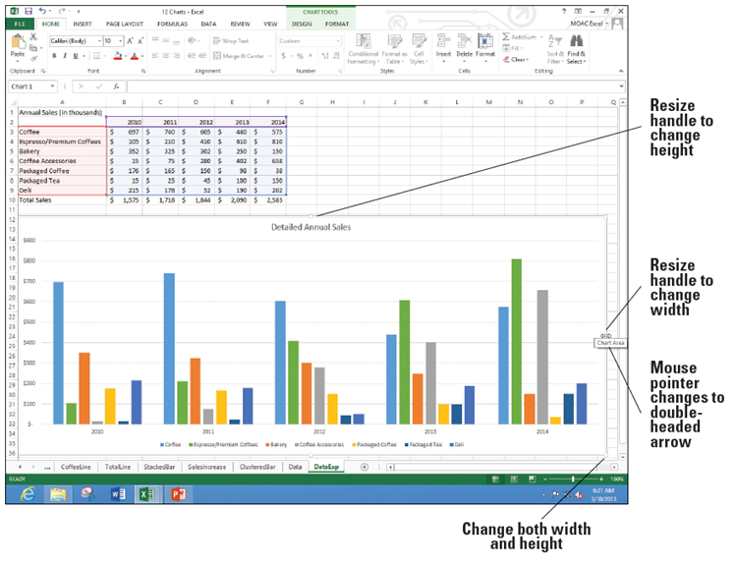
  - Move the mouse to the bottom right corner of the chart. The mouse pointer is a two-headed diagonal arrow on the resize handle. Drag the mouse so it is in the bottom right corner of the screen. The chart expands to take up more of the screen and you can see the columns and legend easier.
  - Click the Chart Title and type Detailed Annual Sales. Click back in the chart to select the chart and move to the right center resize handle. Your screen should look similar to the figure at right.
  - SAVE the workbook.
- PAUSE. LEAVE the work-
book open for the next
exercise.

Step by Step 16: Choose a Different Chart Type
- GET READY. USE the workbook from the previous exercise. The DataExp sheet should be visible and the chart selected.
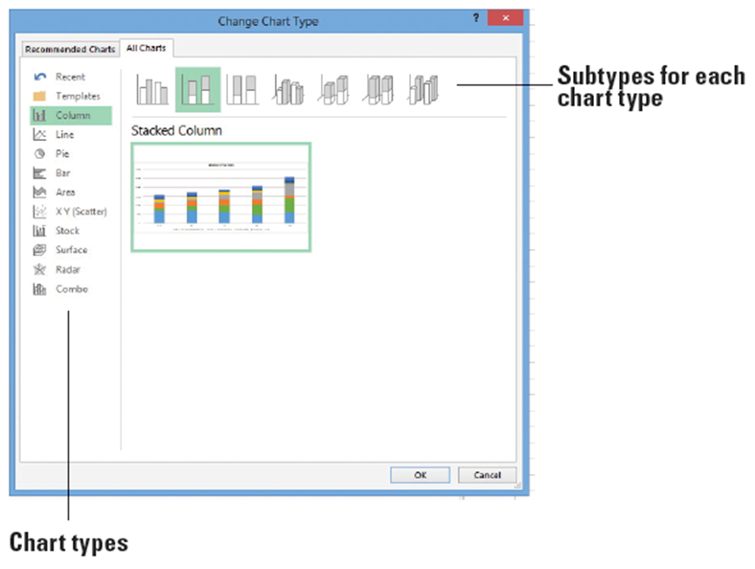
  - Click the DESIGN tab and select the Change Chart Type button. The Change Chart Type dialog box opens.
  - Click each of the chart
types on the left and you
will see a set of different
icons representing sub-
types for each of the
chart types. Click the
Column button. Click
the Stacked Column
subtype (second icon in
the right pane, at the
top of the dialog box).
The screen should look
like thefigure at right.
  - Click OK.
  - Click the Move Chart button and in the New sheet box, type DetSales, and then click OK.
  - COPY the DetSales chart sheet before the DataExp sheet and NAME the tab DetSalesEs.
  - On the DESIGN tab, using the Change Chart Type button, change the chart back to a Clustered Column.
  - Click just one of the Espresso/Premium Coffees columns.
  - On the DESIGN tab, click the Change Chart Type button.
  - The Change Chart Type box opens to the Combo chart type. In the Espresso/Premium Coffees Chart Type box, select Line (below).
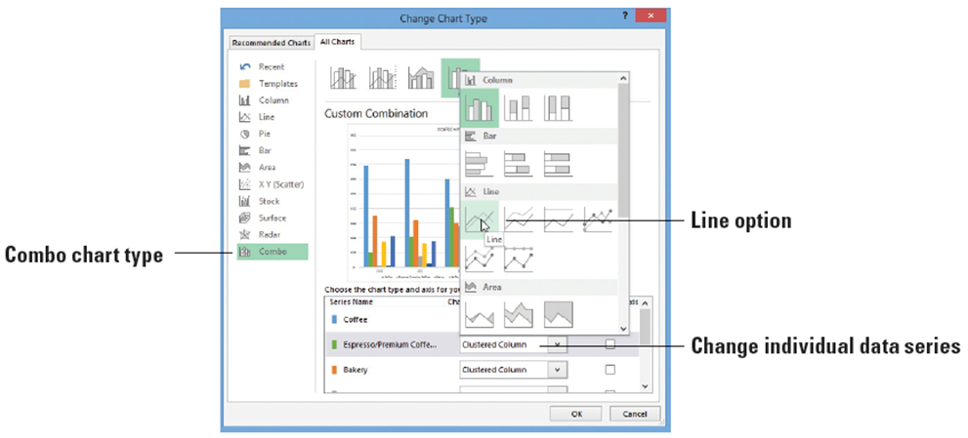
  - Click OK and edit the chart title to read WOW! Look at Espresso/Premium Coffee Sales!
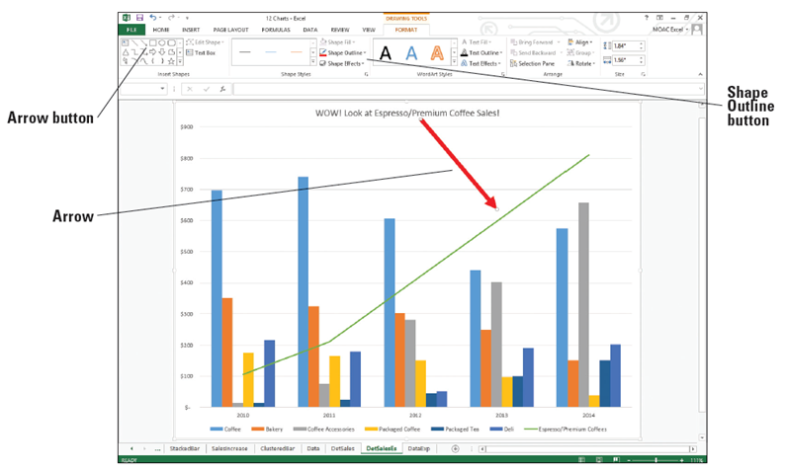
  - Click the FORMAT tab and in the Insert Shapes group, click the Arrow button and drag the arrow from the chart title to the Espresso line. Use the Shape Outline button to change the arrow to Red and the Weight to 6 pt. Your chart should look similar to the figure below.
  - SAVE the work-
book.
- PAUSE. LEAVE the
workbook open for
the next exercise.

Step by Step 17: Switch Between Rows and Columns in Source Data
- GET READY. USE the workbook from the previous exercise.
  - COPY the DetSales chart sheet before the DataExp sheet and NAME the tab DetSalesCat.
  - On the DESIGN tab, use the Change Chart Type button to change the chart back to a Clustered Column.
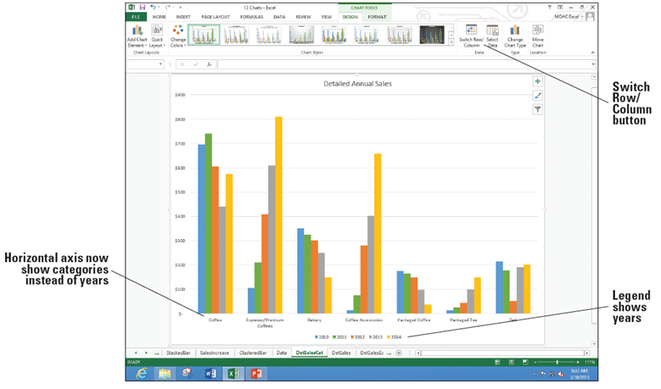
  - The horizontal axis shows each year and the categories repeat within each year. We're going to change the chart so each category is a group and each year is shown as a different bar color. On the DESIGN tab, click the Switch Row/Column button. The chart changes (below).
  - SAVE the work-
book.
- PAUSE. LEAVE the
workbook open for
the next exercise.

Step by Step 18: Add a Chart or Sparklines
- GET READY. USE the workbook from the previous exercise.
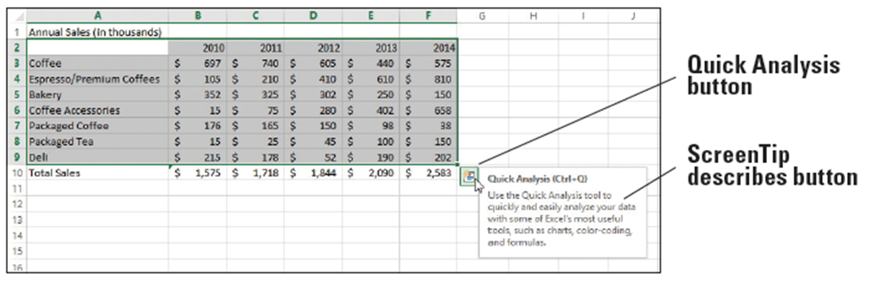
  - Click the DataExp worksheet tab. Select cells A2:F9. The new Quick Analysis icon appears at the bottom right of the selected range. Move the mouse pointer to the button and the ScreenTip displays (below).
  - Click the Quick Analysis button. A small window called the Quick Analysis gallery opens (below).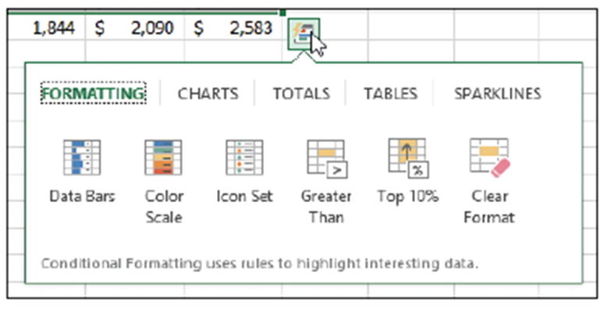

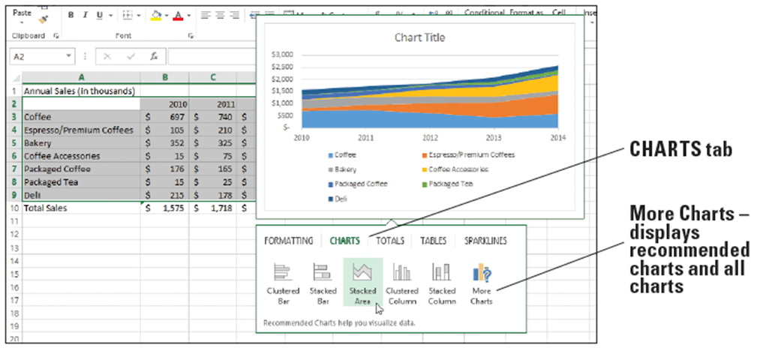
  - Click the CHARTS tab in the gallery. Move the mouse pointer to each of the charts and a preview appears on the screen above the Quick Analysis gallery. For example, move the mouse pointer to the Stacked Area option and you'll see a preview showing this type of chart (below).
  - We will not add any charts from the CHARTS menu at this time.
  - Click the SPARKLINES tab. Move the mouse pointer to preview the Column option. A set of tiny column charts shows in column G.
  - Click the Line option. A series of lines appear in your worksheet in column G.
  - Row 2 (years) should not have a sparkline. Click cell G2 and on the DESIGN tab, click the Clear button. The sparkline is removed in that cell. In cell G2, type Sparkline.
  - Click cell G9. Use the fill handle to drag to cell G10. A sparkline appears for the total.
  - Select G3:G10 and click the DESIGN tab. There are a number of options you can do with the sparklines.
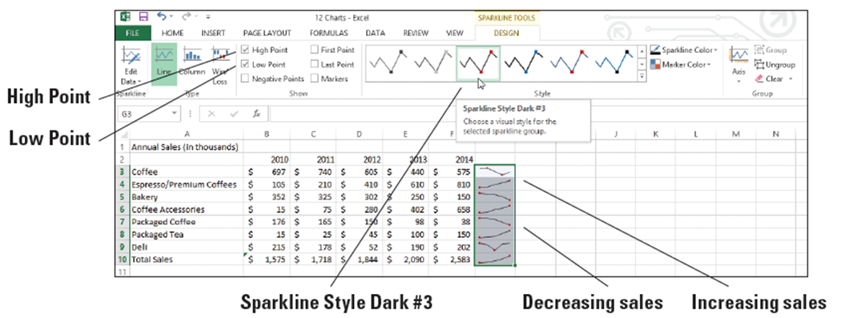
  - In the Show group, click High Point and Low Point and in the Style gallery, choose Sparkline Style Dark #3 (below).
  - SAVE the workbook.
- PAUSE. LEAVE the workbook open for the next exercise.
Step by Step 19: Work with Totals
- GET READY. USE the workbook from the previous exercise and click on the Data worksheet tab.
  - Select A3:F7. Click the Quick Analysis button and select the TOTALS tab.
  - Move to the first icon, Sum (with the blue row highlighted in the icon). You’ll see a preview on the worksheet of Sum overwriting the Total Sales row that was already there.
  - Move to the next icon and you’ll see row 8 previewed with Averages for each column. Move to each of the Count, % Total, and Running total icons and watch the preview of the worksheet change.
  - Move to the second Sum icon (with the orange column highlighted). Notice that the worksheet preview changes to show totals in column G.
  - Click the arrow on the right to show more options. Preview each of the options and return to % Total (below).
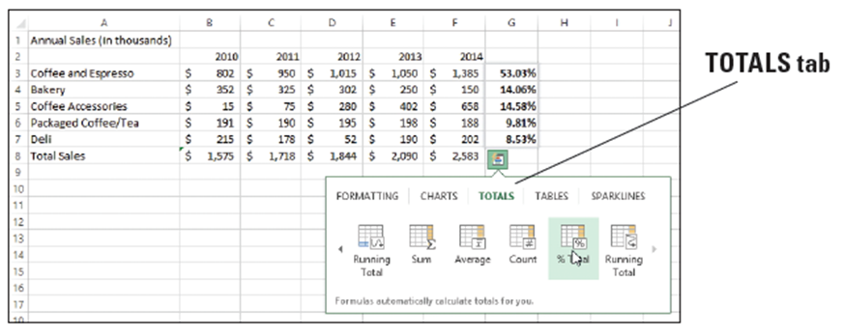
  - Click the % Total option. Click cell G3 and notice the formula =SUM(B3:F3)/SUM($B$3:$F$7) appears in the formula bar.
  - In cell G2, type Average.
  - SAVE the workbook.
- PAUSE. LEAVE the workbook open for the next exercise.

Step by Step 20: Apply Conditional Formatting
- GET READY. USE the workbook from the previous exercise. You should still be on the Data worksheet tab.
  - Select A3:F7. Click the Quick Analysis icon. The FORMATTING tab is selected.
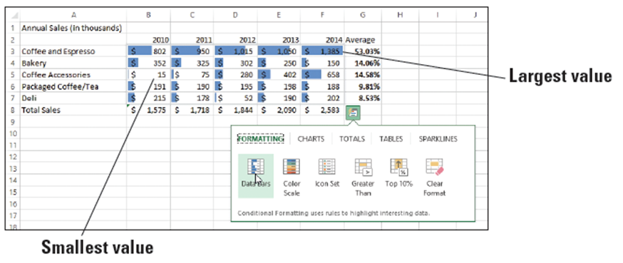
  - Move to the
first icon, Data
Bars. You can
see a preview
on the work-
sheet of small
bars in each
cell indicating the relative value in the cell. The largest value is in F3 and the bar shows the largest width (above).
  - Click the Color Scale option to make this choice. Click in a cell outside the range so the formatting is clearer. The worksheet is formatted (below) with the highest values in green with the highest value in dark green. The lowest values are in red.
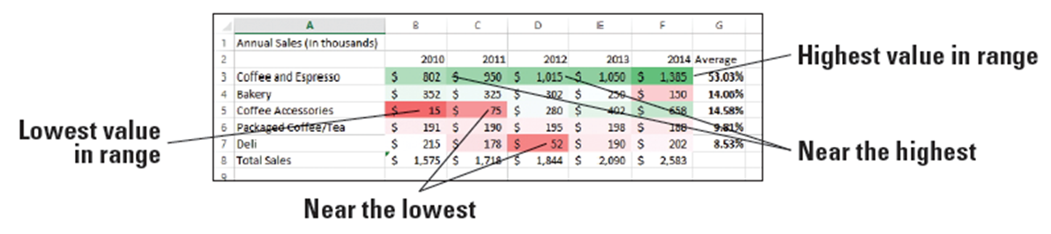
  - If the value is close to the highest or lowest value, the color or the cell is less dark. As the values move away from the value, the color becomes lighter.
  - SAVE and CLOSE the workbook.
- PAUSE. LEAVE Excel open for the next exercise.
Step by Step 21: Create a Basic PivotTable
- GET READY. OPEN 12 School Test Data from the student data files.
  - Click cell A1. Press End and then press the down arrow. Notice that there are 139,129 rows of data.
  - Press Ctrl + Home to return to the top of the worksheet.
  - On the INSERT tab, click the Recommended PivotTables button.
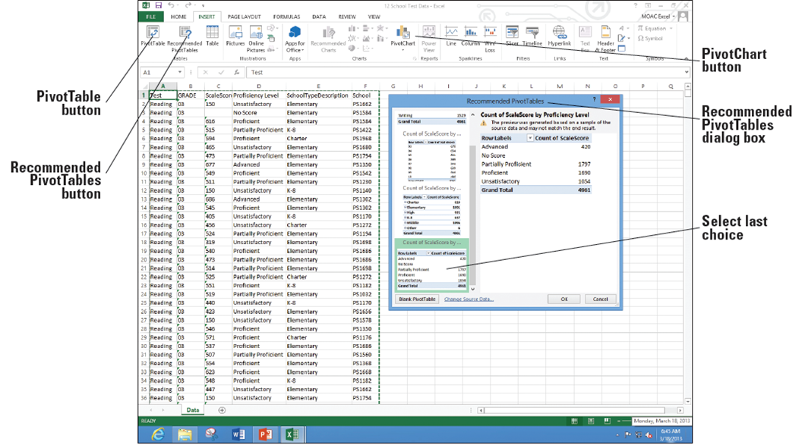
  - Scroll to the bottom and click Count of ScaleScore by Proficiency Level (below).
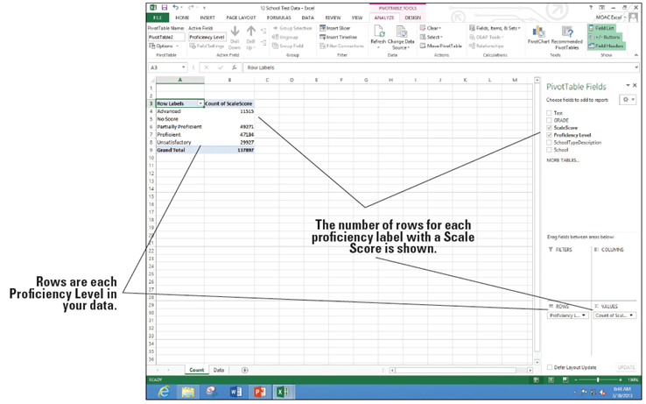
  - Click OK and NAME the new sheet Count. The PivotTable Fields pane opens on the right side of your screen and the data appears on the worksheet (below). Notice that the data for No Score is blank. You
will want to change
the field to count to
a field that has data.
If you look back on
the Data tab, every
row is filled by a
grade so you can use
this column so every
row is counted.
  - Return to the Counts sheet and drag the Grade field in the PivotTable Fields pane down to the VALUES section.
  - Drag the Count of ScaleScore from the VALUES section into the worksheet to remove it. Notice that the No Score row now counts each missing score.
  - Drag the Grade field to the COLUMNS area. You'll see each grade summarized.
  - Drag the Test field to the FILTERS area.
  - Cell B1 currently shows (All). Click the Filter drop-down arrow, choose Math, and click OK.
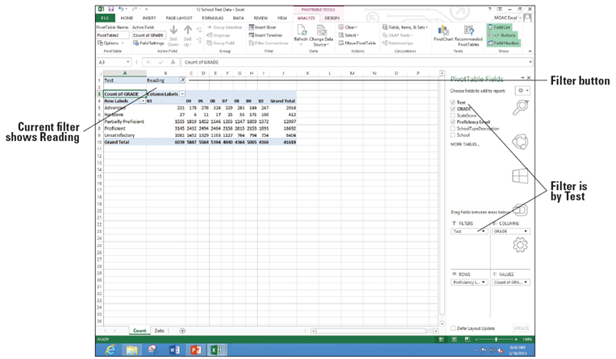
  - On the Filter button, click cell B1 and choose Reading. Click OK. Your data should look similar to the figure at right.
  - SAVE the
workbook as 12
Test PivotTable
Solutions.
- PAUSE. LEAVE the
workbook open for
the next exercise
Step by Step 22: Add a PivotChart
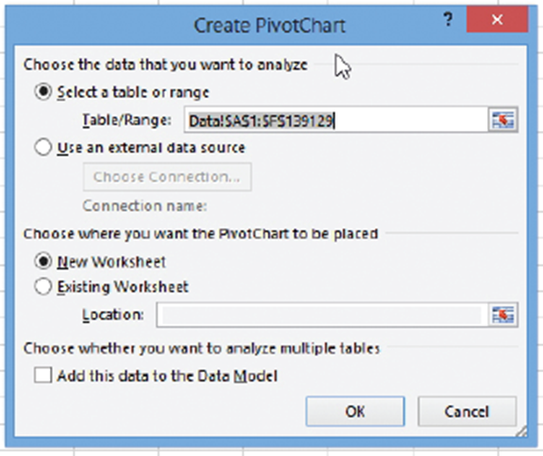
- GET READY. USE the workbook from the previous exercise.
  - On the Data worksheet, click cell A1.
  - On the INSERT tab, click
the PivotChart button and
choose PivotChart. The
Create PivotChart dialog
box opens and the range is
selected (right).
  - The default location is for a New Worksheet so click OK. NAME the new sheet tab PivotChart.
  - Drag the Test field to the FILTERS area.
  - Drag Grade to the VALUES area (count number of items).
  - Drag Grade again to the AXIS area.
  - Drag Proficiency Level to the LEGEND area.
  - Drag Test to the FILTERS area.
  - MOVE the chart to the left edge of the worksheet, below the data, and then resize the chart (see Figure 12-48).
  - On the Test drop-down arrow on the chart, choose Science and click OK. Notice that only 5th, 8th, and 10th grades are available because only those grades take the Science test.
  - Click the FORMAT tab, click the Text Box button, and click the top of the chart. Add a label that says Student Science Test Scores and make this label Bold and 18 points.
  - Click cell A3 and change the label to just say Count.
  - In F4, click on the label for Unsatisfactory.
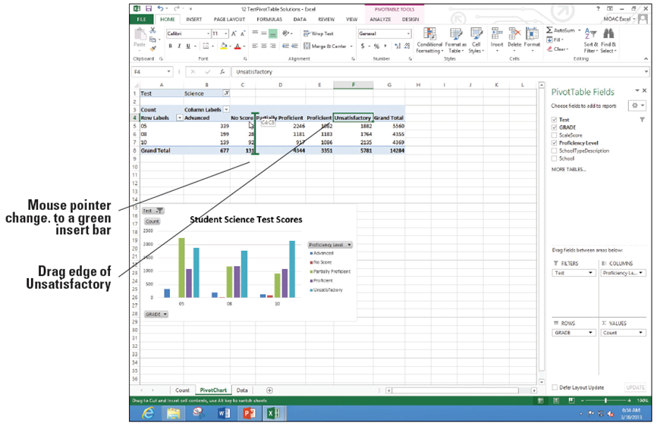
  - Move the mouse pointer to the left edge of the cell until the mouse pointer changes to a four-headed black arrow and drag the mouse between columns C and D (below).
- Repeat Step 14 and move the Advanced column to between Proficient and Grand Total.
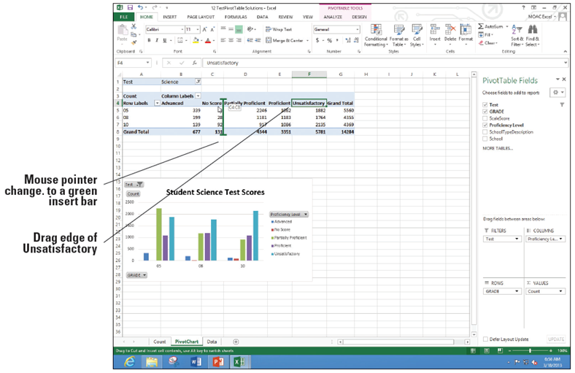
- SAVE the work-
book as 12 Test
PivotChart
Solution. Your
final sheet should
look like that
shown at right.
- PAUSE. CLOSE the
workbook and LEAVE
Excel open for the next
exercise.

