Step by Step 1: Insert a Picture from a File
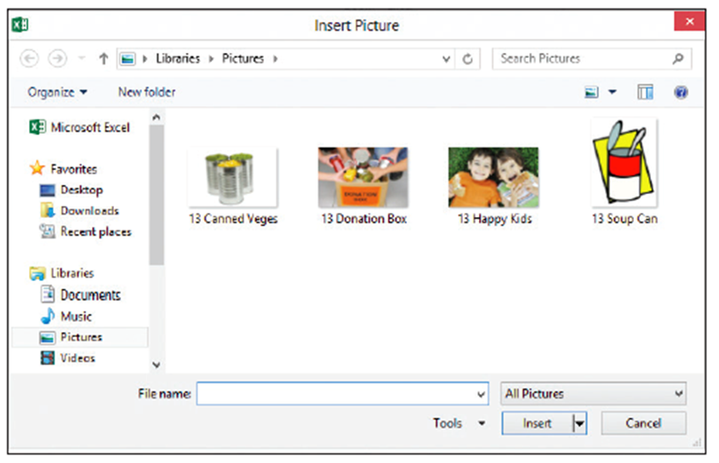
- GET READY. LAUNCH Excel and open a new, blank workbook. Download the image files for this lesson and SAVE them in the My Pictures folder. Alternatively, you can create a subfolder in your student data folder named Lesson 13 Images and save the images in that subfolder.
  - On the INSERT tab, in the
Illustrations group, click the Pictures button. The Insert Picture dialog
box opens (right).
  - Navigate to the folder that holds the image files for this lesson. Double-click the 13 Happy Kids image, or click it once and then click the Insert button. The picture is inserted into your worksheet.
  - SAVE the workbook as 13 Insert Pictures.
- PAUSE. Leave the workbook open to use in the next exercise.
Step by Step 2: Insert Office.com Clip Art (Bing Images)
GET READY. USE the workbook from the previous exercise.
  - Click in cell J1.
  - On the INSERT tab, in the Illustrations
group, click the Online Pictures
button. The Insert Pictures dialog box appears.
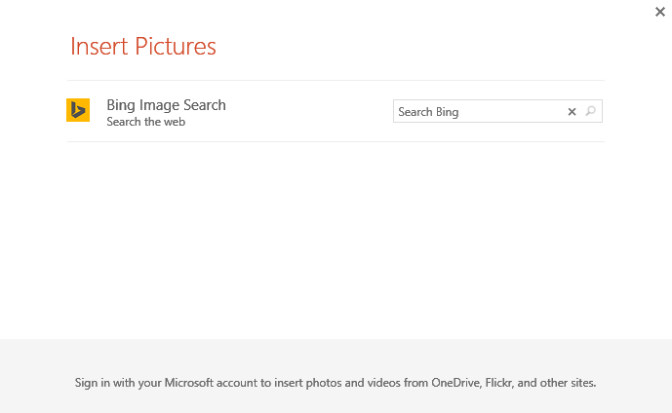
  - To the right of Bing Image Search, click in the Search box. Type a keyword or phrase, such as canned food (above).
  - Click the magnifying glass icon at the right end of the search box or press Enter to begin the search. Excel searches the online Office clip art database for images containing the keywords “canned food” in their metadata.
  - The dialog box displays the images that meet the search criteria. To insert one of the images, click on it and then click the Insert
button in the dialog box. You can also double-click the desired image to insert it into your worksheet. When an image is inserted, the dialog box closes automatically. The figure at right shows a clip art image inserted into the worksheet.
  - SAVE the workbook.
- PAUSE. Leave the workbook open to use in the next exercise.
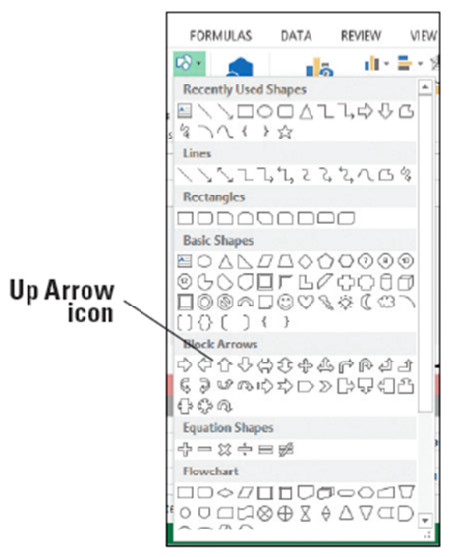
Step by Step 3: Add a Shape
- GET READY. LAUNCH Excel if it’s not already running.
  - OPEN 13 Add Shapes from the data files for this lesson.
  - On the INSERT tab, in the Illustrations group, click the Shapes button. A menu of shape categories appears, as shown at right.
  - Click the Up Arrow shape in the Block Arrows section. The Up Arrow shape is on the first line in the Block Arrows section, third from the left.
  - Move the mouse pointer onto the worksheet, just below the FUNDS RAISED column. The mouse pointer appears as a crosshair. Draw the shape by clicking and dragging down and a little to the right. The shape appears as you drag.
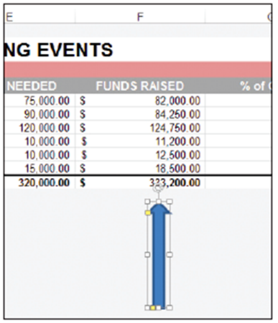
  - When the shape is the desired size (both size and proportions
can be changed later, so don’t worry about being perfect),
release the mouse button. Your block arrow should look
similar the one at right.
  - Click any blank cell.
  - SAVE the workbook.
- PAUSE. Leave the workbook open
to use in the next exercise.
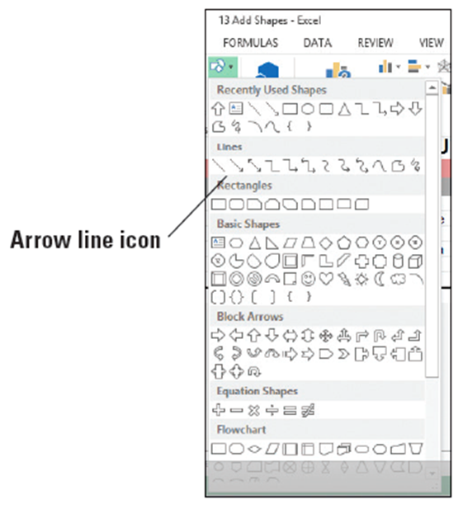
Step by Step 4: Draw Lines
- GET READY. USE the workbook
from the previous exercise.
  - On the INSERT tab, in the
Illustrations group, click the
Shapes button.
  - In the Lines section, click
the Arrow line (right).
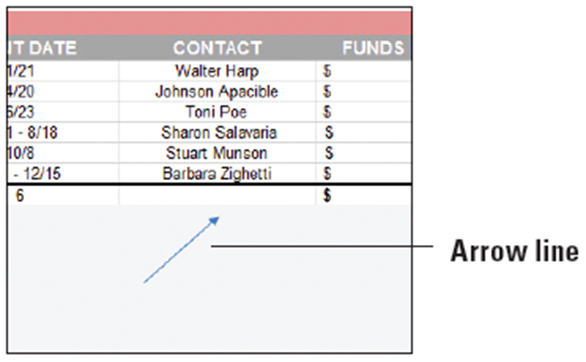
  - Move the mouse pointer
onto the worksheet (it
appears as a crosshair), and
click over the left side of cell
D22 and drag diagonally up and to the right, toward cell D19.
- When your line is
complete, release the
mouse button and
click a blank cell. A
finished line is shown
at right.
- SAVE the workbook.
- PAUSE. Leave the workbook open to use in the next exercise.
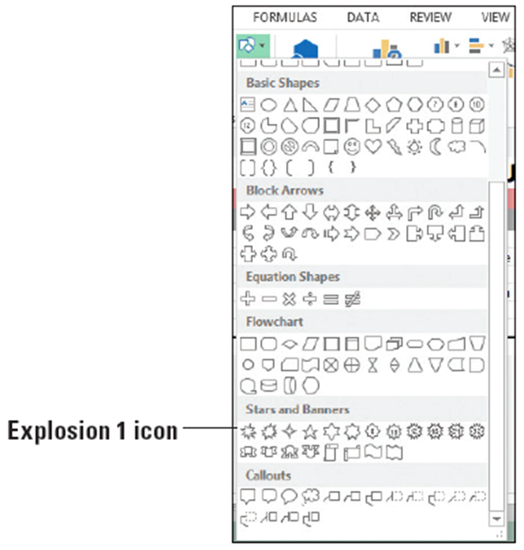
Step by Step 5: Add Text to a Shape
- GET READY. USE the workbook from the previous exercise.
  - On the INSERT tab, in the
Illustrations group, click
the Shapes button.
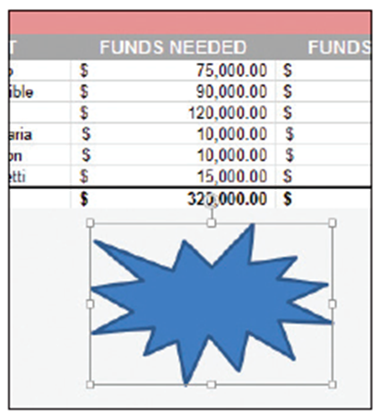
  - In the Stars & Banners
section, click the
Explosion 1 shape
(right).
  - Click and drag the mouse pointer
under the FUNDS NEEDED column,
so the shape looks similar to the
figure at right.
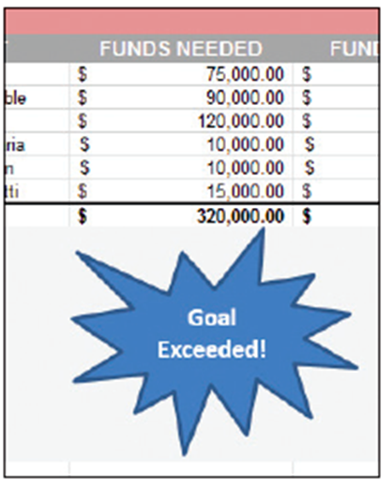
  - With the shape still selected, type
Goal Exceeded!. The text begins in
the upper left of the shape and
wraps within the shape if the width
is too small to display all text on one line. Don’t press Enter unless you want to force the text onto a new line to create a new paragraph or to place words or phrases on separate lines.
  - To format the text in the shape, select the
text by clicking just to the left of the “G”
in Goal and dragging through all text.
Note that when you’re within the shape
that contains text, the mouse pointer
turns to an I-beam cursor.
  - With the text selected, use the formatting
tools in the Mini Toolbar or on the HOME
tab to bold and center the text, and
change the font size to 14. Grab a sizing
handle on either side of the shape and
pull to the left, right, or down a bit until all text appears, above.
  - SAVE the workbook.
- PAUSE. Leave the workbook open to use in the next exercise.
Step by Step 6: Add a Text Box
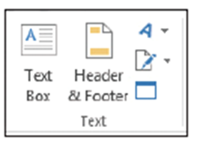
- GET READY. USE the workbook from the previous exercise.
  - On the INSERT tab, in the Text group,
click the Text Box button, right.
  - Move the mouse pointer onto the
worksheet over cell B20. The mouse
pointer turns into a vertical cursor.
  - Click and drag to cell C24 to draw a small box. If you draw a box that’s too big or too small for the text you will type into the box, you can resize the box after typing the text.
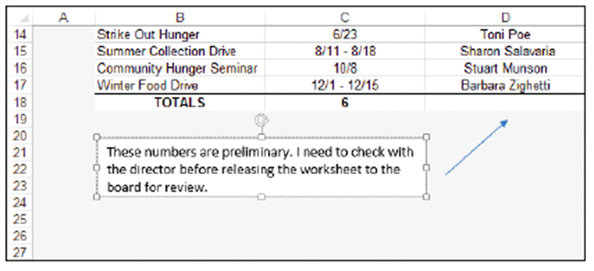
- The text box contains a blinking cursor. Type These numbers are preliminary. I need to check with the director before releasing the worksheet to the board for review. See below.
- Click in cell A1 to
make the text box
non-active and to
prepare for the
next exercise.
- SAVE the
workbook.
- PAUSE. Leave the
workbook open to use in the next exercise.
- You can use the formatting tools on the HOME tab or on the Mini Toolbar to format text in a text box.
Step by Step 7: Use WordArt
- GET READY. USE the workbook from the previous exercise.
  - On the INSERT tab, in the Text group, click the Insert WordArt button. The WordArt styles gallery appears, as shown below.
  - Select the Fill - Blue, Accent 1, Shadow style, which is on the first row, second from the left.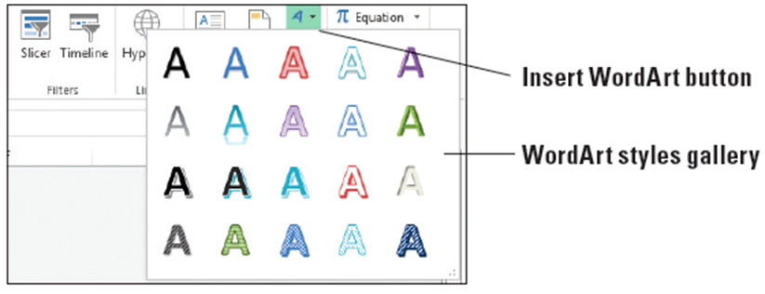
  - A box of sample text appears on the worksheet. Triple-click in the box to select all sample text and type Great Fundraisers!. Notice in the figure below that the style you chose in Step 2 is applied to the sample text.
  - SAVE the workbook as 13 Add Shapes Solution and CLOSE the file
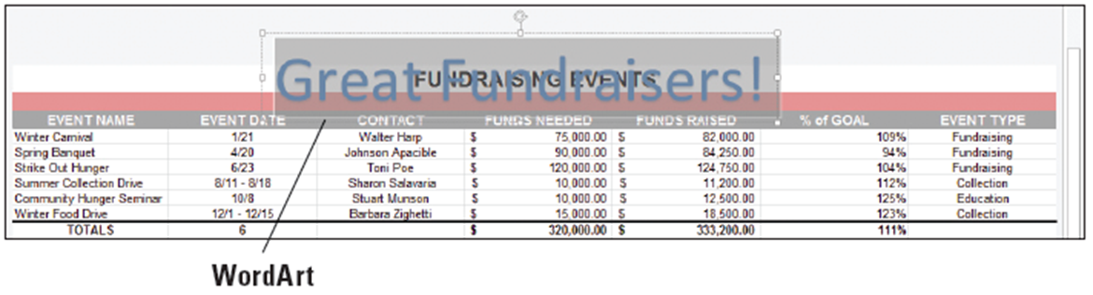
- PAUSE. LEAVE Excel open to use in the next exercise.
Step by Step 8: Delete Graphics
- GET READY. LAUNCH Excel if it’s not already running.
  - OPEN 13 Delete Copy Move from the data files for this lesson.
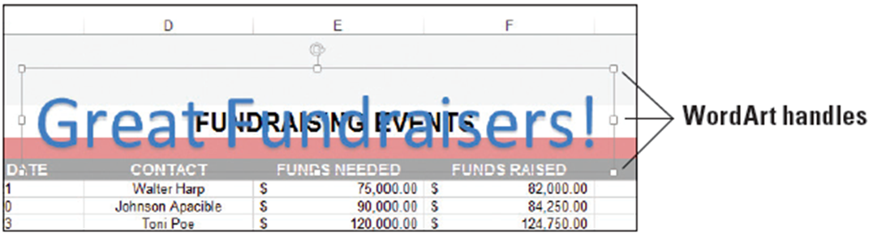
  - On the Fundraising Events worksheet, click the WordArt graphic. Handles appear on its edges as shown below.
- Press the Delete key on your keyboard. Excel deletes the graphic.
- Click the block arrow graphic and press the Delete key.
- SAVE the workbook.
- PAUSE. Leave the workbook open to use in the next exercise.
Step by Step 9: Move Graphics
- GET READY. USE the workbook from the previous exercise.
  - Click the starburst shape. Handles appear on its edges.
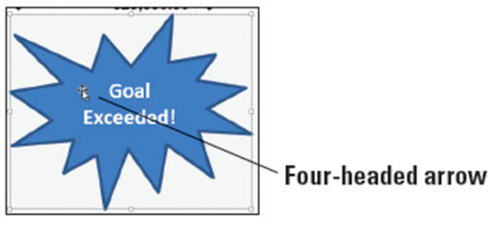
  - Point the mouse pointer inside the graphic. The mouse pointer should change to a four-headed arrow, as shown below.
- Click and drag the graphic so it appears under the % of GOAL column. Release the mouse button.
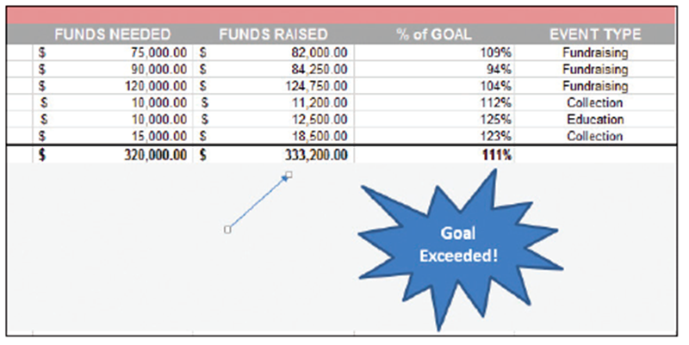
- Click and drag the arrow shape so it points to the FUNDS RAISED column, as shown below.
- SAVE the
workbook.
- PAUSE. Leave the
workbook open to
use in the next
exercise.

Step by Step 10: Copy a Graphic
- GET READY. USE the workbook from the previous exercise.
  - On the Fundraising Events worksheet, click the text box to select it.
  - Right-click a border of the text box and select Copy from the shortcut menu.
  - Click the Volunteers tab.
  - Right-click in cell A1 and under Paste Options in the shortcut menu, select the Use Destination Theme.
  - Triple-click inside the text box to select all text, and then type Confidential. Do not share this information without permission from a committee chair. The text box is shown below.
  - SAVE the workbook as 13 Delete Copy Move Solution and CLOSE the file.
- PAUSE. LEAVE Excel open to use in the next exercise.
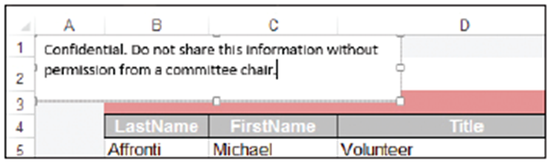
Step by Step 11: Apply a Style to a Shape
- GET READY. LAUNCH Excel if it’s not already running.
  - OPEN 13 Format Graphics from the data files for this lesson.
  - In the Fundraising Events worksheet, click the starburst shape to select it.
  - On the DRAWING TOOLS FORMAT tab, in the Shape Styles group, hold your mouse over each of the styles in the Shape Styles mini gallery. Excel previews each style using the selected shape.
  - To see the full list of styles, click the More arrow in the lower right corner of the Shape Styles mini gallery. The Shape Styles gallery appears (see Figure 13-22).
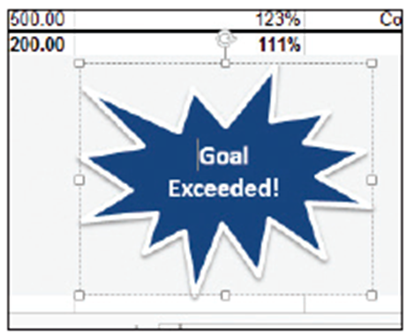
  - From the gallery, select Light 1 Outline, Colored Fill - Olive Green, Accent 3. This style is on the third row, fourth from the left. The style is applied to your shape.
  - To change the shape’s fill color,
in the Shape Styles group, click
the Shape Fill button. The color
palette appears.
  - From the first row of the palette
under Theme Colors, select
Dark Blue, Text 2. The object’s
background color changes to dark blue (above).
- SAVE the workbook.
- PAUSE. Leave the workbook open to use in the next exercise.
Step by Step 12: Resize a Graphic
- GET READY. USE the workbook from the previous exercise.
  - Select the starburst shape.
  - Point to the lower-left corner handle. When the mouse pointer turns to a two-headed arrow, drag inward to make the graphic smaller. With the handle still selected, drag outward to make the graphic larger. By pressing the Shift key while using a corner handle, you maintain the current width-to-height ratio when resizing a graphic.
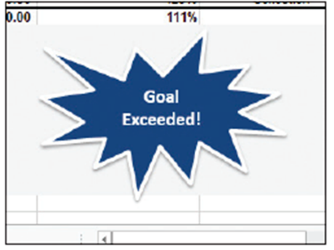
  - To change the height of the shape, drag a top or bottom
handle. This allows you to stretch the shape vertically.
  - To change the width of the shape, drag a side handle–
drag outward to widen it and inward to make it narrower. Adjust your starburst shape so it resembles the figure above.
  - SAVE the workbook.
- PAUSE. Leave the workbook open to use in the next exercise.
Step by Step 13: Rotate a Graphic
- GET READY. USE the workbook from the previous exercise.
  - Select the starburst shape.
  - Point to the rotation handle (below). The mouse pointer turns to a circular arrow.
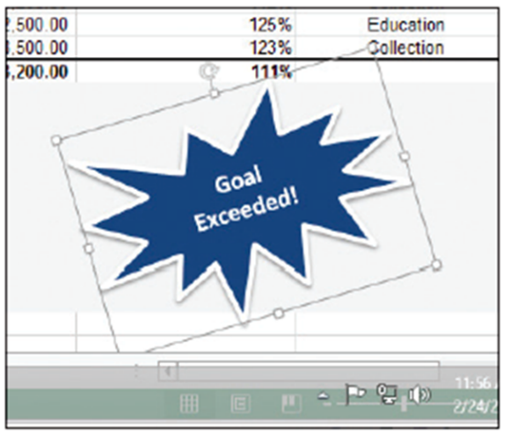
  - Drag the mouse counterclockwise. As you drag, the mouse pointer changes to a series of arrows in a circle.
  - When the shape is rotated
to the desired angle,
similar to the figure at
right, release the mouse
button.
  - SAVE the workbook.
PAUSE. Leave the workbook
open to use in the next exercise
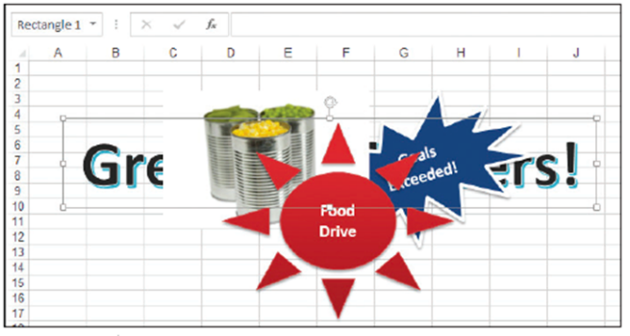
Step by Step 14: Control Stacking Order when Graphics Overlap
- GET READY. USE the workbook from the previous exercise.
  - In the Format Graphics workbook, click the Overlap sheet tab. The worksheet contains several overlapping graphics.
  - Select the border of the WordArt graphic (Great Fundraisers), which has other graphics stacked on top of it. The figure at right shows the stack
of graphics. The WordArt object, which is further down in the stack, is selected.
  - On the DRAWING TOOLS FORMAT tab, in the Arrange group, click the Bring Forward button. The WordArt graphic moves up one level in the stack.
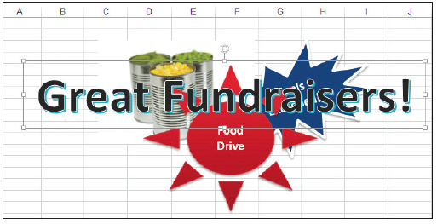
  - Click the Bring Forward arrow button and select Bring to Front. The WordArt graphic appears at the top of the stack (below).
- With the graphic still selected, click the Send Backward button to move it back one level. The Food Drive shape is now on top.
- SAVE the workbook as 13 Format Graphics Solution and CLOSE the file.
- PAUSE. LEAVE Excel open to use in the next exercise.
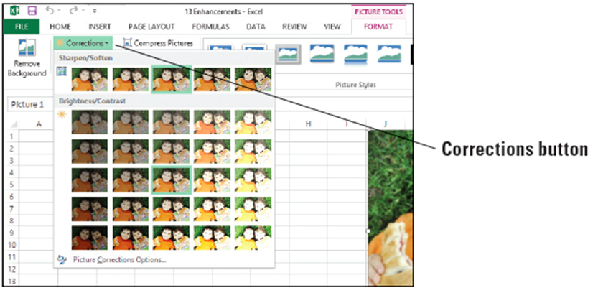
Step by Step 15: Make Corrections to a Graphic
- GET READY. LAUNCH Excel if it’s not already running.
  - OPEN 13 Enhancements from the data files for this lesson.
  - In the Correction worksheet,
select the photo of two
boys.
  - On the PICTURE TOOLS FORMAT tab, in the Adjust group, click the Corrections button. The menu shown above appears.

  - Using the thumbnails of your selected photo from the Sharpen/Soften corrections section, make a choice that represents the adjustment you’re looking for—more sharpness for a blurry picture or perhaps softening for an image that’s too sharp or where the exposure was too harsh. At the far right end of the Sharpen/Soften section, select Sharpen: 50%. The figure below shows two side-by-side images—the image on the left before applying 50% sharpening and the image on the right after.
  - To adjust a photo that’s too dark or too light, use the Brightness/Contrast settings, also represented by thumbnails showing your selected photo in varying stages of correction. Hold your mouse over each of the settings to see their effect on your photo, but don’t select any of the settings.
  - SAVE the workbook.
- PAUSE. Leave the workbook open to use in the next exercise.
Step by Step 16: Change the Color of an Image
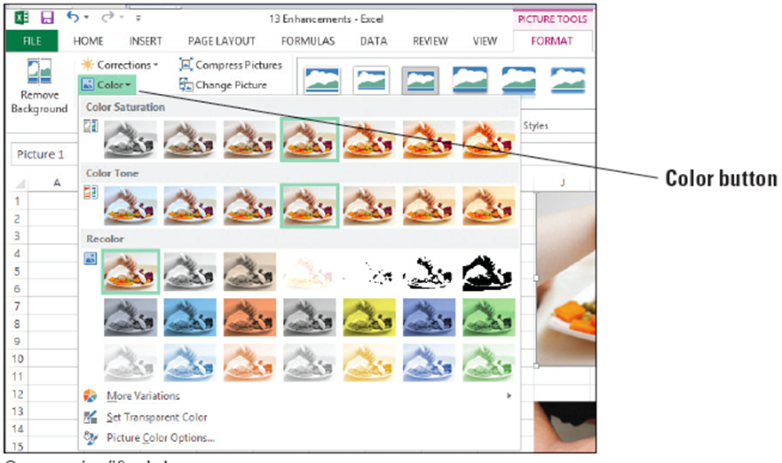
- GET READY. USE the workbook from the previous exercise.
  - Click the Color sheet tab and select the top photo, which shows a baby holding a spoon.
  - On the PICTURE TOOLS
FORMAT tab, in the Adjust
group, click the Color button. The menu shown above appears.
  - Hold your mouse over each thumbnail of your photo to see its effect.
  - In the Recolor section of the Color menu, on the first line of the gallery, select Sepia. The image takes on brown tones.
  - On the PICTURE TOOLS FORMAT tab, in the Adjust group, click the Color button, and then select Picture Color Options at the bottom of the menu.
- In the Format Picture pane on the right, move the Sharpness slider to the right until you reach the 33% value. Your photo should look similar to the figure below.
- Close the Format Picture pane.
- SAVE the workbook.
- PAUSE. Leave the workbook open to use in the next exercise.
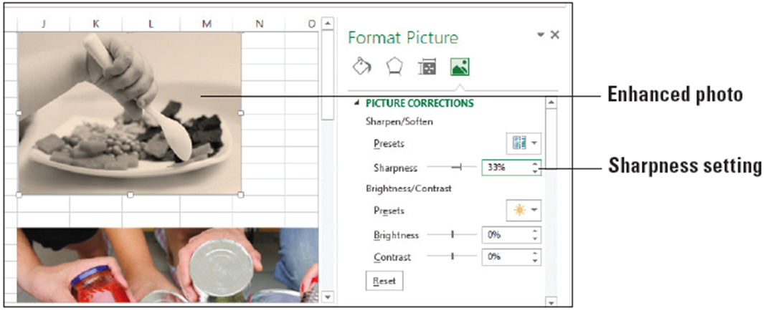
Step by Step 17: Apply Artistic Effects
- GET READY. USE the workbook from the previous exercise.
  - In the Color worksheet, select the donation box photo.
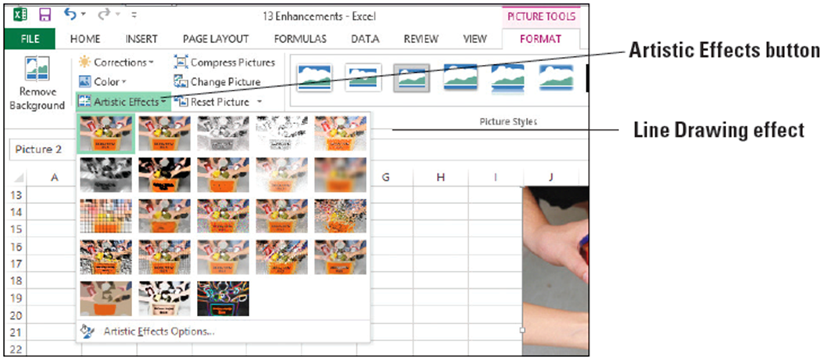
  - On the PICTURE TOOLS FORMAT tab, in the Adjust group, click the Artistic Effects button. The gallery of effects thumbnails is shown below.
  - Hold your mouse over each effect to see its preview on the photo. Select the Line Drawing effect. The figure below shows the Line Drawing effect applied.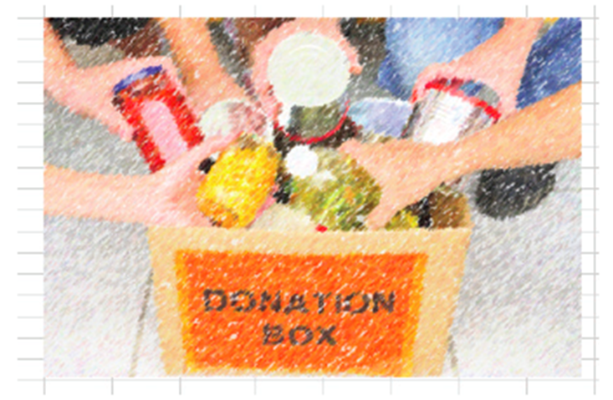
- You can customize the applied effect using the Format Picture pane. To display the pane, open the Artistic Effects menu and select Artistic Effects Options at the bottom of the menu. In the Format Picture pane that appears on the right, move the Pencil Size slider to the right to observe its effect on the photo, stopping at the value 28. Then move the Transparency slider to the right, stopping at the value 51%.
- Close the Format Picture pane.
- SAVE the workbook.
- PAUSE. Leave the workbook open to use in the next exercise.
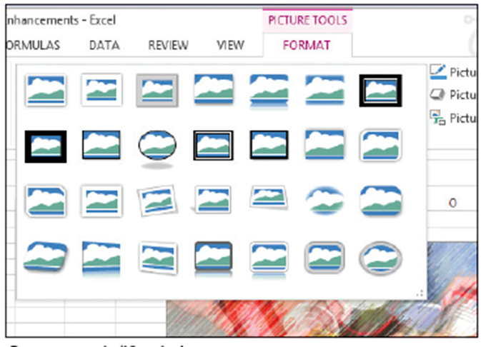
Step by Step 18: Apply Picture Styles
- GET READY. USE the workbook from the previous exercise.
  - In the Color worksheet,
select the donation box
photo.
  - On the PICTURE TOOLS
FORMAT tab, in the
Picture Styles group, hold
your mouse over each of
the styles in the mini
gallery to see their effect
on your photo.
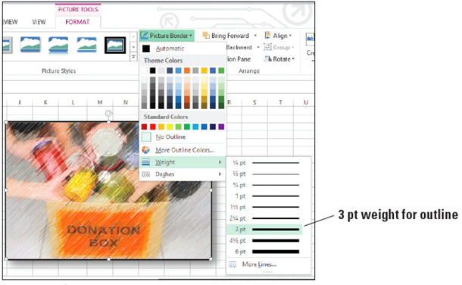
  - In the lower-right corner of the mini gallery, click the More button to display the Picture Styles gallery (above).
- Select Drop Shadow
Rectangle, which is on
the first row, fourth
from the left. The style
is applied to your picture.
- To change the picture
border, click the Picture
Border button, point to Weight, and select 3 pt (above).
- SAVE the workbook.
- PAUSE. Leave the workbook open to use in the next exercise.
Step by Step 19: Reset a Picture
- GET READY. USE the workbook from the previous exercise.
  - On the Color worksheet, scroll down and select the third photo (Give, Gain, Grow).
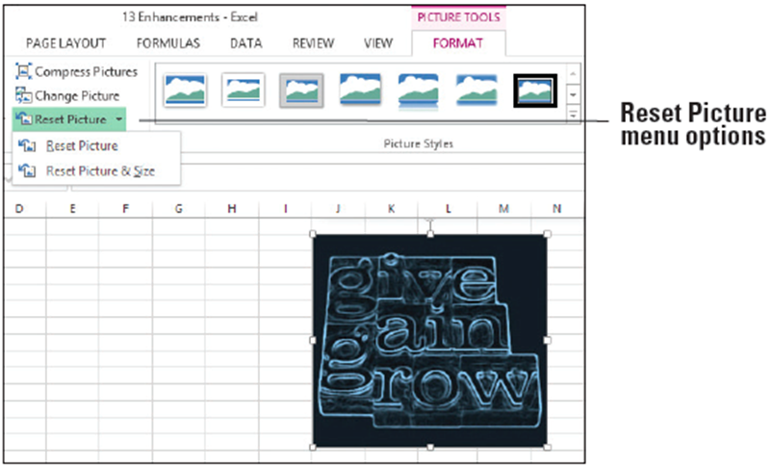
  - On the PICTURE
TOOLS FORMAT
tab, in the Adjust
group, click the
Reset Picture
arrow button.
Two options
appear (right).
- Select Reset Picture & Size to remove all changes made since insertion.
- SAVE the workbook.
- PAUSE. Leave the workbook open to use in the next exercise.
- The Reset Picture option removes corrections, color, styles, and effects.
Step by Step 20: Modify a Picture’s Properties
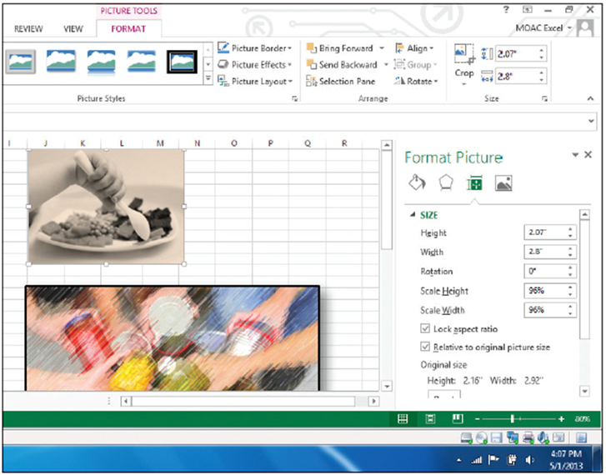
- GET READY. USE the workbook you modified in the previous exercise.
  - Click the Color sheet
tab.
  - Right-click the baby
feeding photo and
select Size and
Properties from the
shortcut menu. The
Format Picture pane
appears on the right
side of the workspace,
as shown at right.
  - Scroll down if necessary and click the PROPERTIES category.
  - Select the Move and size with cells option. This option associates the object with the cells it overlays.
  - Close the Format Picture pane.
  - Grab the column border between column headings J and K, and then drag to the right to widen column J. Notice that the picture becomes wider as well.
  - Click the Undo icon in the Quick Access Toolbar to undo the column width setting.
  - SAVE the workbook as 13 Enhancements Solution and CLOSE the file.
- PAUSE. LEAVE Excel open to use in the next exercise.
Step by Step 21: Capture a Screenshot
- GET READY. LAUNCH Excel if it’s not already running.
  - OPEN 13 Screenshot from the data files for this lesson.
  - OPEN 13 Fundraising Flash from the data files for this lesson. This is a Microsoft Word document. You will capture a screenshot of some content in this document and insert it into an Excel worksheet. Click Enable Editing if the message appears.
  - On the taskbar, click the Excel icon to switch to the Excel workbook. Click in cell A1.
  - On the INSERT tab, in the Illustrations group, click the Take a Screenshot button arrow. The screenshot menu appears, as shown at right.
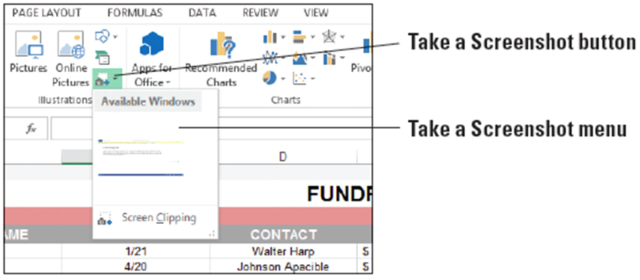
  - Your options include the
windows of other
applications currently open
(in this case, Word), or to implement Screen Clipping, which allows you to draw a box around any space within any open application and make that the inserted graphic. Select Screen Clipping.
  - The Word document appears. Drag the mouse pointer, which looks like a crosshair, over the text and release the mouse button. The screenshot appears in the Excel document.
  - The figure below shows the inserted screenshot, which is a section of a Word document pertaining to the year’s fundraising events.
  - SAVE the workbook as 13 Screenshot Solution and CLOSE the file. CLOSE the Word program.
- PAUSE. LEAVE Excel open to use in the next exercise.
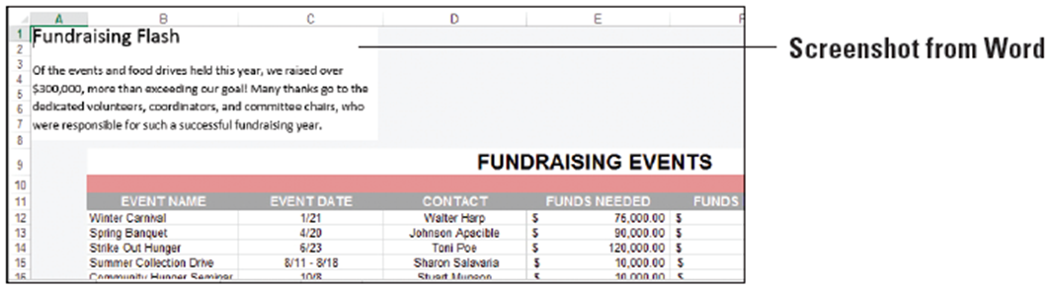
Step by Step 22: Create a Flowchart
- GET READY. LAUNCH Excel if it’s not already running.
  - OPEN 13 SmartArt from the data files for this lesson.
  - At the bottom of the workbook, click the New sheet icon to create a new sheet. Rename it Process and move it to the end of the row of worksheets.
  - On the INSERT tab, in the Illustrations group, click the Insert a SmartArt Graphic button. The Choose a SmartArt Graphic dialog box opens.
  - The list of SmartArt categories appears on the left side of the dialog box. Click the Process category.
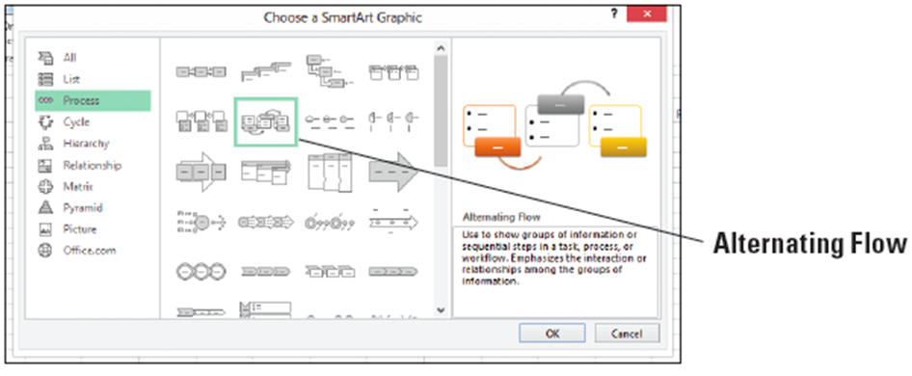
  - From the options, select the flowchart that best suits your needs for the process you want to depict. Chosen in the figure below is the Alternating Flow, which pairs a colored box with the name of a step in the process with a bulleted list of the tasks related to the process.
  - Click OK
to begin
building the
flowchart.
- On the left edge of the SmartArt graphic, click the arrow control to open the Text pane. In the Text pane, enter the names of each step in the process (the top-most bullet) and the tasks related to each one (the sub-bullets under each main bullet). Excel builds the flowchart as you type text. See the figure below for the text to be entered.
- SAVE the workbook.
- PAUSE. Leave the workbook open to use in the next exercise.
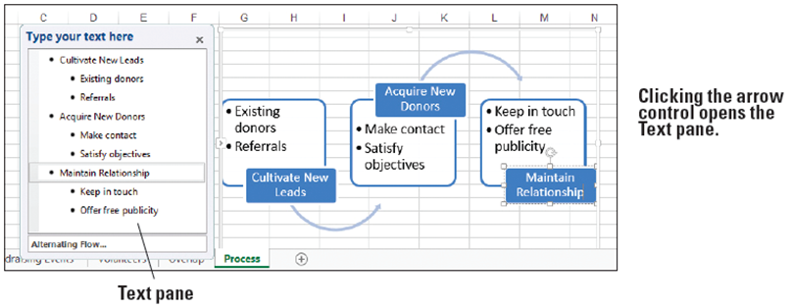
Step by Step 23: Create an Organization Chart
- GET READY. USE the workbook from the previous exercise.
  - Insert a new worksheet, naming the tab Organizational Chart.
  - On the INSERT tab, in the Illustrations group, click the SmartArt button. The Choose a SmartArt Graphic dialog box opens.
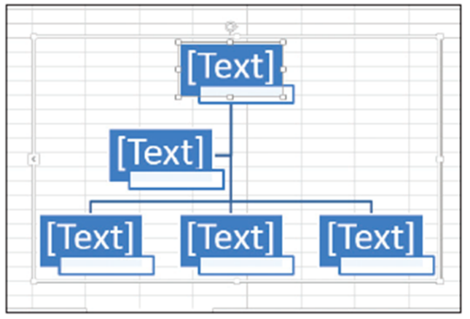
  - In the list of SmartArt categories on the left side of the dialog box, click the Hierarchy category.
  - Select the Name and Title Organization Chart and click OK. The figure at right shows the chart, which pairs a colored
box intended to contain the person’s name and a smaller text box for the person’s job title. The boxes are connected by lines to show relationships and structure.
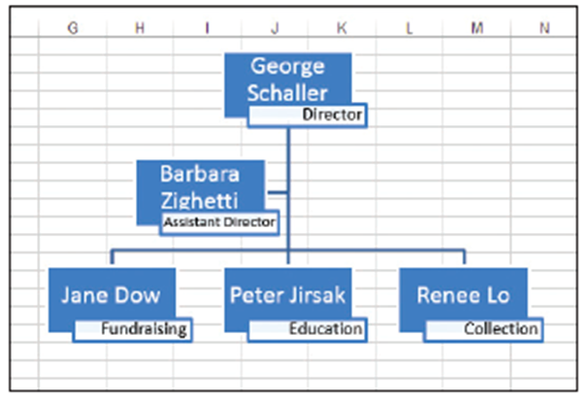
- Using the Text pane, type the
names of the people to be
included in the chart. Enter
job titles for each person by
clicking the white box
underneath the larger
color-filled name box. Type
the job title for each person,
one per box. The completed
chart is shown above.
- SAVE the workbook as 13 SmartArt Solution and CLOSE the file.
- CLOSE Excel.

