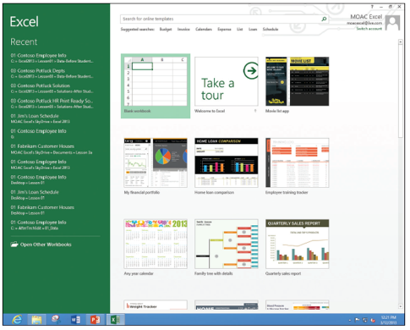
Step by Step 1: Create a Workbook from Scratch
- GET READY. LAUNCH Excel. Excel gives you options for starting a blank workbook, taking a tour, or using templates (right).
  - Click Blank workbook. If you have just launched Excel, Book1 – Excel appears in the title bar at the top of the window. A blank workbook opens with A1 as the active cell.
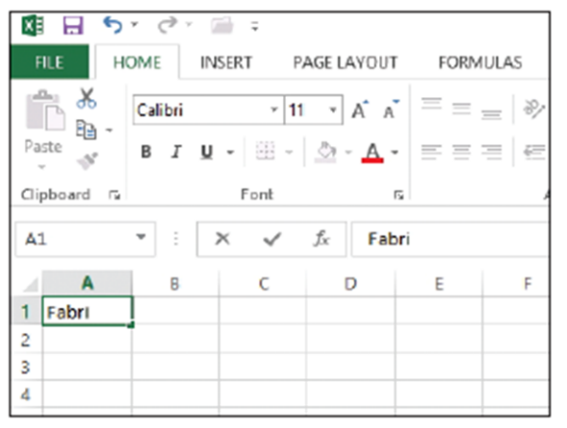
  - In cell A1, type Fabrikam
Inc. This cell is the primary
title for the worksheet.
Note that as you type, the
text appears in the cell and
in the formula bar
(see figure).
  - Press Enter. The text is entered into cell A1, but appears as if it flows into cell B1.
  - In cell A2, type 123 Fourth Street and press Enter.
  - In cell A3, type Columbus, OH 43204 and press Enter.
  - Sometimes you need a quick work area to complete another task while you are in the middle of a workbook. You can open another workbook as a scratch area. Click the FILE tab, and in the left pane, click New. The templates available appear.
  - In the Backstage area, click Blank Workbook. A second Excel workbook opens and Book2 appears in the title bar.
  - In cell A1, type Phone Calls and press Enter.
  - In cell A2, type David Ortiz UA flight 525 arriving 4:30 pm and press Enter.
- PAUSE. LEAVE both Excel workbooks open for the next exercise.
Step by Step 2: Switch Between Open Workbooks
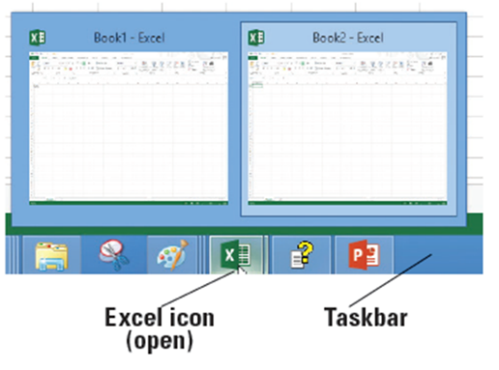
- GET READY. Both temporary workbooks with the address and phone message should be open. The Phone Call workbook is the current workbook in this case.
  - To return to the company address, click the Excel icon
on the taskbar (see figure). Each of the open workbooks appears in a preview window.
When you move the mouse pointer over each workbook, it previews on the screen.
  - Click Book1 - Excel. The unsaved company address becomes the active workbook.
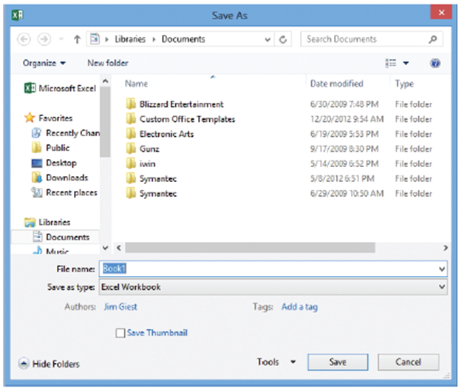
Step by Step 3: Name and Save a Workbook
- GET READY. USE the workbook from the previous exercise or type your name and address in a new workbook.
  - Click the FILE tab to open
Backstage view. In the left
pane, click Save As to
display the save options.
  - Double-click Computer
to open the Save As dialog
box (see figure).
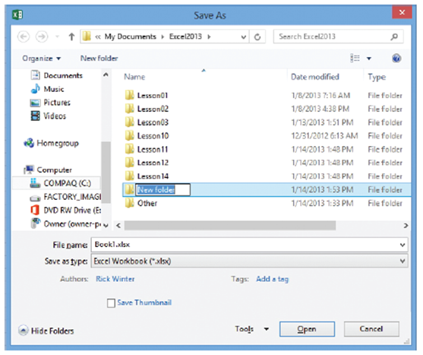
  - From the left-hand navigation pane, in the Save As dialog box, click Desktop. The Desktop becomes the new destination of your saved file. Open up your classroom folder.
  - In the File Name box, type 02 Fabrikam Address Solution.
  - Click the Save button.
- PAUSE. LEAVE the workbook open to use in the next exercise.

Step by Step 4: Save a Workbook Under a Different Name
- GET READY. USE the workbook from the previous exercise or type Fabrikam Inc. in cell A1.
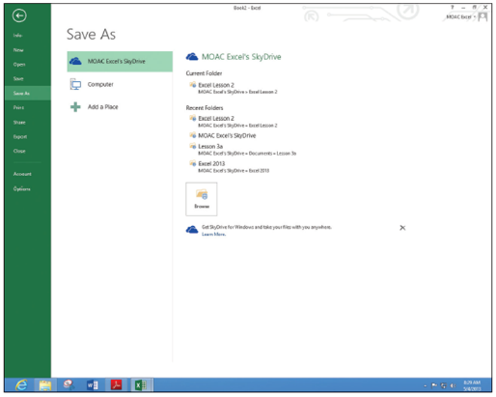
  - In cell A2, type 87 East Broad Street.
  - In cell A3, type Columbus, OH 43215.
  - Click the FILE tab, and in the left pane, click Save As.
  - Click on Computer to return to the drive you used before.
  - Click on your classroom folder.
  - Click in the File name box, click after Fabrikam, and type Broad so the name reads 02 Fabrikam Broad Address Solution.
  - Click Save. You created a new workbook by saving an existing workbook with a new name.
  - Click the FILE tab, click Save As in the left pane, and click on your folder.
  - In the File Name box, type 02 Fabrikam Address Template Solution.
  - In the Save As Type box, click the drop-down arrow and choose Excel Template. Click the Save button.
- PAUSE. EXIT Excel. Do not save the phone message workbook.

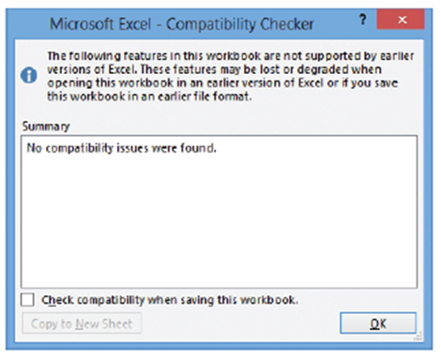
Step by Step 5: Save a Workbook in a Previous Excel Format
- GET READY. LAUNCH Excel.
  - Click the FILE tab, and then click Open.
  - In the Backstage Recent Workbooks pane, click 02 Fabrikam Broad Address Solution.
  - First check for compatibility issues.
Click the FILE tab, click Info, click
Check for Issues, and then click
Check Compatibility. The
Microsoft Excel – Compatibility
Checker dialog box at right opens.
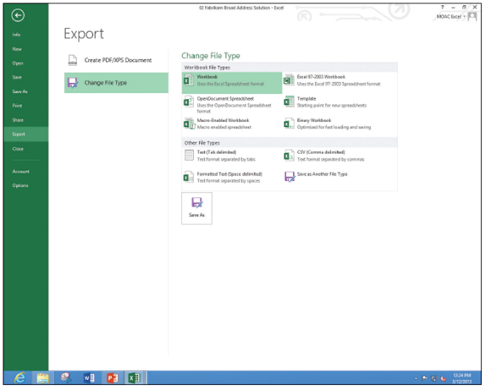
  - Read the information in the Compatibility Checker dialog box and click OK.
  - Click the FILE tab,
click Export, and
then click Change
File Type. The
Backstage window
shows the different
file types (right).
  - Click Excel
97-2003
Workbook (*.xls)
and click Save As.
  - In the File name box, click before Solution and type 97-03, and then click Save.
  - Click the FILE tab, and then click Open. The Recent Workbooks pane in Backstage shows the last set of documents that have been saved.
  - Click 02 Fabrikam Broad Address Solution.
- PAUSE. LEAVE the workbook open to use in the next exercise.
Step by Step 6: Save in Different File Formats
- GET READY. USE the workbook from the previous exercise or type your name and address in a new workbook.
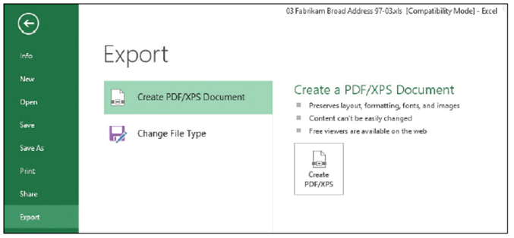
  - Display Backstage view, click the FILE tab, and then click the Export button.
  - Click the Change File Type button. Excel explains the different file types.
  - Click the Create
PDF/XPS Document
option (right).
  - Click the
Create PDF/XPS
button in the right pane.
  - In the left navigation pane, click Desktop.
  - Double-click on your folder to move to that folder.
  - The file name gives the last name with a PDF extension.
  - Click Publish.
  - The Reader application
opens with the PDF file
displayed (right).
  - Close the Reader. Right-click in a blank area, and then click More, Close file.
  - If necessary, press Alt+Tab to return to the Excel file.
- PAUSE. CLOSE all open workbooks and LEAVE Excel open to use in the next exercise.

Step by Step 7: Enter Basic Data in a Worksheet
- GET READY. If necessary LAUNCH Excel and OPEN a new workbook.
  - Click cell A1, type Fabrikam Inc., and press Enter. Notice that the active cell moves to the next row, to cell A2.
  - In cell A2, type Employee List and press Enter.
  - Click cell A4, type Name, and press Tab. Notice that the active cell moves to the next column, to cell B4.
  - Type Extension and press Enter. Notice that the active cell moves to the first cell in the next row.
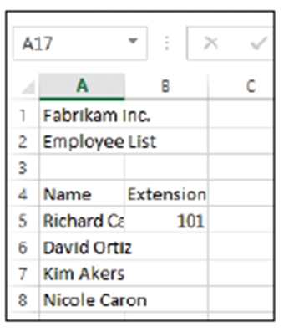
  - Type Richard Carey and press Tab.
  - Type 101 and press Enter. Richard Carey looks cut off.
  - Click cell A5 and notice that the complete entry for Richard Carey appears in the formula bar.
  - Click cell A6, type David Ortiz, and
press Enter.
  - Type Kim Akers and press Enter.
  - Type Nicole Caron and press Enter.
  - SAVE the workbook in the Computer’s
Excel Lesson 2 folder as 02 Fabrikam
Employees Solution. Your file should
look like the figure at right.
- PAUSE. LEAVE the workbook open for the next lesson.
Step by Step 8: Change the Column Width
- GET READY. Use the 02 Fabrikam Employees Solution file from the previous exercise.
  - Move the mouse pointer between columns A and B, to the column markers at the top of the worksheet (below). The mouse pointer changes to a double-headed arrow.
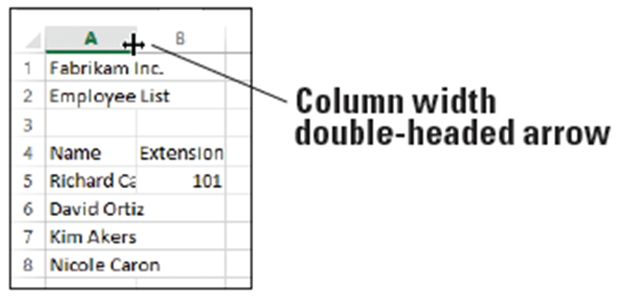
  - Double-click the
column marker
between A and B.
The width of the
column changes to
the widest entry in
column A. In this
case, it is Employee list and Richard Carey's name.
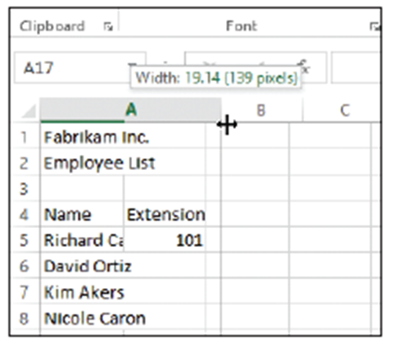
  - Drag the double-headed arrow mouse pointer between columns B and C until the ScreenTip shows Width: 12.00 (89 pixels) or something close to this amount (below).
  - SAVE the 02 Fabrikam
Employees Solution file. This
overwrites your previous
version without the column
width change.
- PAUSE. CLOSE the workbook and
LEAVE Excel open for the next
exercise.
Step by Step 9: Edit a Cell’s Contents
- GET READY. OPEN a blank workbook.
  - Click cell A1, type Fabrikam, and press Enter. The insertion point moves to cell A2 and nothing appears in the formula bar.
  - Click cell A1. Notice that the formula bar displays "Fabrikam."
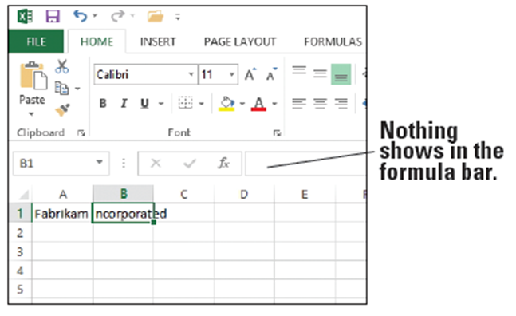
  - Click after Fabrikam in the formula bar, type a space, type Incorporated, and press Tab. The insertion point moves to cell B1 and nothing appears in the formula bar (right).
  - Click cell A1 and
double-click on
Incorporated in the
formula bar to select it.
Type Inc. and press
Enter.
  - Type Sales and
press Enter.
  - Click cell A2 and click after Sales. The insertion point moves to the formula bar.
  - Press Home. The insertion point moves to the beginning of the formula bar.
  - Type Monthly and then press the spacebar. Press Enter.
  - In cell A3, type January and press Enter.
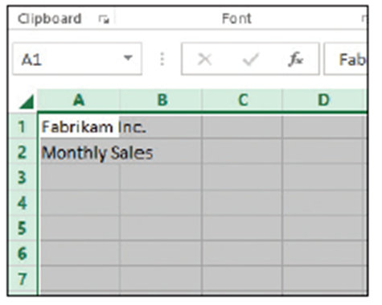
  - Click cell A3, type February, and press Enter. Cell A3's original text is gone and February replaces January.
- PAUSE. CLOSE the workbook without saving and LEAVE Excel open for the next exercise.

Step by Step 10: Delete and Clear a Cell’s Contents

- GET READY. OPEN a blank workbook.
  - In cell A1, type 1 and press Enter.
  - Type 2 and press Enter.
  - Type 3 and press Enter.
  - Type 4 and press Enter.
  - Highlight cells A1 through A4 (containing the numbers 1 through 4).
  - Press Delete. All the cells are erased.
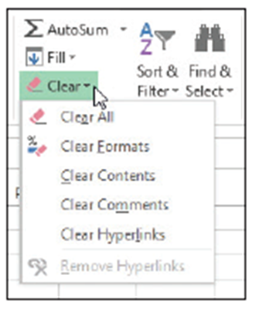
  - On the Quick Access Toolbar, click the Undo button to return the cell entries.
  - Click cell B5, type $275,000, and press Enter. The value and format are placed into the cell.
  - Click cell B5 and Type 225000 without the dollar sign and comma and press Enter. Notice that $225,000 is formatted. Although the text is gone, the cell retains the previous format when you press Delete.
  - Click cell B5 and on the HOME tab, in the Editing group, click Clear (right).
  - Click Clear Formats. 225000 displays without the dollar sign and comma.
- PAUSE. CLOSE the workbook without saving and LEAVE Excel open for the next exercise.

Step by Step 11: Enter Labels and Use AutoComplete
- GET READY. OPEN a blank workbook.
  - In cell A1, type Fabrikam Inc. and press Enter.
  - Type Monthly Sales.
  - Click cell A4 and type Agent and press Tab.
  - In cell B4, type Last Closing Date and press Tab.
  - In cell C4, type January and press Enter.
  - Click cell A5, type Richard Carey, and press Enter.
  - In cell A6, type David Ortiz and press Enter.
  - In cell A7, type Kim Akers and press Enter.
  - Type Nicole Caron and press Enter.
  - Click cell A9 and type R. As shown below, AutoComplete is activated when you type the R because it matches the beginning of a previous entry in this column. AutoComplete displays the entry for Richard Carey. 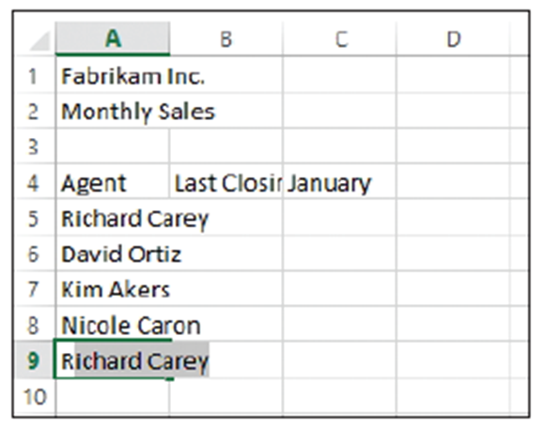
  - Type y. The AutoComplete entry disappears. Finish typing the entry for Ryan Calafato and press Enter.
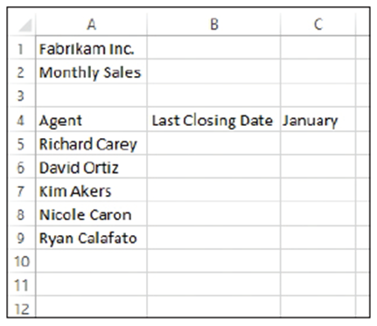
  - Type R. Notice that no AutoComplete entry appears this time. Type i and notice that the AutoComplete entry shows Richard Carey.
  - Press Esc to undo the entry.
  - Increase the column widths for columns A and B so you can see the entries in row 4 and below (right).
- PAUSE. LEAVE the workbook open to
use in the next exercise.

Step by Step 12: Enter Numeric Values
- GET READY. USE the workbook from the previous exercise.
  - Click cell C5, type $275,000, and press Enter.
  - Click cell C5 and notice that 275000 appears in the formula bar and the formatted value appears in the cell.
  - Click cell C6, type 125,000, and press Enter. Be sure to include the comma in your entry. The number is entered in C6 and C7 becomes the active cell. The number appears in the cell with the comma and no dollar sign (unlike the entry in C5); however, the formula bar displays the true value and disregards the special characters.
  - Type 209000 and press Enter. The number is entered with no dollar sign and no comma.
  - Type 258,000 and press Enter.
  - Type 145700 and then click cell C5. Figure 2-22 illustrates how your spreadsheet should look with the values you just typed.
- PAUSE. LEAVE the workbook open to use in the next exercise.

Step by Step 13: Enter Dates
- GET READY. Use the workbook from the previous exercise.
  - Click cell B5, type 1/4/2014, and press Enter.
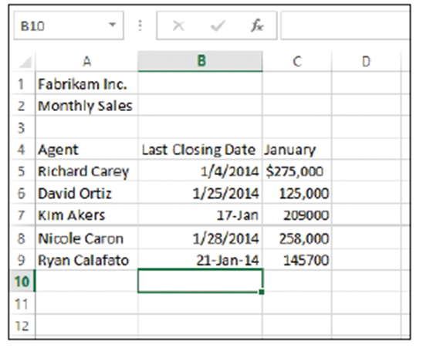
  - Click cell B6, type 1/25/14, and press Enter. The date is entered in C6 as 1/25/2014 and B7 becomes the active cell.
  - Type 1/17 and Press Enter. 17-Jan is entered in the cell. Click cell B7, and notice that 1/17/20XX (with XX representing the current year) appears in the formula bar.
  - If the year is not 2014, click cell B7 and press F2. Change the year to 2014 and press Enter.
  - In cell B8, type 1/28/14 and press Enter.
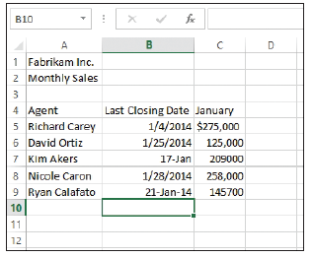
  - Type January 21, 2014 and press Enter. 21-Jan-14 appears in the cell. If you enter a date in a different format than specified or had already entered something in the cell and deleted it, your worksheet might not reflect the results described. The date formats in column B is not consistent (right). You apply a consistent date format in the next section.
  - In cell B9, type 1/1/10 and press Enter. Notice that the value changes but the formatting remains the same.
  - Click the Undo button to return to the workbook shown at right.
- PAUSE. LEAVE the workbook open to use in the next exercise.

Step by Step 14: Fill a Series with Auto Fill
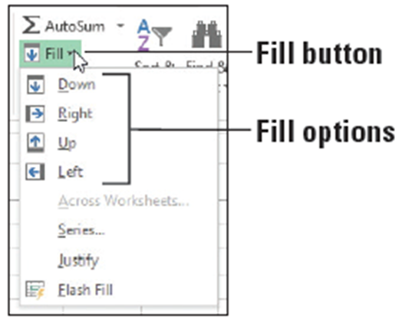
- GET READY. USE the workbook from the previous exercise or type the text in Figure 2-23.
  - Select the range C4:H4. January is in the first cell.
  - On the HOME tab, in the Editing group, click the Fill button. The Fill menu appears
(right).
  - From the menu, click Right. The contents of C4 (January) are filled into all the cells.
  - Click the Undo button.
  - Select the range C9:C13 and click the Fill button. Choose Down. The content of C9 is copied into the four additional cells.
  - Click the Undo button.
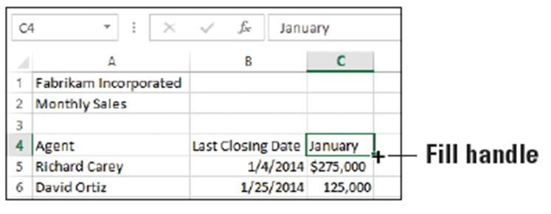
  - Click cell C4, point to the fill handle in the lower-right corner of the cell (below), and drag it to E4 and release. The Auto Fill Options button appears, and January through March are displayed.
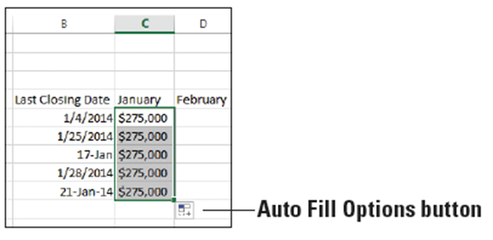
  - Click cell C5, point to the
fill handle, and drag it to
C9 and release. All the
numbers turn to $275,000
in column C. The Auto Fill
Options button appears in
D10 (right).
  - Click the Auto Fill Options button, and choose Fill Formatting Only from the list that appears. All the numbers return to their values and are formatted with dollar signs and commas.
  - Repeat Step 9 for the range B5:B9.
  - Click cell A9, and then drag the fill handle down to A15. Ryan Calafato's name is repeated.
  - Click the Undo button to return the spreadsheet to what is shownbelow.
  - SAVE the workbook as 02 Fabrikam Sales Solution.
- PAUSE. EXIT Excel.
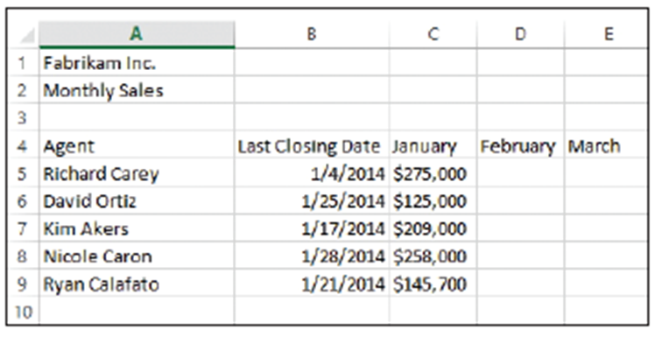

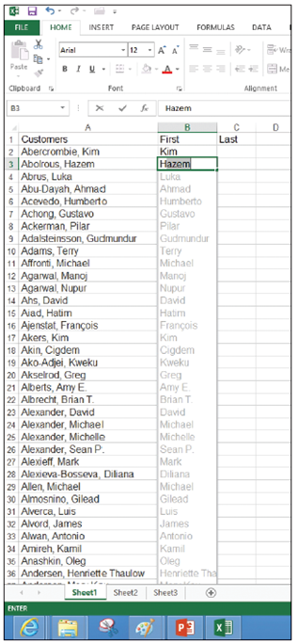
Step by Step 15: Fill Cells with Flash Fill
- GET READY. Before you begin these steps, LAUNCH Microsoft Excel.
  - Open the 02 Customers file.
  - Click cell B1, type First, and press Tab.
  - Click cell C1, type Last, and press Enter.
  - Click cell B2, type Kim, and press Enter.
  - In cell B3, type H. Notice that Hazem
shows in the rest of the cell and the
other first names of the customers
appear (right).
  - Press Enter.
  - Click cell C2, type Abercrombie, and press Enter.
  - In cell C3, type A and notice that Abercrombie is repeated with AutoComplete. Continue typing bol and notice that the last names all appear. Press Enter.
  - Double-click the right border of columns B and C to set the column width.
  - Scroll down and notice that the entire worksheet is filled in.
  - SAVE the file as 02 Customers Solution.
- PAUSE. EXIT Excel.

Step by Step 16: Copy a Data Series with the Mouse
- GET READY. Before you begin these steps, LAUNCH Microsoft Excel.
  - Open the 02 Customer Houses file.
  - Select the range A12:A22.
  - Press Ctrl and hold the mouse button down as you point to the right border of the selected range. The copy pointer is displayed.
  - With the copy pointer displayed, hold down the left mouse button and drag the selection to the right, until H12:H22 appears in the scrolling ScreenTip next to the selection.
  - Release the mouse button and then release Ctrl. The data in A12:A22 also appears in H12:H22.
- PAUSE. LEAVE the workbook open to use in the next exercise.
Step by Step 17: Move a Data Series with the Mouse
- GET READY. USE the 02 Customer Houses workbook from the previous exercise.
  - Select E12:E22.
  - Point to the right border of the selected range. The move pointer is displayed.
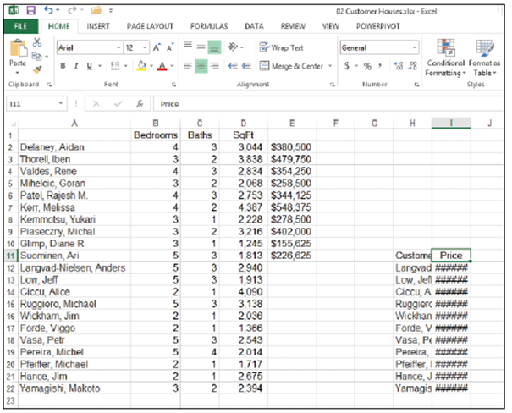
  - With the move pointer displayed, hold down the left mouse button and drag the selection to the right, until I12:I22 appears in the scrolling ScreenTip beside the selected range.
  - Release the mouse button. In your worksheet, the destination cells are empty; therefore, you are not concerned with replacing existing data. The data previously in E12:E22 is now in I12:I22.
  - Drag A1 to H12. Note that a dialog box warns you about replacing the contents of the destination cells.
  - Click Cancel.
  - Drag A1 to H11.
  - Drag E1 to I11. Your worksheet should look like the one shown
above.
- PAUSE. LEAVE the workbook
open to use in the next exercise.
Step by Step 18: Copy and Paste Data
- GET READY. USE the 02 Customer Houses workbook from the previous exercise.
  - On the HOME tab of the ribbon, click the Clipboard Dialog Box Launcher. The Clipboard pane opens on the left side of the worksheet. The most recently copied item is always added at the top of the list in this pane, and it is the item that will be copied when you click Paste or a shortcut command.
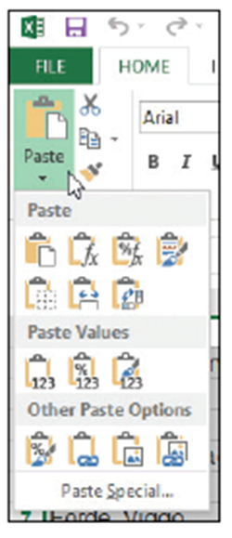
  - Select A1:E22 and press Delete.
  - Select H11:I22 and in the Clipboard group, click the Copy button. The border around the selected range becomes a moving border.
  - Select A1 and click the Paste button. The moving border remains active around H11 through I22. A copied range does not deactivate until you type new text, issue another command, or double-click on another
cell or you can press Esc.
  - Select A20 and click the down arrow on
the Paste button. The Paste options
menu appears (right).
  - Select the first option under Paste Values. Notice that the values in column B are no longer formatted.
  - Click the Undo button.
  - Select H11:I22 and press Delete.
  - Press Ctrl + Home to return to the top of the workbook.
  - SAVE the workbook as 02 Customer Houses Solution.
- PAUSE. LEAVE the workbook open to use in the next exercise.
Step by Step 19: Cut and Paste Data
- GET READY. USE the 02 Customer Houses Solution workbook from the previous exercise.
  - Select A1:B12 to highlight the Customer House Prices table.
  - In the Clipboard group, click the Cut button. The contents of A1:B12 are displayed in the Clipboard pane.
  - Click the + New sheet button on the bottom of the worksheet.
  - You create Sheet2 and cell A1 is active.
  - Click Paste to move the former contents of Sheet1 to cell A1 into Sheet2.
- PAUSE. EXIT Excel and do not save the workbooks if requested.

Step by Step 20: Assign Keywords
- GET READY. Before you begin these steps, LAUNCH Microsoft Excel.
  - OPEN the 02 Customer Houses Solution file you worked with in the previous exercises.
  - Click FILE. The Backstage window displays current properties on the right side of the window (below). 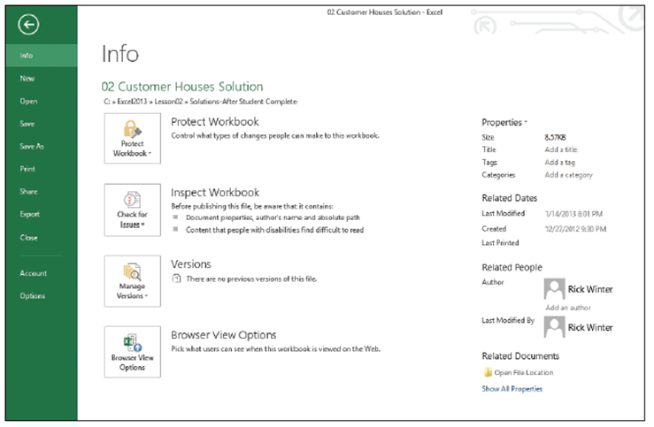
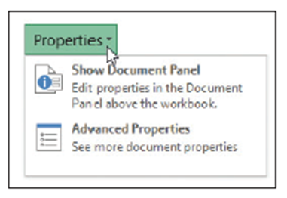
  - Click the Properties button at
the top of the right pane. The
Properties drop-down menu
shows two options (right).
Click Show Document Panel.
  - Click the Keywords field and type Customer, Sq Ft, Price.
  - Click the Category field and type Revenue.
  - Click the Author field and type your name.
  - Above the Author field, click the Document Properties drop-down arrow, and then click Advanced Properties. The Properties dialog box opens.
  - Click the Summary tab in the dialog box to see the properties you entered.
  - Click the Statistics tab to see the date you modified the file.
  - Click OK to close the Properties dialog box.
  - At the top right corner of the Document Information panel, click the Close button.
  - SAVE the workbook as 02 Customer Houses Prop Solution.
- PAUSE. EXIT Excel.

