Step by Step 1: Access Backstage View
- GET READY. LAUNCH Excel and OPEN a blank workbook.
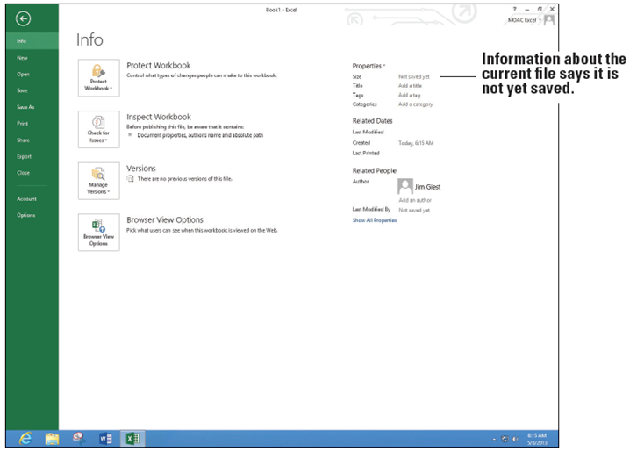
  - Click the FILE tab to display Backstage view with the Open tab selected.
  - In the upper left corner
of Backstage view, click
the Return to
document button.
  - In cell A1, type abc
and press Enter.
  - Click the FILE tab.
Backstage view, like
the ribbon, is context-
sensitive and changes to the Info tab (above).
  - Click the Save tab. Notice that there are additional tabs depending on your setup. In this case, SkyDrive, Computer, and Add a Place appear.
  - Click the Save As tab. Notice that this looks identical to the Save tab. This is how it looks the first time you save the file.
  - Click Computer and notice that the Recent Folders section where you last saved your previous workbooks appears (below). 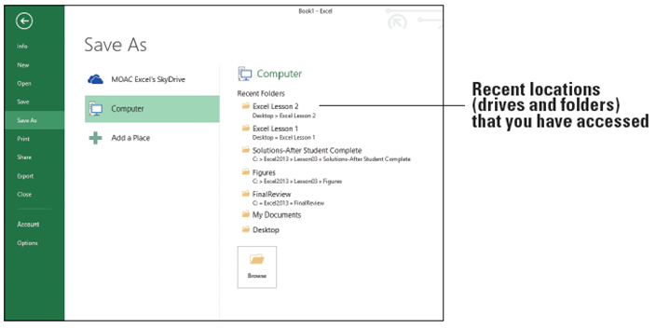
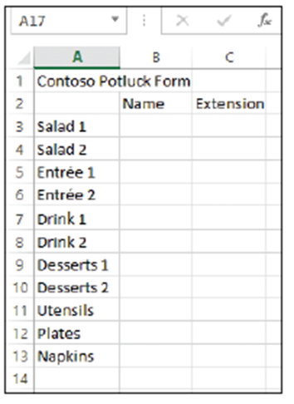
  - Click Browse, in the File name box, type Temp, and then click Save.
  - Click FILE. Notice the Info tab appears.
  - Click Save. Notice that you do not
see the options shown at right (and
Step 5 previously), but that you return
directly to the workbook.
  - Click FILE and click Close. This action
closes the workbook, but not Excel.
  - Click FILE and the Open tab appears.
In the list of Recent Workbooks, select Temp and your workbook returns.
- PAUSE. EXIT Excel.
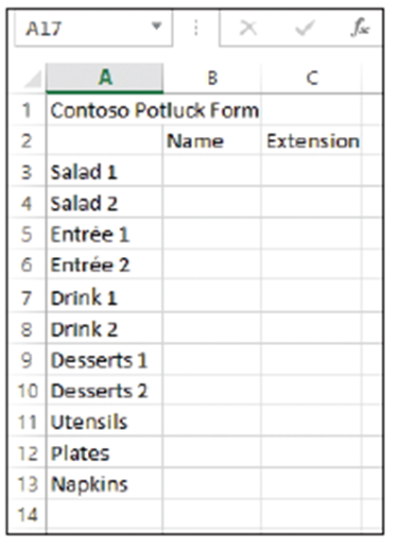
Step by Step 2: Print and Preview a Document
- GET READY. LAUNCH Microsoft Excel 2013.
  - Create a new workbook, enter the
worksheet data shown at right, and
save it as 03 Contoso Potluck Solution.
  - EXIT Excel.
  - LAUNCH Excel again and notice
that 03 Contoso Potluck Solution
appears in your Recent list. Click
the file to bring it back up.
  - Click the FILE tab to automatically display the Info tab. As shown below, the Properties area shows the size of the file, when it was last modified, and who the author is.
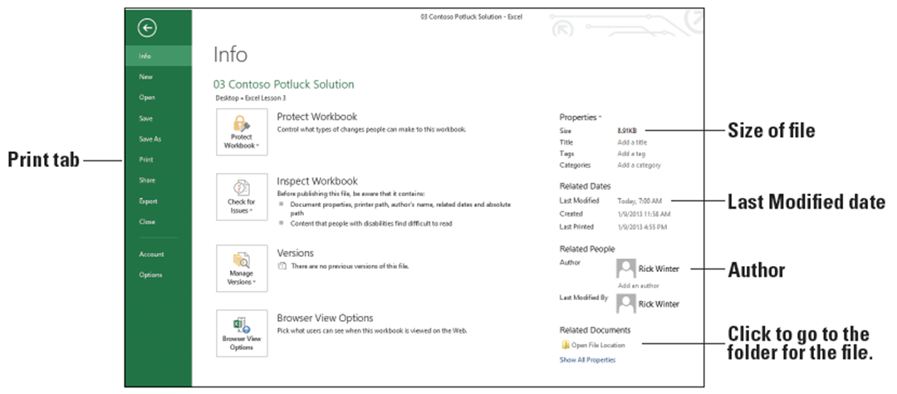
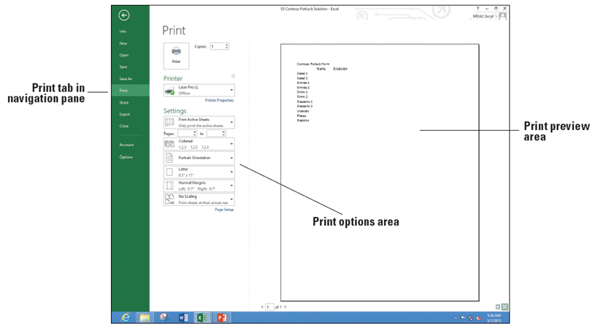
  - Click the Print tab. Note that this displays the Print options in Backstage view. Take a moment to preview the workbook in the Print Preview section in the right pane and read through the Print options listed in
the center section of
the page (right).
  - To print your work-
sheet, at the top of
the Print screen,
click the Print
button.
- PAUSE. LEAVE the
workbook open for the
next exercise.
Step by Step 3: Use Quick Print to Print a Worksheet
- GET READY. USE the open workbook from the previous exercise or open 03 Contoso Potluck Solution.
  - On the Quick Access Toolbar, if you do not see the Quick Print button, click the Customize Quick Access Toolbar arrow at the end of the toolbar, and select Quick Print (below).
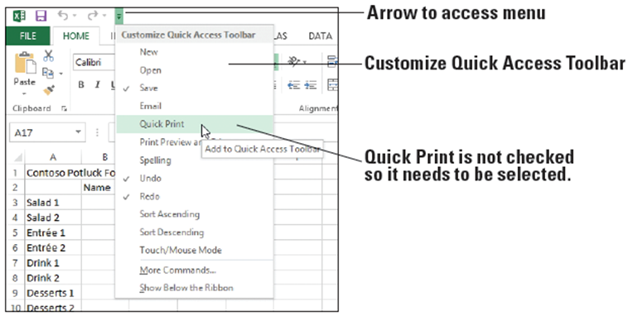
- On the Quick Access Toolbar, click Quick Print (below).
- Retrieve the printed copy of the worksheet from your printer.
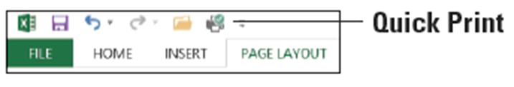
- Click the FILE tab, and then click Print. The preview pane should match what was printed.
- Click the Return to document arrow.
- Notice that a dotted vertical line appears in the middle of the screen. The line shows the right edge of the printed page. The line displays the first time you print or preview a page.
- PAUSE. LEAVE the workbook open for the next exercise.
Step by Step 4: Set the Print Area
- GET READY. USE 03 Contoso Potluck Solution that is already open or create the workbook shown on slide 11.
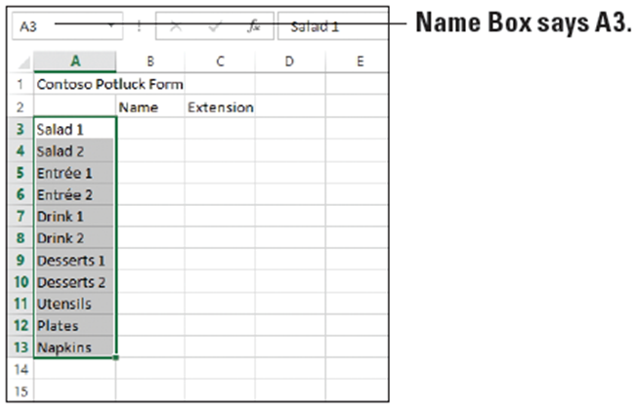
  - Click the PAGE LAYOUT tab.
  - In the Page Setup group,
point to the Print Area
button. Note the ScreenTip
that displays and defines the
task to be completed.
  - On the worksheet, click cell
A3, hold the mouse button,
and drag to cell A13. Your cell range should be highlighted in gray (above).
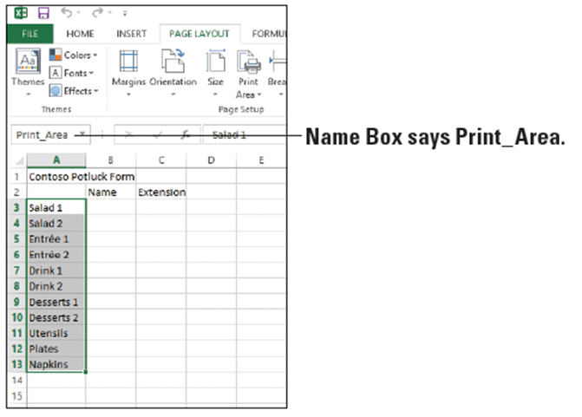
  - With these cells highlighted, click the Print Area drop-down arrow and click Set Print Area from the menu that appears. You have now set the print area. While the area is still selected, note that the Name Box now says “Print_Area” (right).
  - Click the FILE tab to
access Backstage view.
  - Click Print and notice in the Print Preview pane that you can see only the list of items to bring and not the text in rows 1 and 2 and columns B and C.
  - Click the Return to document button. You will not print at this time.
- PAUSE. SAVE the workbook with the current name
03 Constoso Potluck Solution and CLOSE Excel.
Step by Step 5: Print Selected Worksheets
- GET READY. LAUNCH Excel 2013, and then perform these steps:
  - OPEN 03 Contoso Potluck Depts. This is a modified version of the potluck workbook you created previously. In this case, there are three different worksheets for three different departments.
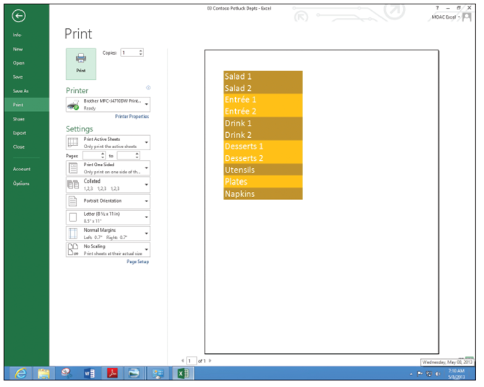
  - Click each of the three worksheet tabs: HR, Operations, and Finance. Notice that the title in C1 shows the department name and there are a different number of items to bring to each potluck depending on the size of the department. Click the HR tab.
  - Press Ctrl + P to display
the Print options in the
Backstage view. In the
Print Preview pane, the
entire worksheet does
not display (right). This is
because of the selected
print area.
  - Press Esc or click the
Return to document
button.
  - Click the PAGE LAYOUT tab, click Print Area, and then Clear Print Area.
  - Click the FILE tab and click Print. Notice that the entire worksheet for HR appears. Also notice that the page number shows 1 out of 1 indicating that only one of the worksheets will print, and it will all fit on one page.
  - In the Settings section of the center pane in Print options, click the Print Active Sheets drop-down arrow. In the drop-down menu that appears, as shown in Figure 3-12, you can select several printing options for your workbook or worksheet.
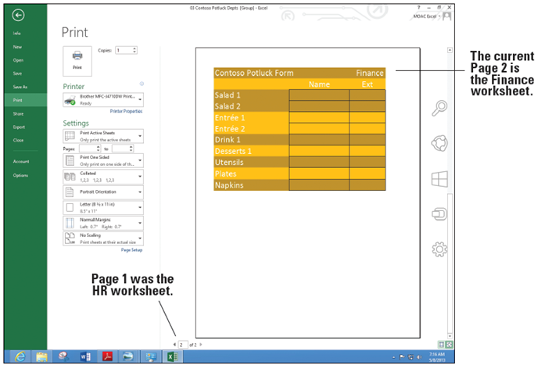
  - Click the Return to document button.
  - While the HR worksheet is active, hold down Ctrl and click on the Finance tab. Now both the HR and Finance worksheets are selected.
  - Click the FILE tab and click Print. Now in the Print Preview area, the bottom of the screen shows 1 of 2 with the HR worksheet preview. Click the right arrow to go to the second page and notice that the Finance worksheet previews (above).
  - Click the Return to document button to return to the workbook without printing.
- PAUSE. CLOSE the workbook without saving. LEAVE Excel open for the next exercise.
Step by Step 6: Print Selected Workbooks
- GET READY. With Excel open from the previous exercise, perform the following steps.
  - Click the FILE tab and click Open if it is not selected. Because you just used the 03 Contoso Potluck Depts workbook, it should be at the top of the list of the Recent Workbooks (below).
  - Click 03 Contoso Potluck Depts to open it.
  - Click the FILE tab and click Print.
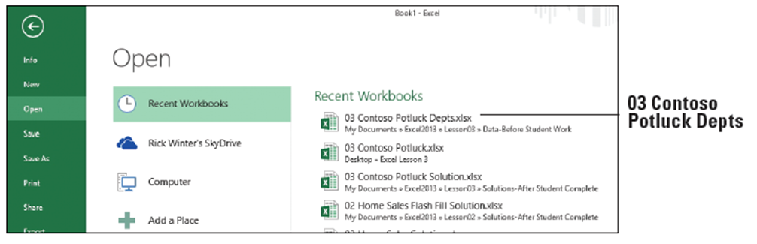
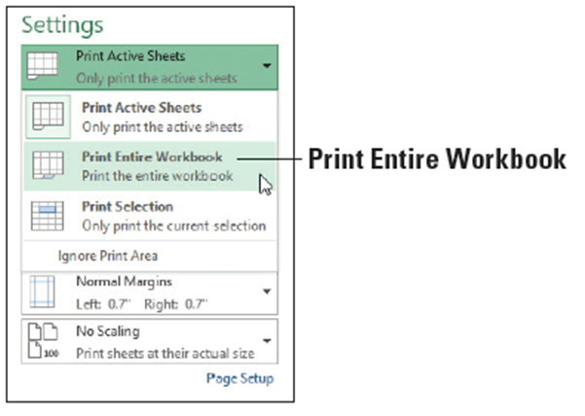
- Notice that the complete worksheet for HR does not display. This is because you did not save the workbook after you cleared the print area. Clear the print area as you did in Step 5 of the previous section and return to the Print tab of Backstage view.
- In the Print window’s Settings
options, click the Print Active
Sheets drop-down arrow and
click Print Entire Workbook
(right). You will not print at this
time.
- PAUSE. EXIT Excel and do not
SAVE the workbook.
Step by Step 7: Apply Print Options
- GET READY. LAUNCH Excel, OPEN 03 Contoso Potluck HR, and make sure the HR-P1 worksheet is selected.
  - Click the FILE tab and select Print (below). Notice that the worksheet is small and it might be nice to have lines for people to write in on a printed page.
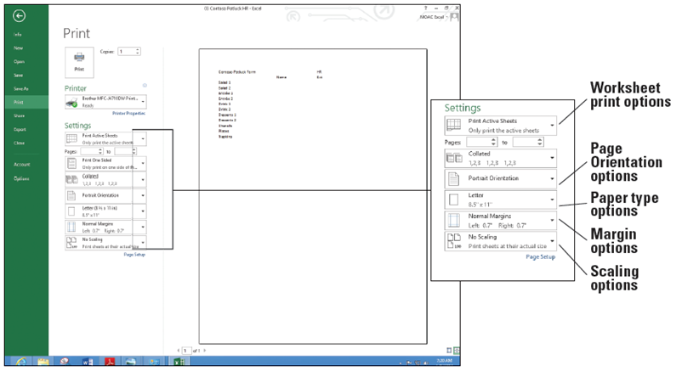
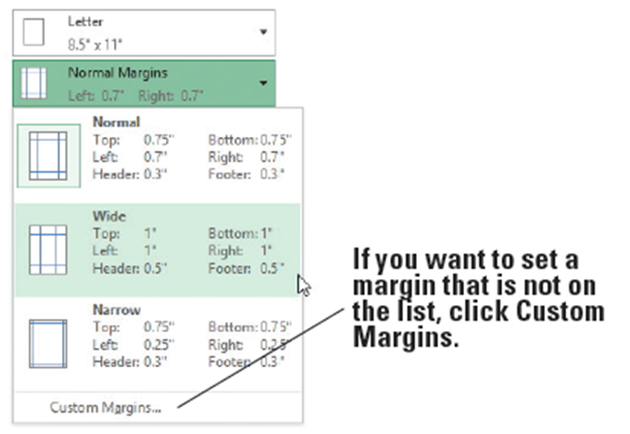
  - In the Settings section of the Print window, click the Margins drop-down and click Wide (below). The new margins will allow the worksheet to be hole-punched and put in a binder.
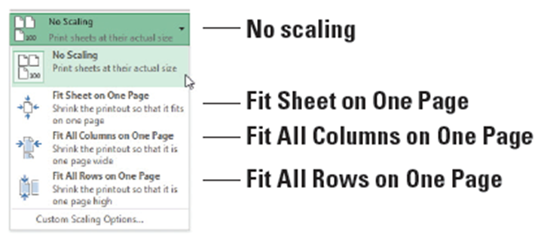
  - Click the Scaling drop-down and see the choices below (right).
The scaling options
ensure that all columns,
rows, or the entire
worksheet fit on one page.
- Current choice is No scaling, so the document prints the same size as the screen.
- If you want to fit everything that is on the worksheet on one page, select Fit Sheet on One Page.
- If there are just a couple of columns extra, click Fit All Columns on One Page. If there are just a couple of rows extra, click Fit All Rows on One Page.
  - In this case, you make the text larger without changing the font. Click Custom Scaling Options. The Page Setup dialog box opens.
  - Make sure that the Page tab is selected and select Landscape so the page prints horizontally.
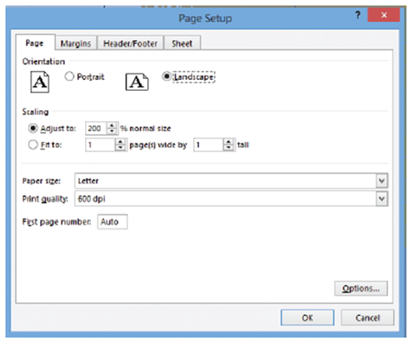
  - In the Scaling area, type 175
for the % normal size (right).
  - Click the Sheet tab and in the
Print section, select the Gridlines box.
  - Click OK to return to Backstage view. Notice that the bottom of the screen still says, "1 of 1," meaning that only one page will print and notice that Print Preview shows larger text with boxes around each cell (below).
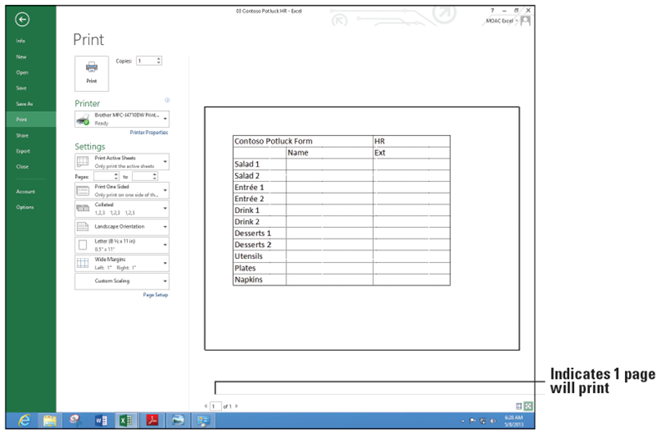
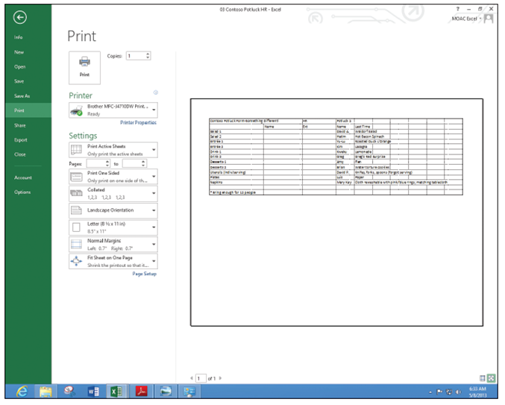
  - Without printing the document, click the Return to document button and then click the HR-P2 worksheet.
  - Press Ctrl + P to go to the Print tab of the Backstage view and notice that the bottom of the screen indicates that the document will print on two pages.
  - Change the Settings to print Landscape, to Fit Sheet on One Page, and add gridlines based on the previous steps in this section. Print Preview should look like the figure at right.
- SAVE the workbook as 03 Contoso Potluck HR Print Ready Solution.
- PAUSE. LEAVE the workbook open for the next exercise.
Step by Step 8: Change a Printer
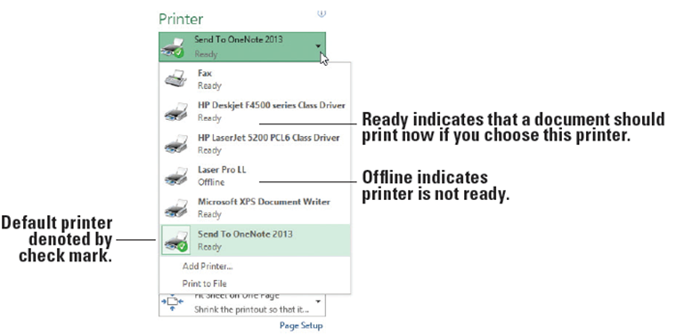
- GET READY. Continue with the previous workbook or if necessary, open 03 Contoso Potluck HR Print Ready Solution.
  - Press Ctrl + P to
display the Print tab
of the Backstage view.
  - Your current default
printer is displayed
in the Printer options
section of the Print
tab. Click the Printer
drop-down arrow to produce a menu of installed printers, similar to the one shown above. Your printers will be either Ready or Offline.
  - Click on a printer (other than your default printer) in the printer list. This printer should now be visible as your active printer. Should you attempt to print at this time with an inactive printer, you will get an error.
  - Once again, click the drop-down arrow for the printer, and select your default printer (the one with the checkmark).
- PAUSE. CLOSE your workbook and don't save if prompted.
Step by Step 9: Customize the Quick Access Toolbar
- GET READY. OPEN a blank workbook in Excel.
  - Click the FILE tab to access Backstage view.
  - In the navigation pane, click the Options tab. The Excel Options dialog box opens.
  - In the left pane of the dialog box, click Quick Access Toolbar to display the Quick Access Toolbar options (below). In the right pane, the list on the left includes the commands that you can add to the toolbar. The list on the right shows the commands that are currently included on the toolbar.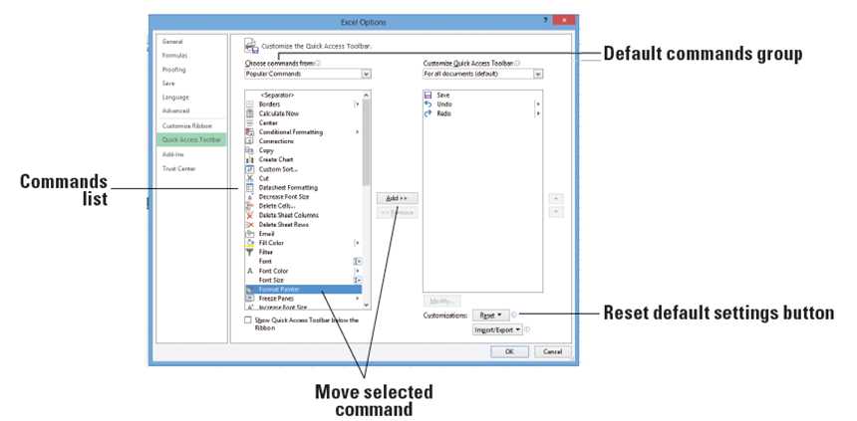
  - In the list on the left, scroll down and click Format Painter, and then click the Add button in the center of the two lists to add the Format Painter to the Quick Access Toolbar.
  - Using the same process, move five more commands you use often to the Quick Access Toolbar. When you are done, click OK to apply your changes (the changes don't take effect until you click OK).
  - Your Quick Access Toolbar should now include additional command buttons, much like the example shown below. Similarly, you can remove any command that you added to the toolbar. At any time, you can reset the toolbar to its default settings.
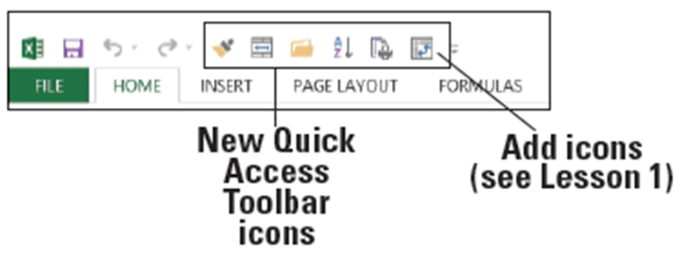
- PAUSE. CLOSE Excel.

Step by Step 10: Customize the Excel Default Settings
- GET READY. Continue with a blank workbook from the previous exercise.
  - Click on the FILE tab to access Backstage view.
  - In the navigation pane, click Options. By default, the Excel Options dialog box opens with the General options displayed.
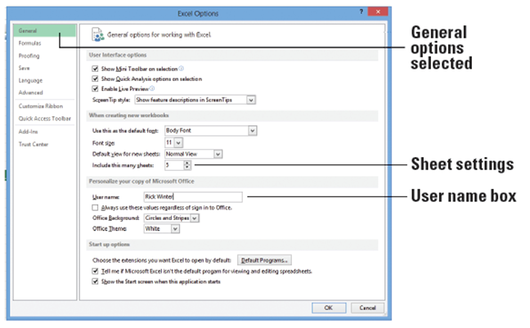
  - In the When creating new workbooks section, click in the Include this many sheets text box and type 5 to change the number of worksheets that appear by default in new workbooks.
  - In the Personalize your
copy of Microsoft Office
section, click the User
name box and type [your
first and last name] in the
text box (right). Click OK.
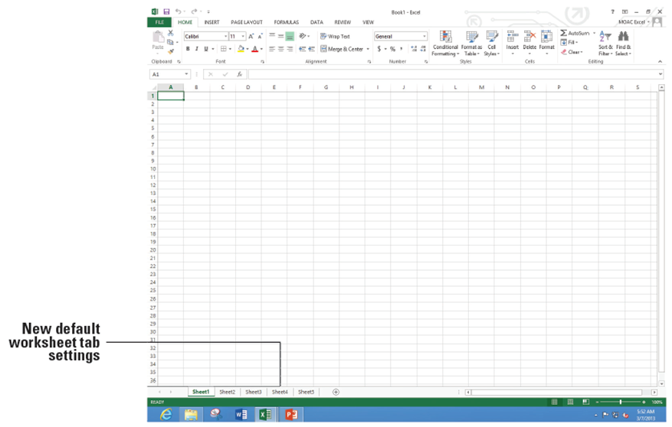
  - EXIT and RESTART Excel and select Blank workbook. Note that instead of one worksheet tab, you now have five in your workbook (below).
- PAUSE. LEAVE the workbook open for the next exercise.

Step by Step 11: Reset Default Settings, Ribbon, and Quick Access Toolbar
- GET READY. Continue with a blank workbook from the previous exercise.
  - Click the FILE tab, and click Options.
  - On the General tab, in the When creating new workbooks section, in the Include this many sheets box, type 1.
  - Click the Customize Ribbon tab.
  - In the bottom right of the dialog box, click the Reset button and then click Reset all customizations.
  - In the Confirmation dialog box, click Yes to clear all ribbon and Quick Access Toolbar customizations for this program.
  - Click OK to return to the workbook.
- PAUSE. LEAVE the workbook open for the next exercise.
Step by Step 12: Select a Template from the New Tab
- GET READY. If necessary, OPEN a blank workbook.
  - Click the FILE tab and click New. The New window displays as shown below, with a series of featured templates. (If the templates are not shown, click in the search bar and type in the desired template.) You already used the Blank workbook template in this book.

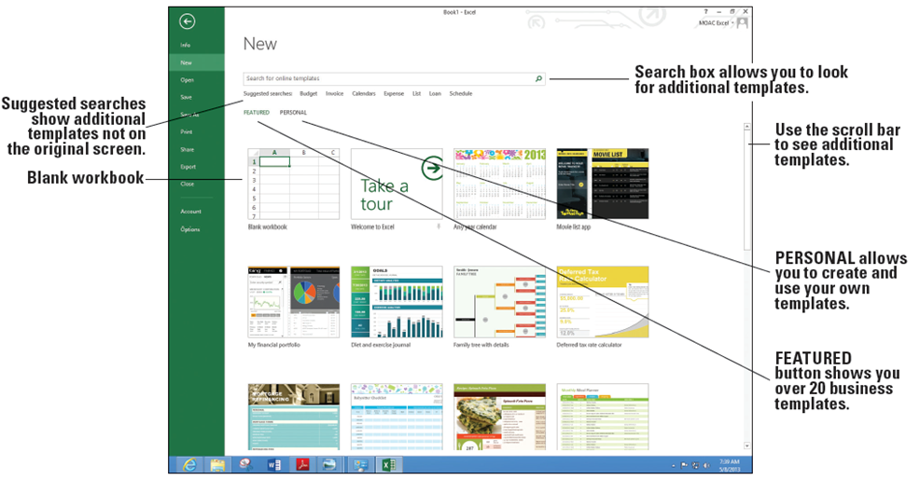
- Scroll down if necessary, and click on the Project Tracker icon. The figure below shows a larger window with a larger picture and description of the template.
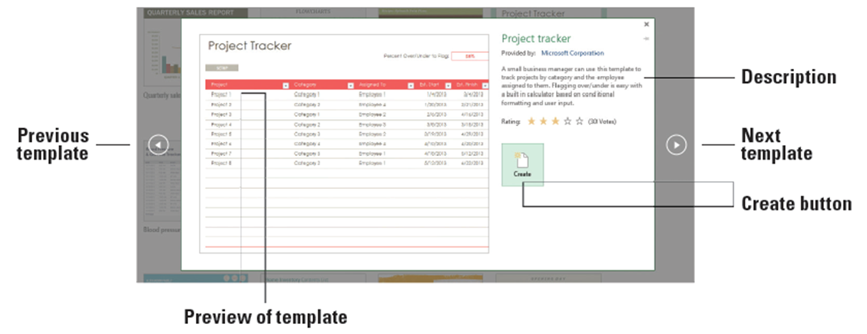
- Click the Create button. Excel might take a moment to download the workbook.
- Notice that there are two worksheets in this workbook: Project Tracker with the sample data you can change and Setup that allows you to input a list of categories and employees. When you are finished looking at this template, click FILE and click Close. If prompted, do not save changes.
- Click the FILE tab, click New, and scroll to the bottom of the templates list.
- Click the Any year calendar template and click the Create button.
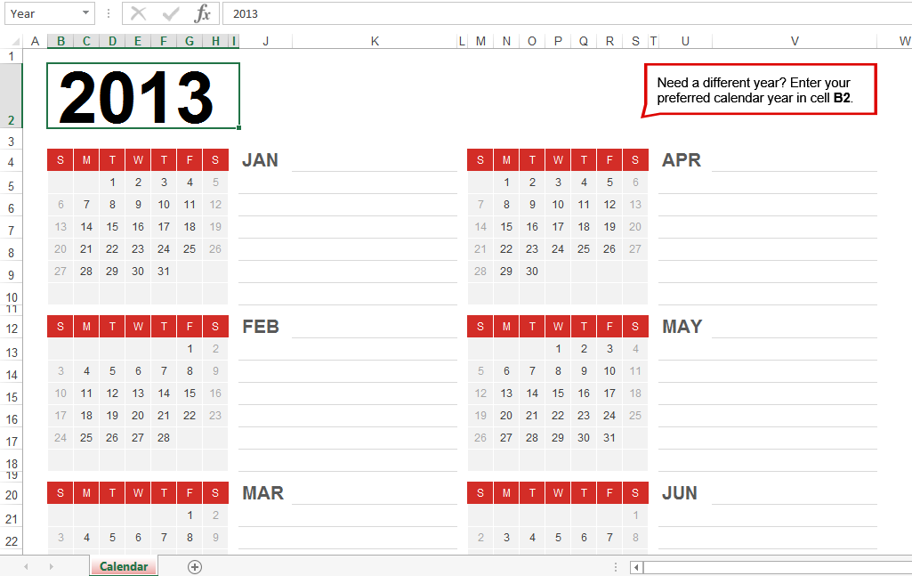
- Click cell that has the year 2013, and type [the current year].
- Scroll down to the current month, and make sure the dates coincide with actual days and dates.
- SAVE the workbook as 03 My Calendar Solution.
- Click the FILE tab and click New. Notice that the Any year calendar template appears as the third item on your list of templates because it was recently used.
- PAUSE. CLOSE the workbook and LEAVE Excel open for the next exercise.
Step by Step 14: Search for Additional Templates
- GET READY. If necessary, OPEN a blank workbook.
  - Click the FILE tab and click New. Notice the Suggested searches and Search for online templates box.
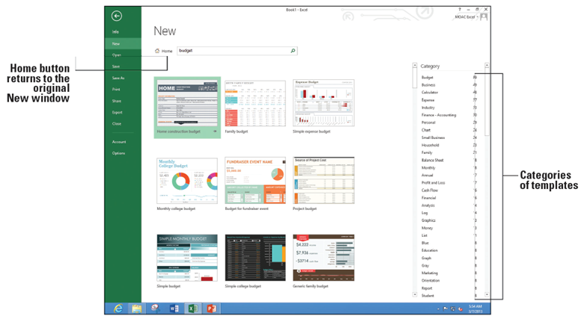
  - Click Budget on the Suggested searches row. As shown below, the New window changes to show templates specifically related to working with budgets.

  - Scroll back to the top of the New window and click Home to return to the original templates screen.
  - In the Suggested Searches row, click Calendars.
  - Scroll to the Student assignment planner and read the description. Close the template description window.
  - In the Search box, type College and press Enter. Scroll through the list of suggested templates for college students and open the Weekly college schedule template.
  - Type in [Today's date] in B1 and play with the workbook. (Go to the formula bar, and type date here.)
  - SAVE the workbook as 03 My Weekly Schedule Solution. Click Yes when prompted to save this as a macro-free workbook.
- PAUSE. EXIT Excel.

