Step by Step 1: Display Formulas
- GET READY. Before you begin these steps, LAUNCH Microsoft Excel and OPEN a new blank workbook.
  - Click cell A1.
  - Type =7+8*3/2-4 and press Enter. You just entered a formula.
  - Click cell A1. Notice that the result of the formula displays in the cell, but the formula itself appears in the formula bar (below).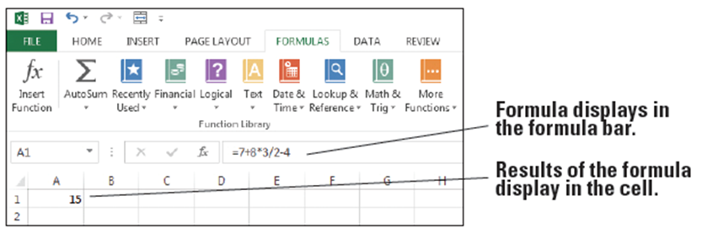
  - Double-click cell A1. The formula appears in both the active cell and the formula bar. You can edit the formula in this mode.
  - Press Enter.
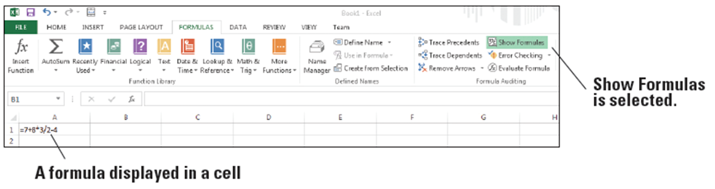
  - On the FORMULAS tab, in the Formula Auditing group, click Show Formulas. The formula in cell A1 displays (below).
  - Click Show Formulas again to turn off formula display.
  - SAVE the workbook as 04 Formula Practice Solution.
- PAUSE. LEAVE the workbook open to use in the next exercise.
Step by Step 2: Understand Order of Operations
- GET READY. USE the worksheet from the previous exercise.
  - Click cell A1 to make it the active cell.
  - Click in the formula bar.
  - Insert parentheses around 7 + 8.
  - Insert parentheses around 3 / 2.
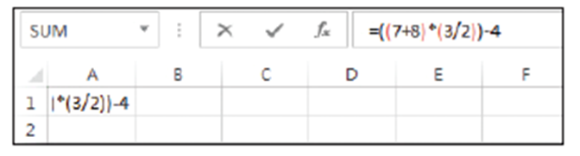
  - Insert parentheses around (7 + 8) * (3 / 2), as shown below. Press Enter. The result in A1 changes to 18.5.
  - SAVE the workbook as 04 Order of Operations Solution and CLOSE it.
- PAUSE. LEAVE Excel open to use in the next exercise.
Step by Step 3: Create a Formula that Performs Addition
- GET READY. LAUNCH Microsoft Excel if it is not already open.
  - OPEN the 04 Budget Start data file for this lesson.
  - In cell A18, type January Rent plus Deposit and press Enter.
  - In cell B18, type the equal (=) sign, type 1200+500, and press Enter. This is the simplest way to enter an addition formula. Excel adds the values and displays the result, 1700, which is your first month’s rent plus a $500 deposit (below).
  - SAVE the workbook as 04 Budget Basic Formulas.
- PAUSE. LEAVE the workbook open to use in the next exercise.
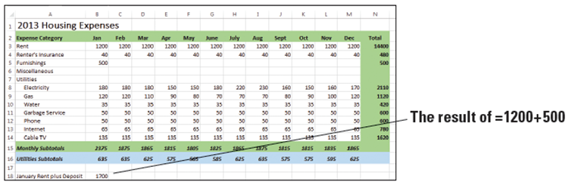
Step by Step 4: Create a Formula that Performs Subtraction
- GET READY. USE the worksheet you modified in the previous exercise.
  - Double-click cell A18.
  - Click after the word “Deposit,” type , minus Discount, and press Enter.
  - Right-click cell A18, select Format Cells, click the Alignment tab, select the Wrap text check box, and click OK. Now you can see all of the new text added to A18.
  - Click cell B18 to make it the active cell.
  - Click in the formula bar.
  - Position the cursor immediately after =1200+500, type -100, and press Enter. Your landlord gave you a $100 discount for moving into your rental home early, so you are subtracting $100 from your first month’s rent. The value in cell B18 changes to 1600 (below).
  - SAVE the workbook.
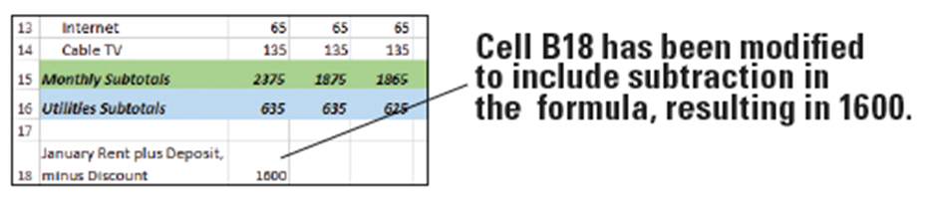
- PAUSE. LEAVE the workbook open to use in the next exercise.
Step by Step 5: Create a Formula that Performs Multiplication
- GET READY. USE the worksheet you modified in the previous exercise.
  - In cell A19, type Annual Rent per Lease and press Enter.
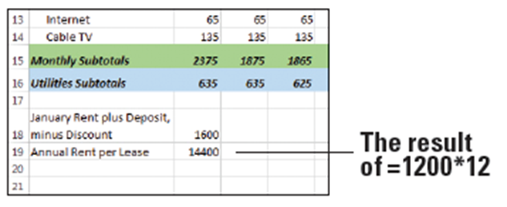
  - In cell B19, type =1200*12 and press Enter. The result displays in cell B19, which is the total amount of rent you will pay in one year (below).
  - SAVE the workbook.
- PAUSE. LEAVE the work-
book open to use in the
next exercise.
Step by Step 6: Create a Formula that Performs Division
- GET READY. USE the worksheet you modified in the previous exercise.
  - In cell A20, type Average Electricity and press Enter.
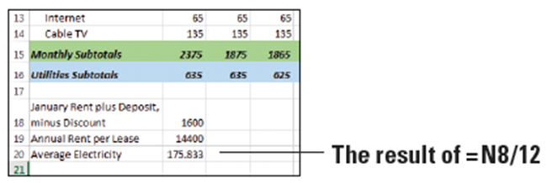
  - In cell B20, type =N8/12 and press Enter. The result displays in cell B20, which is the average amount of money you will pay for electricity in one year (below).
  - SAVE the workbook
as 04 Budget Basic
Formulas Solution and
CLOSE it.
- PAUSE. LEAVE Excel open to use in the next exercise.

Step by Step 7: Use Relative Cell References in a Formula
- GET READY. USE the workbook named 04 Budget Cell References.
  - Click cell B18.
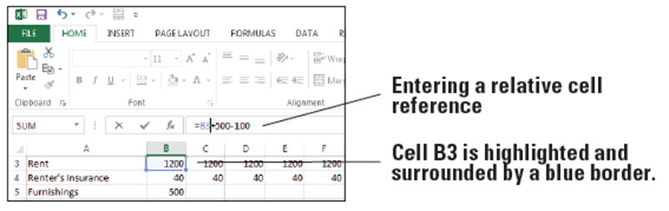
  - Click in the formula bar and replace 1200 with cell B3. Notice that cell B3 is highlighted and surrounded by a blue border while you’re modifying the formula (below).

  - Press Enter. The formula in cell B18 now uses a relative cell reference to cell B3.
  - Copy cell B18 to cell B21. The displayed result changes to 400.
  - Notice in the formula bar that the formula in cell B21 is =B6+500-100, but the formula you copied is =B3+500-100. That’s because the original cell reference of cell B3 changed to cell B6 when you copied the formula down three cells, and cell B6 is blank. The cell reference is adjusted relative to its position in the worksheet.
  - An alternate way to use a cell reference is to click the cell being referenced while creating or modifying a formula. With cell B21 still active, click in the formula bar and select cell B6.

  - Click cell B3. Cell B3 becomes highlighted and surrounded by a blue dashed border, and cell B3 appears in the formula bar rather than cell B6 below). Press Enter.
  - SAVE the workbook.
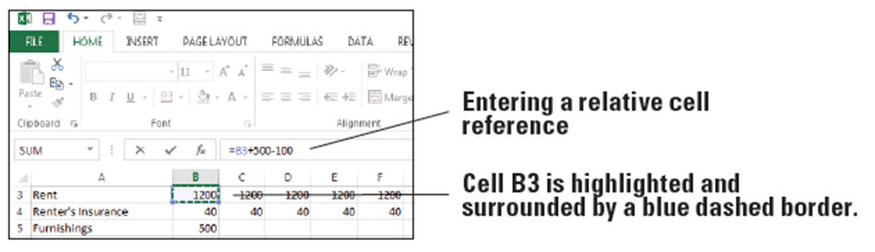
- PAUSE. LEAVE the workbook open to use in the next exercise.
Step by Step 8: Use an Absolute Cell Reference in a Formula
- GET READY. USE the worksheet you modified in the previous exercise.
  - Click cell B18.
  - Click in the formula bar and insert dollar signs in the B3 cell reference so it looks like $B$3.
  - Press Enter. The formula in cell B18 now uses an absolute cell reference to cell B3.
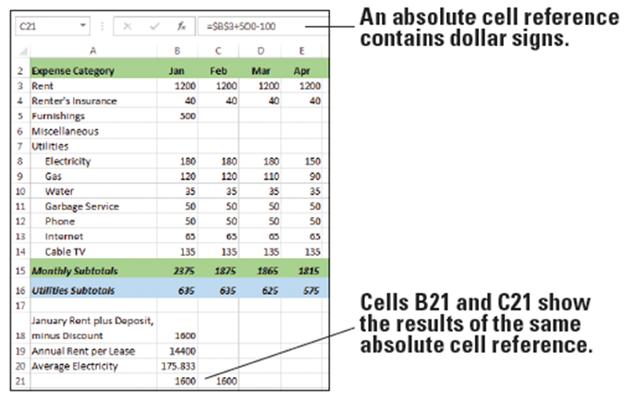
  - Copy cell B18 to cell B21. The displayed result is 1600, which matches B18.
  - Copy cell B21 to cell C21. The displayed result is still 1600.
  - Notice in the formula bar that the formulas in cells B21 and C21 are both =$B$3+500-100. The figure below shows the formula for cell C21. Regardless of where you copy the formula in the worksheet, the formula still refers to cell B3.
  - SAVE the workbook.
- PAUSE. LEAVE the workbook open to use in the next exercise.
Step by Step 9: Use a Mixed Cell Reference in a Formula
- GET READY. USE the worksheet you modified in the previous exercise.
  - Click cell B21.
  - Click in the formula bar and delete the dollar sign before 3 in the formula so it looks like $B3.
  - Press Enter. The formula in cell B21 now uses a mixed cell reference.
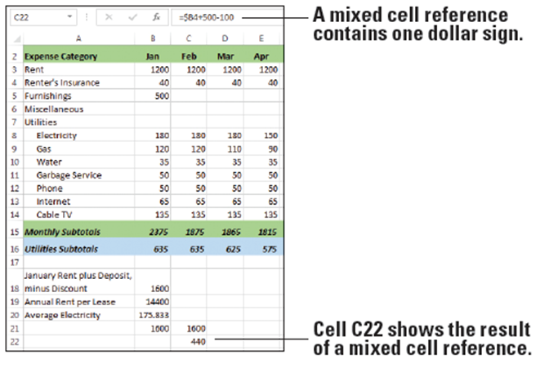
  - Copy cell B21 to cell C22. The displayed result is 440, which is different from the result in B21. That’s because the formula in C22 references cell B4 (see below). The dollar sign before the B in the formula is absolute, but the row number is relative.
  - Delete the contents of cell B21, cell C21, and cell C22.
  - SAVE the workbook.
- PAUSE. LEAVE the workbook open to use in the next exercise.

Step by Step 10: Refer to Data in Another Worksheet
- GET READY. USE the worksheet you modified in the previous exercise.
  - Click the Summary sheet tab in the 04 Budget Cell References workbook.
  - Click cell D8. You want the average payment for electricity to appear in this cell, similar to the content that appears in B20 in the Expense Details worksheet. However, your formula must reference the Expense Details worksheet to gather the data.
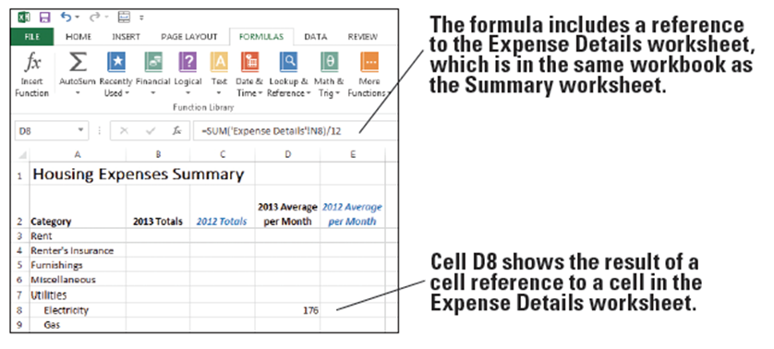
  - Type =SUM('Expense Details'!N8)/12 and press Enter. This formula divides the value of cell N8 in the Expense Details worksheet by 12. The result is 176, rounded due to cell formatting applied to the worksheet (see below).
  - SAVE the workbook.
- PAUSE. LEAVE the workbook open to use in the next exercise.
Step by Step 11: Reference Data in Another Workbook
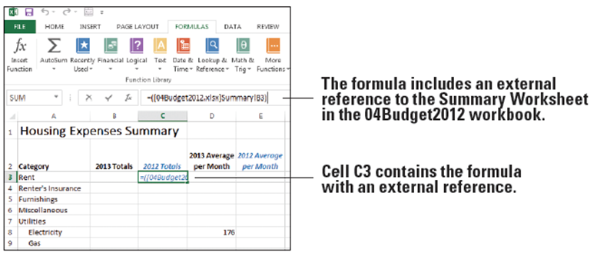
- GET READY. USE the worksheet you modified in the previous exercise.
  - Open a second
workbook file
named
04Budget2012.
  - In 04 Budget Cell
References, on the
Summary sheet, click cell C3.
  - Type =([04Budget2012.xlsx]Summary!B3), as shown in Figure 4-14, and press Enter. The formula links to cell B3 on the Summary sheet in the workbook named 04Budget2012.
  - SAVE the workbook as 04 Budget Cell References Solution and CLOSE it.
  - CLOSE 04Budget2012.
- PAUSE. LEAVE Excel open to use in the next exercise.
Step by Step 12: Name a Range of Cells
- USE the workbook named 04 Budget Ranges.
  - Click the Expense Details sheet tab.
  - Select B3:B14. These are the cells to be named.
  - Click in the Name box, to the left of the formula bar.
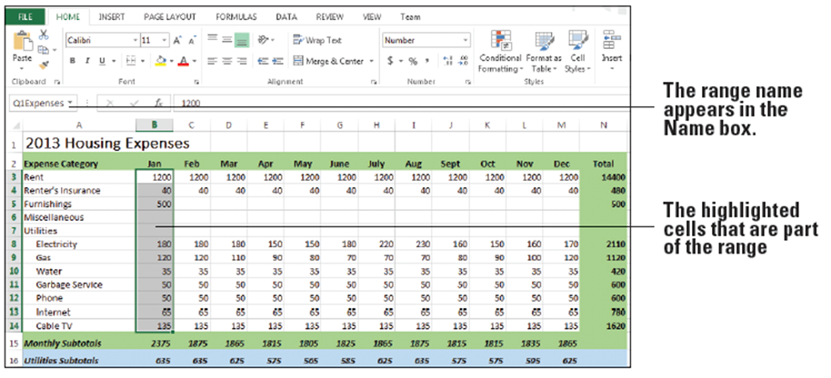
  - Type a one-word name for the list, such as Q1Expenses, and press Enter. The range name appears in the Name box (see below). Excel saves this name and uses it in any subsequent reference to this range. (Don’t worry about the apparent misnaming of the range. You modify this range to include additional months in an exercise later in this lesson.)
  - An alternative way to name a range is to use the New Name dialog box. Select B16:M16.
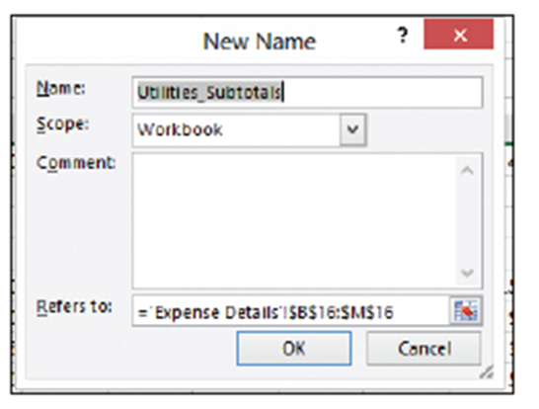
  - On the FORMULAS tab, in the Defined Names group, click Define Name. The New Name dialog box appears (right).
  - Excel uses the row heading as the range name, shown in the Name text box. You can change the name if you like. For this exercise, leave the default name.
  - Select B16:M16, FORMULAS tab, in the defined Names group, Click Define Name.
  - The name Utilities_Subtotals is in the name box for the range B16:M16. Click OK.
  - Select N2:N14. On the FORMULAS tab, in the Defined Names group, click Define Name. The name is Total.
  - Click OK. The range is saved with the name Total.
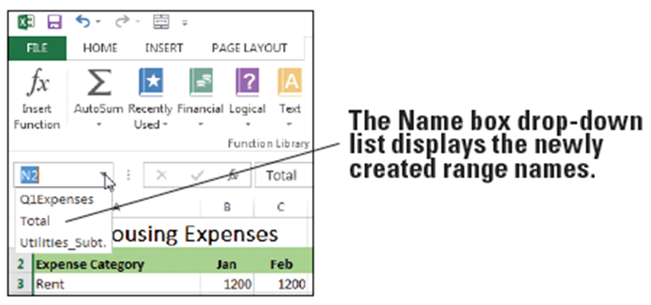
  - Open the Name box drop-down list (below). You have three named ranges from which to select.
  - SAVE the workbook.
- PAUSE. LEAVE the workbook open to use in the next exercise.

Step by Step 13: Change the Size of a Range
- USE the worksheet you modified in the previous exercise.
  - Click the Expense Details sheet, if it’s not already active.
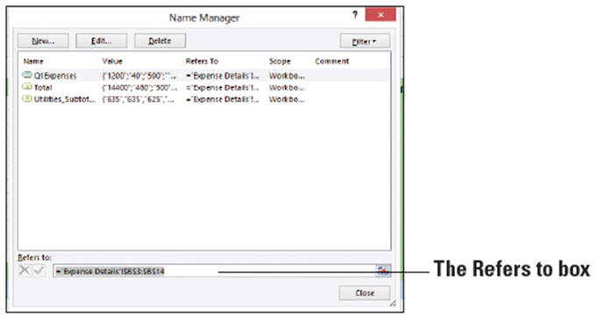
  - On the FORMULAS tab, in the Defined Names group, click Name Manager.
  - Select Q1Expenses
in the list.
  - Highlight everything
in the Refers to box
at the bottom of the
dialog box (right).
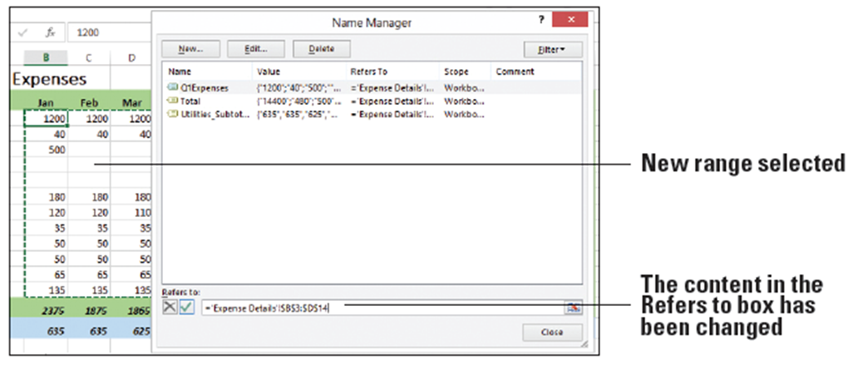
  - In the Expenses Details worksheet, select B3:D14. The content in the Refers to box in the Name Manager dialog box reflects the new range (below).
  - Click Close, and then click Yes when asked if you want to save your changes.
  - SAVE the workbook.
- PAUSE. LEAVE the workbook open to use in the next exercise.
Step by Step 14: Create a Formula that Operates on a Named Range
- USE the worksheet you modified in the previous exercise.
  - In the Expense Details sheet, click A21.
  - Type First Quarter Expenses and press Enter.
  - In B21, type =SUM(.
  - On the FORMULAS tab, in the Defined Names group, click Use in Formula.
  - Select Q1Expenses from the list (see below), type ) to close the equation, and press Enter. The total amount of expenses for January through March appears in B21.
  - SAVE the workbook.
- PAUSE. LEAVE the workbook open to use in the next exercise.
