Step by Step 1: Insert Cells into a Worksheet
- GET READY. Launch Microsoft Excel.
  - OPEN the 06 Patient Visits Insert Delete data file for this lesson. Click Enable Editing, if prompted.
  - Click in cell G5 to make it the active cell.
  - On the HOME tab, in the Cells group, click the top part of the Insert button, as shown below. All cells in column G beginning with G5 shift down one cell.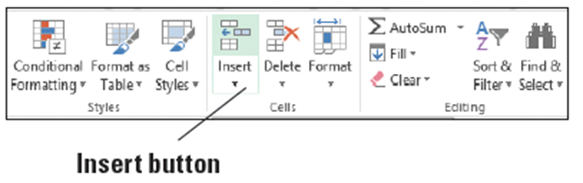
  - Type 590 and press Enter.
  - Now let’s insert a range of cells. Select O3:O9.
  - On the HOME tab, in the Cells group, click the Insert button arrow and then select Insert Cells.
  - In the Insert dialog box, ensure the Shift cells right option is selected, as shown below. Click OK.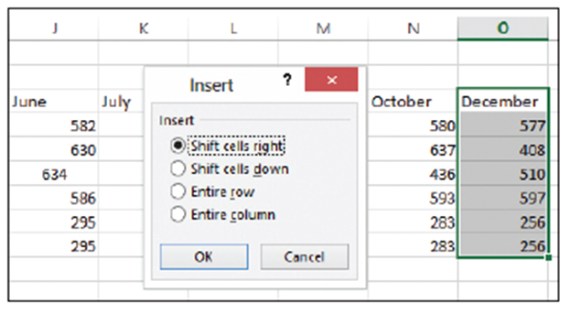
  - Notice that the cells formerly in O3:O9 shift one cell to the right. The worksheet should look similar to the figure below.
  - In cell O3, type November.
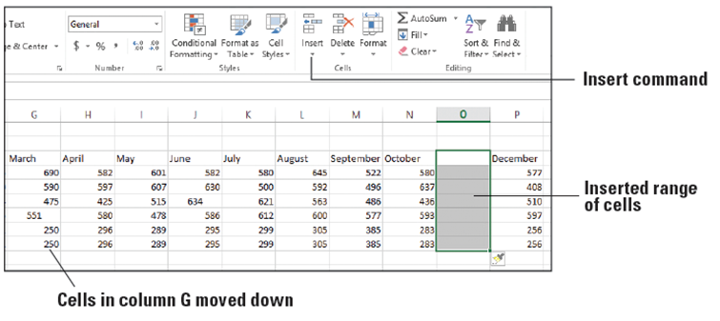
  - Enter the following numbers in cells O4 through O9:
  - 480
  - 502
  - 446
  - 577
  - 302
  - 302
  - SAVE the workbook.
- PAUSE. Leave the workbook open to use in the next exercise.
Step by Step 2: Delete Cells from a Worksheet
- GET READY. USE the workbook you modified in the previous exercise.
  - Click cell P7 to make it the active cell.
  - On the HOME tab, in the Cells group, click the Delete button arrow, and then select Delete Cells.
  - In the Delete dialog box, select the Shift cells left option and click OK. The content in cell Q7 shifts to the left and appears in cell P7.
  - Highlight the range A8:P8.
  - Right-click the selection, which is a duplicate of the next row of data, and select Delete from the shortcut menu.
  - In the Delete dialog box, ensure Shift cells up is selected and click OK.
  - To delete a range of cells in a column, highlight the range D3:D8, and on the HOME tab, in the Cells group, click the Delete button arrow and then select Delete Cells. Ensure Shift cells left is selected, and click OK. The worksheet should look similar to the figure below.
  - SAVE the workbook as 06 Patient Visits Insert Delete Solution and CLOSE the file.
- PAUSE. Leave Excel open to use in the next exercise.
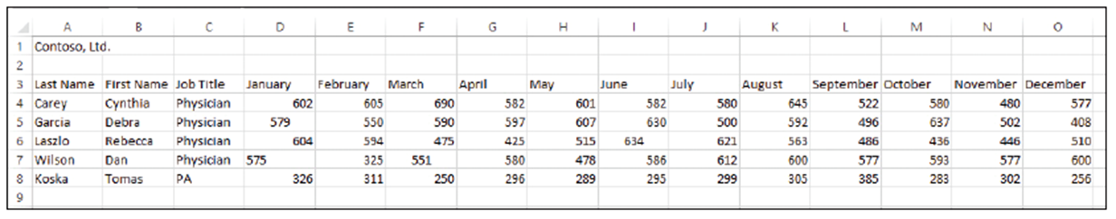
Step by Step 3: Align Cell Contents
- GET READY. LAUNCH Excel if it is not already running.
  - OPEN the 06 Patient Visits Format Cells data file for this lesson. Click Enable Editing, if prompted.
  - Select A3:O3.
  - On the HOME tab, in the Alignment group, click the Center button, as shown below. The column labels are now horizontally centered.
- Select D4:O8, and then on the HOME tab, in the Alignment group, click the Align Right button. All numbers in the months columns are now right-aligned.
- SAVE the workbook.
- PAUSE. Leave the workbook open to use in the next exercise.
Step by Step 4: Indent Cell Contents
- GET READY. USE the workbook you saved in the previous exercise.
  - Select C4:C8.
  - On the HOME tab, in the
Alignment group, click the Increase Indent button, as shown above. The cell content moves toward the right cell border.
  - Click the Decrease Indent button. The cell content moves back toward the left cell border.
- PAUSE. Leave the workbook open to use in the next exercise.
Step by Step 5: Change Text Orientation
- GET READY. USE the workbook from the previous exercise.
  - Select A3:O3.
  - Click the Orientation button to open the menu, as shown below.
  - Select Angle Counterclockwise. The column heading labels appear angled from lower left to upper right within each cell.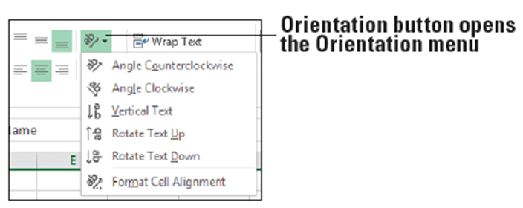
  - Click the Orientation button, and select Angle Clockwise. The column heading labels appear angled from upper left to lower right.
  - Click the Orientation button, and select Vertical Text. The column heading labels appear in a vertical line from top to bottom.
  - Click the Orientation button, and select Rotate Text Up and then Rotate Text Down to see how these settings affect the text.
  - Click the Orientation button, and select Format Cell Alignment. In the Format Cells dialog box, enter 0 in the Degrees box and click OK. The column heading labels return to their original orientation.
PAUSE. Leave the workbook open to use in the next exercise.

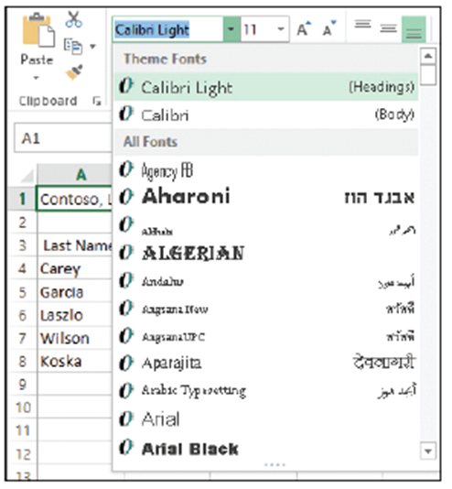
Step by Step 6: Choose Fonts and Font Sizes
- GET READY. USE the workbook from the previous exercise.
  - Click A1.
  - On the HOME tab, in the Font
group, open the Font menu
and select the first option under
Theme Fonts at the top, Calibri
Light, as shown at right. Only
the text in cell A1 changes to
the new font.
  - With cell A1 still selected, open the Font Size menu indicated below. Select 18. The font size of the text changes to 18 point.
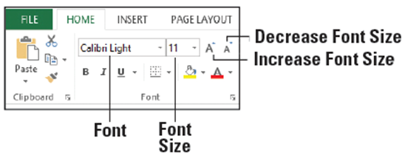
  - Select A3:O3 and from
the Font list, select Arial.
  - With A3:O3 still selected,
change the Font Size to 10. The column heading labels are now in Arial 10-point.
  - SAVE the workbook.
- PAUSE. Leave the workbook open to use in the next exercise.
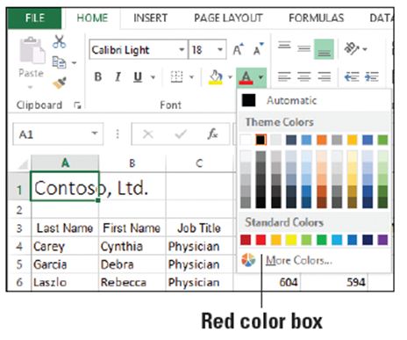
Step by Step 7: Change Font Color
- GET READY. USE the workbook you saved in the previous exercise.
  - Click A1.
  - Open the Font Color menu, as
shown at right, and under Standard
Colors, click the Red color box. The
text “Contoso, Ltd.” now has a red
font color.
  - Select A3:O3, open the Font Color
menu, and click the Blue color box
under Standard Colors (third from the right).
  - SAVE the workbook.
- PAUSE. Leave the workbook open to use in the next exercise.
Step by Step 8: Apply Special Character Attributes
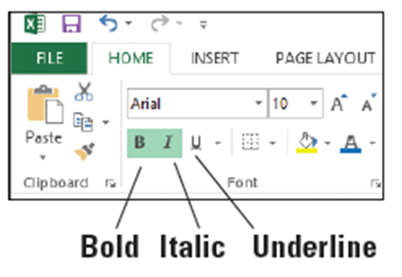
- GET READY. USE the workbook you saved in the previous exercise.
  - Select A3:O3.
  - In the Font group, click the Bold button, and then click the Italic button, as shown below. The column labels appear in bold and italics.
- Select A4:B8 and click the Bold button. The first and last names are now bolded.
- SAVE the workbook.
- PAUSE. Leave the workbook open to use in the next exercise.
Step by Step 9: Fill Cells with Color
- GET READY. USE the workbook you saved in the previous exercise.
  - Select A3:O3.
  - In the Font group, click the Fill Color button arrow, as shown below. The Theme Colors and Standard Colors palettes appear. 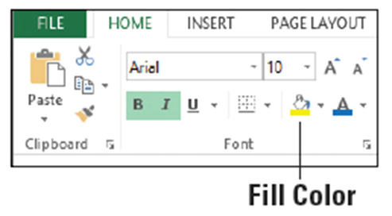
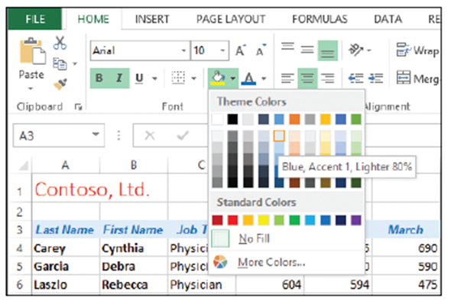
  - Select the Blue, Accent 1,
Lighter 80% color box, as
shown at right. A light blue
background is applied to
the column heading row.
  - SAVE the workbook as
06 Patient Visits Format
Cells Solution and CLOSE
the file.
- PAUSE. Leave Excel open to use in the next exercise.
Step by Step 10: Apply Number Formats
- GET READY. With Excel running, perform these actions:
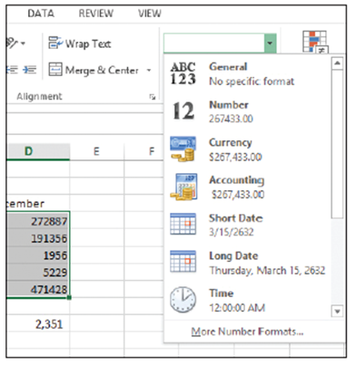
  - OPEN the 06 Contoso Revenue data file for this lesson. Click Enable Editing, if prompted.
  - Ensure that Sheet1 is the active sheet.
  - Select B4:D8. This data should be formatted as General, without commas or decimal places. On the HOME tab, in the Number
group, open the Number Format
menu as shown at right.
  - Select Currency. The numbers are
now formatted as dollars, with two
decimal places to represent cents.
  - With B4:D8 still selected, in the
Number Format menu, select
Accounting. This format left-aligns the dollar sign in each cell.
  - In the Number group, click the Decrease Decimal button twice to display no decimal places. The Increase Decimal and Decrease Decimal buttons are shown below. The numbers are now rounded to whole dollars.
  - Click in a blank cell, such as A11.
  - Click Sheet2.
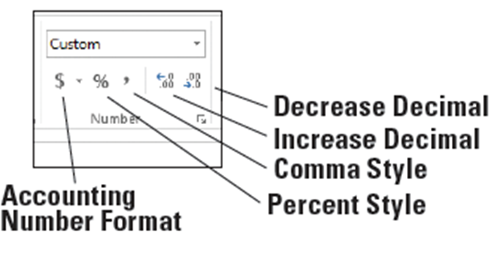
  - Select B6:B11.
  - In the Number group, click the Comma Style button. Notice that the numbers are formatted with a thousands separator and two decimal places but no dollar sign.
  - With B6:B11 still selected, in the Number group, click the Accounting Number Format button, and then click the Decrease Decimal button twice. These actions make the current range consistent with the number format on Sheet1.
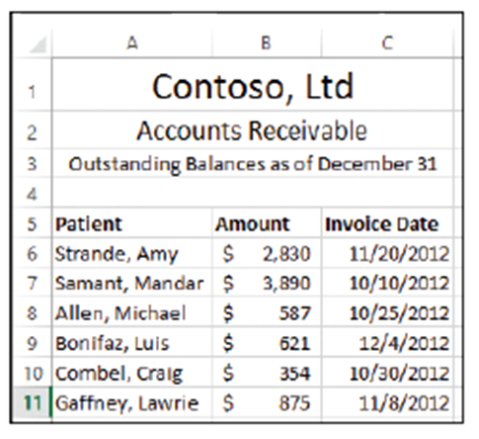
  - Select C6:C11.
  - In the Number Format menu, select Short Date. The dates are now in the mm/dd/yyyy format.
  - Manually decrease the width
of column C to eliminate extra
space, similar to the figure at
right.
  - SAVE the workbook.
PAUSE. Leave the workbook open
to use in the next exercise.
Step by Step 11: Wrap Text in a Cell
- GET READY. USE the workbook you saved in the previous exercise.
  - Click Sheet1. Notice that the content in two cells in column A cannot be fully displayed because of length.
  - Click A4, and then hold down the Ctrl key and click A7. Both cells—A4 and A7—are selected.

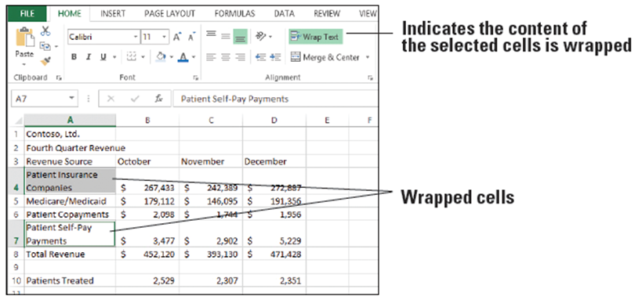
  - On the HOME tab, in the Alignment group, click the Wrap Text button. The text in both cells wraps to a second line without affecting the column width, as shown below. Notice that the Wrap Text button takes on a green background, indicating that the text in the current cell is wrapped.
- SAVE the workbook.
- PAUSE. Leave the workbook open to use in the next exercise.
Step by Step 12: Merge and Split Cells
- GET READY. USE the workbook you saved in the previous exercise.
  - On Sheet1, select A1:D1.
  - On the HOME tab, in the Alignment group, click the main part of the Merge & Center button. The company name remains in a single cell, which is now centered across the columns.
  - Select A2:D2.
  - On the HOME tab, in the Alignment group, open the Merge & Center menu. Select Merge & Center. The heading remains in a single cell, which is now centered across the columns. This step has the same effect on A2:D2 as Step 2 had on A1:D1.
  - Select A3:D3.
  - Select Merge & Center from the Merge & Center menu.
  - Read the error message that appears and click OK.
  - Only the heading in the first column remains, which is not the effect we want. Press Ctrl + Z to undo the last change and restore the headings (below).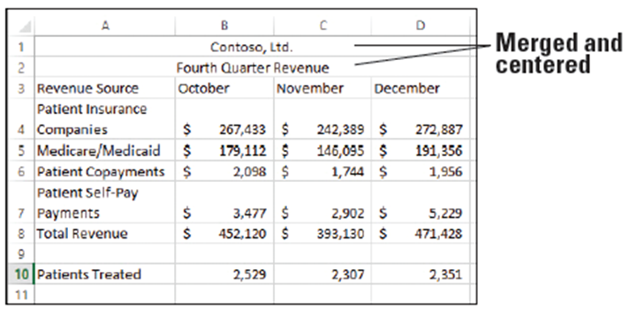
- SAVE the workbook.
- PAUSE. Leave the workbook open to use in the next exercise.
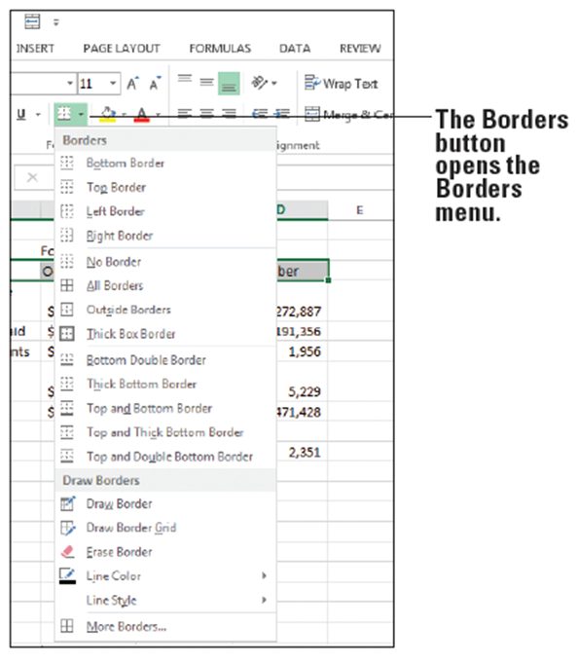
Step by Step 13: Place Borders around Cells
- GET READY. USE the workbook you saved in the previous exercise.
  - On Sheet1, select A3:D3.
  - On the HOME tab, in the Font
group, click the Borders button
to open the Borders menu,
as shown at right.
  - Select Top and Bottom
Border. The selected text now
has a top and bottom border.
  - With A3:D3 still selected, open
the Borders menu and select
More Borders.
  - In the Format Cells dialog box, click the Border tab, if necessary.
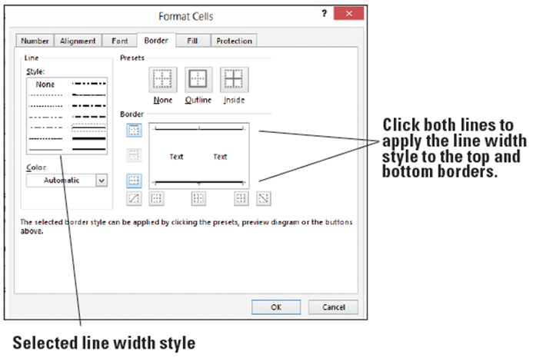
  - Click a thicker line
weight, such as the
fifth line in the second
column under Style.
Then click the top and
bottom border lines
shown in the preview
to the right to apply
the thicker line. See above.
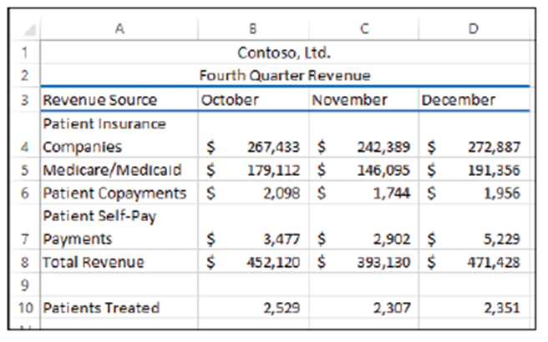
- Open the Color list and under Standard Colors, select the Blue color box (third from right under Standard Colors), and then click the top and bottom border lines shown in the preview to the right to apply the color. Click OK and then click in a blank cell so you can view the result. See right.
- SAVE the workbook
as 06 Contoso
Revenue Solution and
CLOSE the file.
- PAUSE. Leave Excel open
to use in the next exercise.
Step by Step 14: Use the Format Painter to Copy Formatting
- GET READY. LAUNCH Excel if it is not already running.
  - OPEN the 06 Contoso Painter Paste Special data file for this lesson. Click Enable Editing, if prompted.
  - Click Sheet2.
  - Click in cell A5.
  - On the HOME tab, in the Alignment group, click the Center button.
  - On the HOME tab, in the Clipboard group, click the Format Painter button. The mouse pointer changes to plus sign with a paint brush, as shown below.
  - Drag over B5:C5. The formatting from A5 is applied to B5 and C5.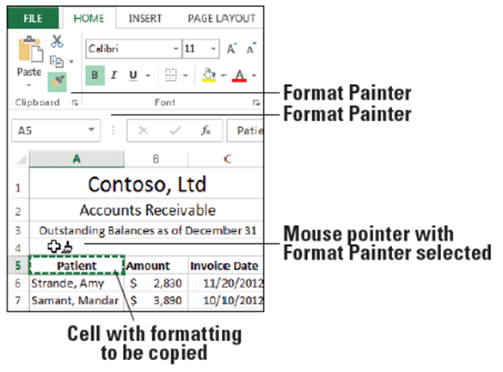
  - If Format Painter is still active, click the Format Painter button again or press Esc to turn off the Format Painter.
  - SAVE the workbook.
- PAUSE. Leave the workbook open to use in the next exercise.
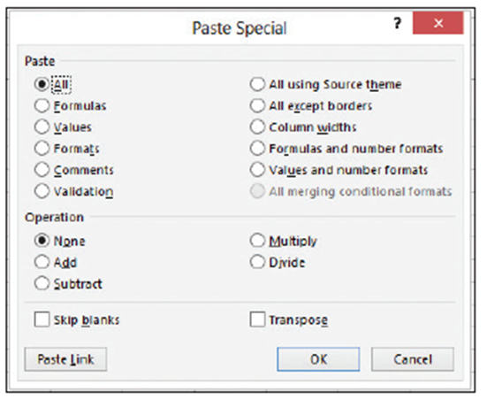
Step by Step 15: Understand Paste Special Options
- GET READY. USE the workbook
you saved in the previous exercise.
  - Ensure you are on Sheet2.
  - In cell A12, type
Jacobsen, Lola.
  - Select B11:C11.
  - Press Ctrl + C to copy the
selection to the Clipboard.
  - Right-click in cell B12 and select Paste Special from the shortcut menu. The Paste Special dialog box opens, as shown above.
  - Select Formats and click OK. Only the formatting from B11:C11 is applied to B12:C12.
  - In B12, type 1534 and press Enter. The content is formatted the same as B11.
  - In C12, type 12/15/12 and press Enter. The content takes on the same date format as C11.
  - Click in A13 and type the label Total.
  - Click in B13, and on the HOME tab, in the Editing group, click the AutoSum button, and press Enter. The values in B6:B12 are totaled.
  - Click in B13 and press Ctrl + C to copy the selection to the Clipboard.
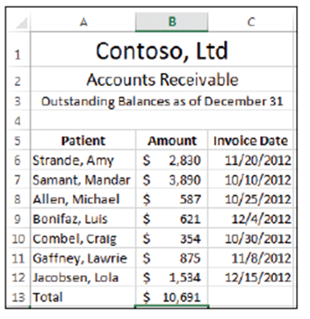
- Right-click in B14, select Paste Special, in the Paste Special dialog box, select Values, and then click OK. Press Esc to cancel the moving border in cell B13. Only the value of the formula in B13 was copied to B14, not the formula itself or any cell formatting.
- Delete the content in cell B14. See right.
- SAVE the workbook as 06 Contoso
Painter Paste Special Solution and
CLOSE the file.
- PAUSE. Leave Excel open to use in the
next exercise.
Step by Step 16: Apply Cell Styles
- GET READY. LAUNCH Excel if it is not already running.
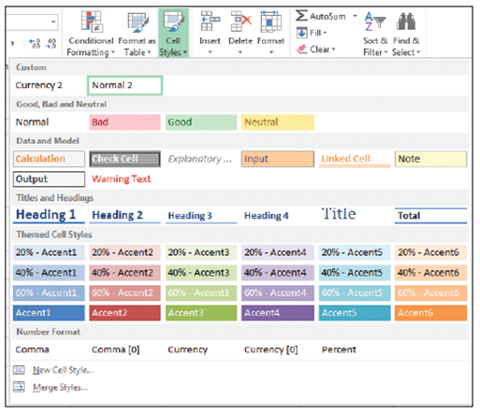
  - OPEN the 06 Contoso Cell Styles data file for this lesson. Click Enable Editing, if prompted.
  - Click Sheet1.
  - Select cell A1.
  - On the HOME tab, in the
Styles group, open the
Cell Styles menu. The Cell
Styles gallery appears, as
shown at right.
  - In the Titles and Headings section, select the Heading 1 style to apply it to the first cell of the worksheet.
  - Select cell A2.
  - Open the Cells Styles gallery and in the Themed Cell Styles section, select Accent1. A blue background with white text is applied to cell A2.
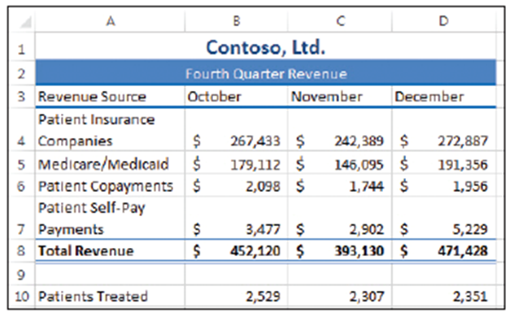
  - Select A8:D8.
  - Open the Cells Styles gallery and in the Titles and Headings section, select Total. A thin blue border appears above A8:D8, and a double underline appears under the range of cells. Select a blank cell to see the results. See right.
  - SAVE the workbook.
- PAUSE. Leave the workbook
open to use in the next
exercise.
Step by Step 17: Customize a Cell Style
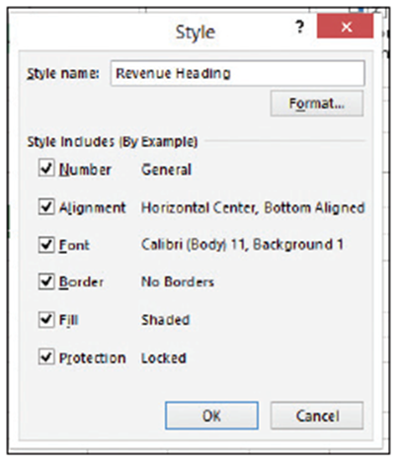
- USE the workbook you saved in the previous exercise.
  - On Sheet1, click A2.
  - On the HOME tab, in the Styles group, open the Cell Styles menu and select New Cell Style near the bottom of the menu. The Style dialog box opens.
  - In the Style name text box, enter
Revenue Heading, as shown
at right.
  - Click the Format button.
  - Click the Font tab, in the Font style list, select Bold Italic, and click OK.
  - Click OK to close the Style dialog box.
  - With A2 still selected, open the Cell Styles menu and click Revenue Heading to apply the new style.
  - SAVE the workbook as 06 Contoso Cell Styles Solution.
- PAUSE. Leave Excel open to use in the next exercise.
Step by Step 18: Insert a Hyperlink in a Cell
- GET READY. LAUNCH Excel if it is not already running.
  - OPEN the 06 Contoso Hyperlink data file for this lesson. Click Enable Editing, if prompted.
  - Click Sheet2.
  - Click in cell A15.
  - Type Company website: and press Enter.
  - Manually widen column A until all content displays properly in cell A15.
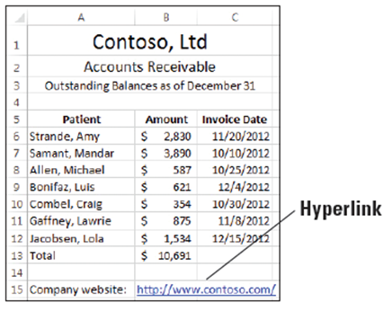
  - Right-click cell B15 and select Hyperlink from the shortcut menu.
  - In the Insert Hyperlink dialog box, type http://www.contoso.com/ in the Address box and click OK. The hyperlink appears in the worksheet, as shown below.
  - SAVE the workbook as
06 Contoso Hyperlink Solution.
- PAUSE. Leave the workbook open
to use in the next exercise.
Step by Step 19: Use a Hyperlink
- GET READY. USE the workbook you saved in the previous exercise.
  - Click the hyperlink in cell B15. Because the hyperlink points to a website, your default web browser opens.
  - Close the browser window.
- PAUSE. Leave the workbook open to use in the next exercise.
Step by Step 20: Remove a Hyperlink from a Cell
- GET READY. USE the workbook you saved in the previous exercise.
  - Right-click cell B15 and select Remove Hyperlink from the shortcut menu, as shown in Figure 6-35. The hyperlink is removed from the URL, but the URL text remains.
  - CLOSE the workbook without saving your changes.
- PAUSE. Leave Excel open to use in the next exercise.
Step by Step 21: Apply a Specific Conditional Format
- GET READY. LAUNCH Excel if it is not already running.
  - OPEN the 06 Patient Visits Conditional Formatting data file for this lesson. Click Enable Editing, if prompted.
  - Select D4:O8.
  - Open the Conditional Formatting menu in the Styles group on the HOME tab and select Highlight Cells Rules > Greater Than. The Greater Than dialog box appears.
  - Enter 600 in the Format cells that are GREATER THAN box.
  - Leave the default fill color, as shown below. Click OK. Cells that contain a value greater than 600 are formatted with a light red background color and a dark red text color. This data represents the months in which the physicians were seeing more than the ideal number of patients.
  - SAVE the workbook.
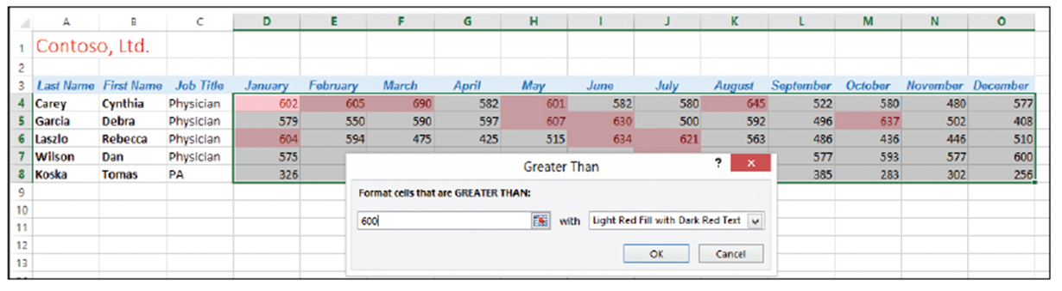
  - PAUSE. Leave the workbook open to use in the next exercise.

Step by Step 22: Apply Multiple Conditional Formatting Rules
- GET READY. USE the workbook you saved in the previous exercise.
  - Select D4:O8.
  - On the HOME tab, in the Styles group, click the Conditional Formatting menu and then select Highlight Cells Rules > Less Than.
  - Enter 300 in the Format cells that are LESS THAN box.
- Select the Yellow Fill with Dark Yellow Text option from the drop-down menu. Click OK. All values of less than 300 appear with a yellow background and dark yellow text color, along with values over 600 indicated by a light red background and dark red text, as shown below.
- SAVE the workbook as 06 Patient Visits Conditional Formatting Solution.
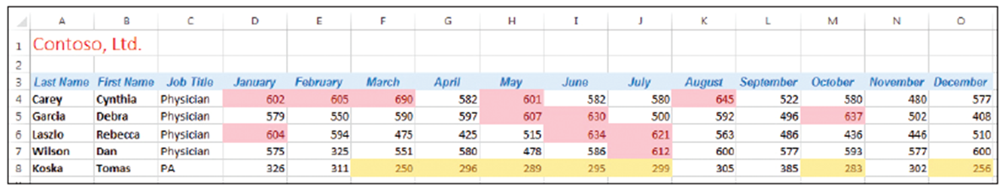
- PAUSE. Leave the workbook open to use in the next exercise.
Step by Step 23: Use the Rules Manager to Apply Conditional Formats
- GET READY. USE the workbook you saved in the previous exercise.
  - Select D4:O8.
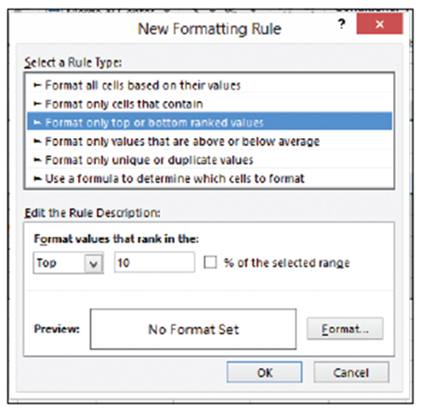
  - On the HOME tab, in the Styles group, click the Conditional Formatting menu and select Clear Rules > Clear Rules from Selected Cells.
  - Open the Conditional Formatting menu again and select Manage Rules. The Conditional Formatting Rules Manager dialog box appears.
  - Click the New Rule button. In the New Formatting Rule dialog box, select Format only top or bottom ranked values. The dialog box changes
as shown at right.
  - In the Edit the Rule Description section, click the % of the selected range checkbox.
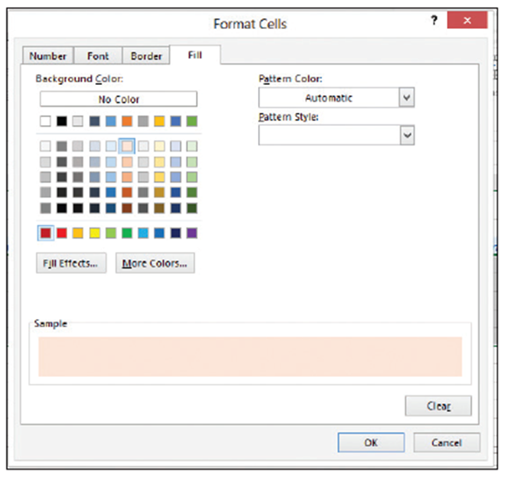
  - Click the Format button.
The Format Cells dialog box
opens.
  - Click the Fill tab if it’s not already selected, and then select the light red (pink) color box, as shown at right. Click OK twice.
  - In the Conditional Formatting Rules Manager
dialog box, click the New Rule button.
  - In the New Formatting Rule dialog box, select Format only top or bottom ranked values.
  - In the Edit the Rule Description section, select Bottom from the first drop-down list on the left and click the % of the selected range checkbox.
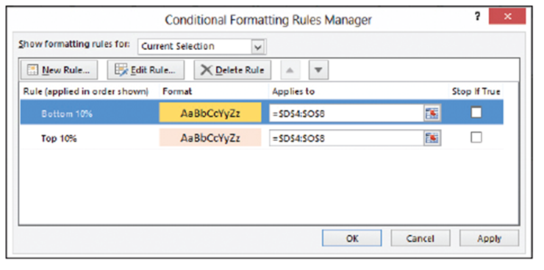
  - Click the Format
button.
  - In the Format Cells
dialog box, click a
yellow background
color on the Fill tab,
and then click OK
twice. The Conditional Formatting Rules Manager dialog box should look similar to the figure above.
  - Click OK. The Rules Manager applies the rules to the selected cells, as shown below. This view lets you see the top 10 percent and bottom 10 percent values in the range.
  - SAVE the workbook as 06 Patient Visits Conditional Formatting Revised Solution.
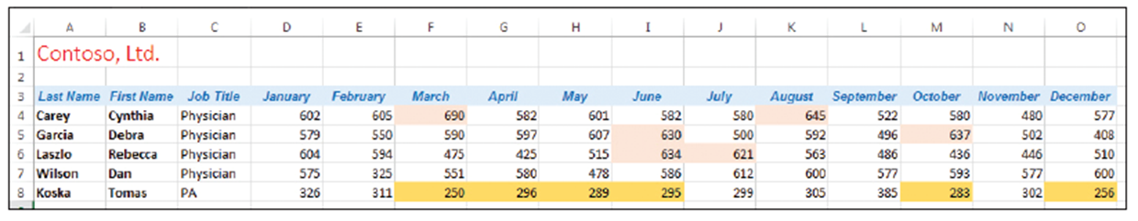
- PAUSE. Leave the workbook open to use in the next exercise.
Step by Step 24: Clear a Cell’s Formatting
- GET READY. USE the workbook you saved in the previous exercise.
  - Select A3:O3.
  - On the HOME tab, in the Editing group, click the Clear menu and select Clear Formats. The formatting for the range A3:O3 is removed.
  - Click the Select All button (at the intersection of the column and row headings) in the upper-left corner of your worksheet, or press Ctrl+A.
- From the Clear menu, click Clear Formats. All worksheet formatting disappears.
- Close the workbook without saving your changes.
- CLOSE Excel.
- As you saw in this exercise, clearing formatting from cells or an entire worksheet does not affect the text, numbers, or formulas in the worksheet.

