Step by Step 1: Copy a Worksheet
- GET READY. Before you begin these steps, LAUNCH Microsoft Excel.
  - OPEN the 08 Spa Services workbook for this lesson.
  - Click the FILE tab and then click Save As. At the bottom of the Computer list, click Browse.
  - In the Save As dialog box, in the left pane, scroll to the group of storage devices listed under Computer. Click the entry that represents your USB flash drive.
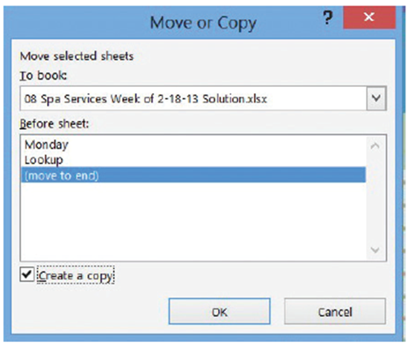
  - Click New Folder. In the right pane, type Lesson 8 and press Enter.
  - SAVE the workbook in the Lesson 8 folder as 08 Spa Services Week of 2-18-13 Solution.
  - With the Monday worksheet active, click the HOME tab, in the Cells group, click Format.
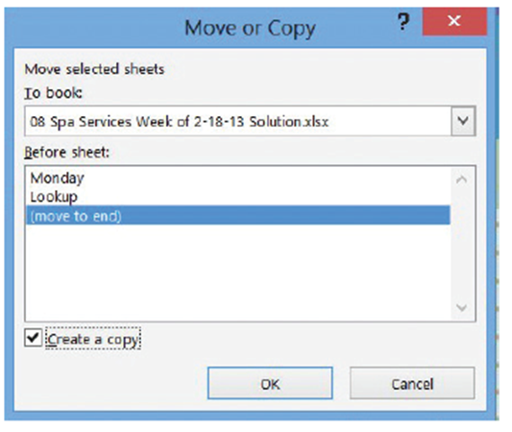
  - Click Move or Copy Sheet.
The dialog box shown at
right opens. Here, the Before
sheet list shows the current
sequence of worksheets in
the workbook even if there’s
only one. The sheet selected
represents the place you
want to put the copied
sheet in front of.
  - In the Before sheet list, select
(move to end). Next, select
the Create a copy box, as
shown at right, and then click
OK. A copy of the Monday
worksheet is inserted at the
end of the sequence, to the
right of Lookup. The new
worksheet is given the
default name Monday (2).
  - Click the Monday worksheet tab. Next, click and hold the Monday tab, and then press and hold Ctrl. The pointer changes from an arrow to a paper with a plus sign in it.
  - Drag the pointer to the right until the down-arrow just above the tabs bar points to the divider to the right of Monday (2). Release the mouse button and Ctrl key. A new worksheet is created, with its tab located just to the right of where the down-arrow was pointing. Its name is Monday (3).
  - With Monday (3) active, click cell B4 and type the date 2/19/2013.
  - Select cells B8:H13.
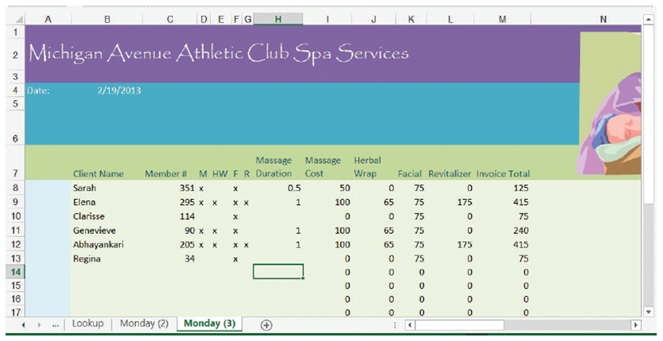
  - Beginning in cell B8, enter the following data, skipping over cells without an “x” or a number, as shown in the following (below):
- PAUSE. SAVE the workbook and LEAVE it open to use in the next exercise.
Step by Step 2: Rename a Worksheet
- GET READY. USE the workbook from the previous exercise.
  - Double-click the Monday (3) worksheet tab to select its name.
  - Type Tuesday and press Enter. The new name appears on the tab.
  - Repeat this process for the Monday (2) worksheet tab, renaming it Wednesday.
  - With the Wednesday worksheet active, select cell B4 and type the date 2/20/2013.
  - Select cells B8:H15. Beginning in cell B8, enter the following data, skipping over cells without an “x” or a number as shown in the following (below):
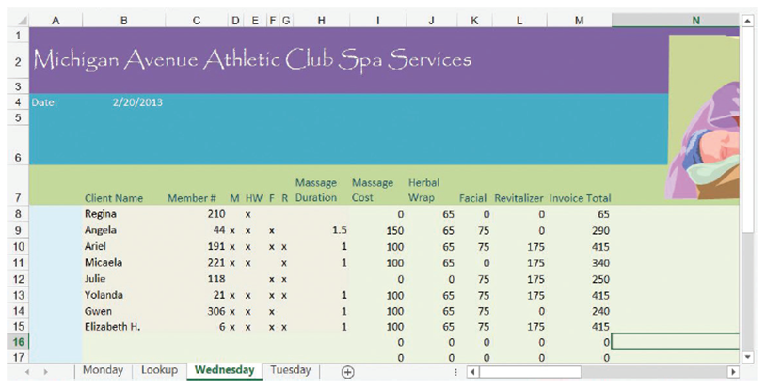
- PAUSE. SAVE the workbook and LEAVE it open to use in the next exercise.

Step by Step 3: Reposition the Worksheets in a Workbook
- GET READY. USE the workbook from the previous exercise.
  - Click the Tuesday worksheet tab. On the HOME tab, in the Cells group, click Format.
  - Click Move or Copy Sheet. The Move or Copy dialog box opens.
  - To make sure Tuesday appears before Wednesday, click Wednesday in the Before sheet list, and then click OK. Click and hold the Lookup worksheet tab. The pointer changes from an arrow to a paper without a plus sign.
  - Drag the pointer to the right until the down-arrow just above the tabs bar points to the divider to the right of Wednesday. Release the mouse button. The Lookup worksheet is repositioned at the end of the sequence, and nothing inside the worksheet itself is changed.
  - Click the Monday worksheet tab.
  - Select cells B8:H11.
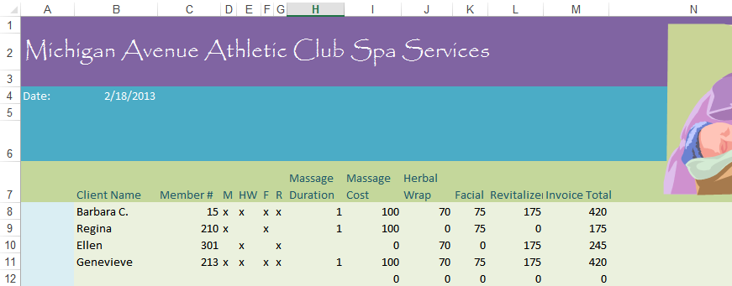
  - Beginning in cell B8, enter the following data, skipping over cells without an “x” or a number as shown in the following:

- PAUSE. SAVE the workbook and LEAVE it open to use in the next exercise.
Step by Step 4: Change the Color of a Worksheet Tab
- GET READY. USE the workbook from the previous exercise.
  - Right-click the Monday worksheet tab.
  - In the shortcut menu, click Tab Color.
  - In the popup menu, under Standard Colors, click Red. Excel gives a slightly red tint to the Monday worksheet tab.
  - Click the Tuesday worksheet tab. Notice the Monday worksheet tab is now the bold red color you chose. Excel applies only the gradient tint to the tab for the currently visible worksheet to make it stand out above the others.
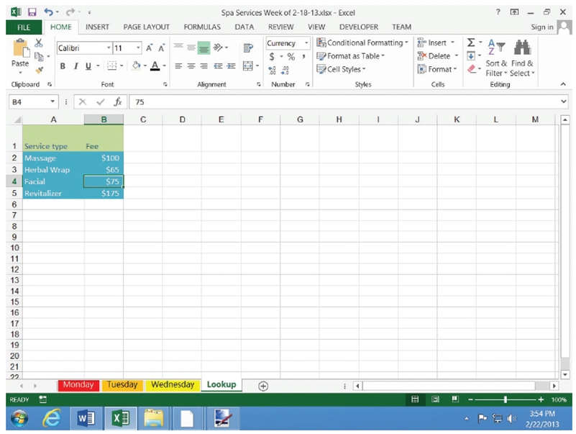
  - Repeat the color selection process for the Tuesday and Wednesday worksheet tabs, choosing Orange and Yellow, respectively.
- Click the Lookup
worksheet tab.
Your tabs bar
should now
appear as
shown at right.
- PAUSE. SAVE the
workbook and LEAVE it
open to use in the next
exercise.

Step by Step 5: Hide and Unhide a Worksheet
- GET READY. USE the workbook from the previous exercise.
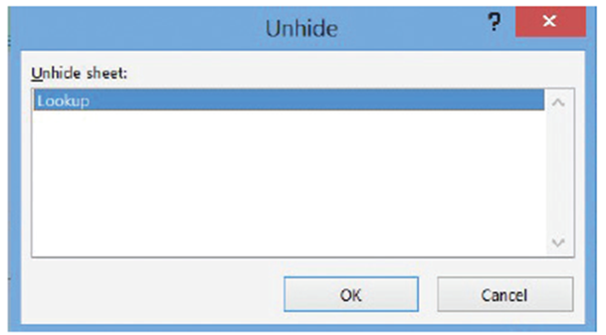
  - With the Lookup worksheet tab active, on the HOME tab, in the Cells group, click Format.
  - Click Hide & Unhide and then click Hide Sheet. The Lookup worksheet is no longer visible.
  - Click Format, click
Hide & Unhide, and
then click Unhide Sheet.
The Unhide dialog box
appears (right).
- Make sure Lookup is chosen in the Unhide sheet list, and then click OK. The Lookup worksheet reappears and is activated.
- In the Lookup worksheet, select cell B3.
- Type 70 and press Enter.
- Right-click the Lookup worksheet tab, and click Hide. The Lookup worksheet disappears again, although the change you made to one price is reflected in the other sheets that refer to it.
- PAUSE. SAVE the workbook and LEAVE it open to use in the next exercise.
Step by Step 6: Insert a New Worksheet into a Workbook
- GET READY. USE the workbook from the previous exercise.
  - Click the Wednesday tab.
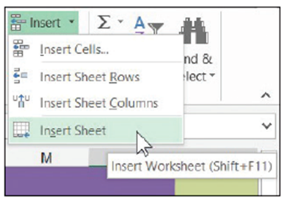
  - On the HOME tab, in the Cells group, click the down-arrow next to Insert (right).
  - Click Insert Sheet. A new,
blank worksheet is created,
and its tab is inserted before the tab of the active sheet (Wednesday). Excel gives it a temporary name, beginning with Sheet followed by a number.
  - Move the new worksheet to the end of the tab sequence.
  - Rename the new worksheet Survey.
  - Click the Wednesday worksheet tab again.
  - Click the + button to the right of the worksheet tabs. Another new worksheet is created with a temporary name, and this time, its tab is inserted after Wednesday.
  - Rename this new worksheet Totals.
- PAUSE. SAVE the workbook and LEAVE it open to use in the next exercise.
Step by Step 7: Delete a Worksheet from a Workbook
- GET READY. USE the workbook from the previous exercise.
  - Click the Totals worksheet tab.
  - On the HOME table, in the Cells group, click the down-arrow next to Delete.
  - Click Delete Sheet. The Totals worksheet is removed and its tab disappears.
  - Right-click the Survey tab, and click Delete. The Survey worksheet is removed and its tab disappears.
- PAUSE. SAVE the workbook and LEAVE it open to use in the next exercise.
Step by Step 8: Work with Multiple Worksheets in a Workbook
- GET READY. USE the workbook from the previous exercise.
  - SAVE the workbook in the Lesson 8 folder as 08 Spa Services Week of 2-18-13 Solution 2.
  - Right-click any worksheet’s tab and click Select All Sheets. The title bar now reads Spa Services Week of 2-18-13.xlsx [Group]. All visible worksheets are enrolled in this group, whereas hidden worksheets are excluded. Although all the worksheets’ tabs are now boldface, the active worksheet remains highlighted in green.
  - Select cells I8:M33.
  - Click $ (Accounting Number Format) in the Number group of the Home menu tab. The cell formats for the range switch to a currency style where the dollar sign is aligned left, and the value aligned right with dollars and cents. Column K (Facial) is too narrow for its contents, so its values currently read ####.
  - Adjust the width of column K to fit its contents (see Lesson 7, “Formatting Worksheets”).
  - Select column M.
  - In the Font group, click B (Bold). All cells in column M are now boldfaced.
  - Click the tab for a worksheet other than Wednesday. The group is now dissolved, but the changes you made to the previous sheet are reflected here, as demonstrated by the reformatted Wednesday worksheet shown below.
  - Select the Monday worksheet.
  - On the VIEW tab, in the Window group, click New Window. A new Excel window appears, also containing the Monday worksheet.
  - With the new window active, select the Tuesday worksheet.
  - Click the View tab and click New Window again. Another window appears.
  - With this new window active, select the Wednesday worksheet.
  - On the VIEW tab, in the Windows group, click Arrange All. The Arrange Windows dialog box opens.
  - In the dialog box, click Vertical, and then click OK. Excel rearranges your three windows to appear as shown below.
- PAUSE. LEAVE the workbook open to use in the next exercise.
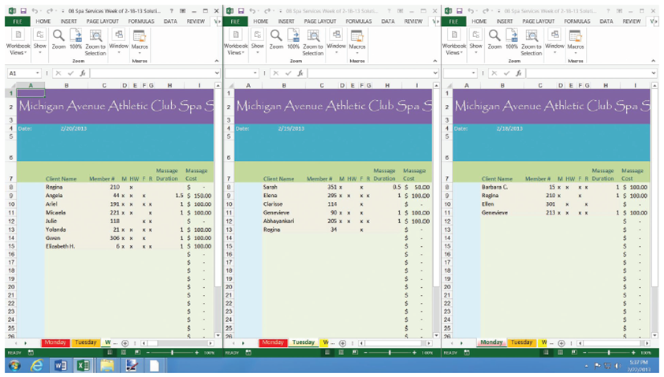

Step by Step 9: Hide and Unhide Worksheet Windows in a Workbook
- GET READY. USE the workbook from the previous exercise.
  - With all three non-hidden worksheets visible, click the title bar of the window containing the Monday worksheet.
  - On the VIEW tab, in the Window group, click Hide. The Monday window is closed.
  - In either of the visible windows, on the VIEW tab, in the Window group, click Unhide. The Unhide dialog box appears.
  - In the Unhide workbook list, choose the hidden window and click OK.
- PAUSE. SAVE the workbook and LEAVE it open to use in the next exercise.
Step by Step 10: Use Zoom and Freeze to Change the Onscreen View
- GET READY. USE the workbook from the previous exercise.
  - SAVE the workbook in the Lesson 8 folder as 08 Spa Services Week of 2-18-13 Solution 3.
  - Maximize the window containing the Monday worksheet.
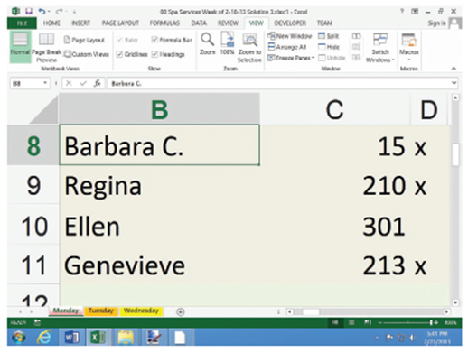
  - Select cell B8.
  - To increase magnification, click
and hold the zoom control in the
lower right corner (right) and slide
the pointer to the right. The
maximum zoom is 400%. Notice
the window zooms in on the cell
you select.
  - Click the VIEW tab, and in the
Zoom group, click 100%. The worksheet returns to standard magnification. Scroll to the top of the worksheet so that row 1 is visible again. If you need to, scroll left so you can also see column A again.
  - On the VIEW tab, in the Window group, click Freeze Panes, and then click Freeze Panes in the menu that appears. Cells above and to the left of the selected cell (B8) are now frozen in place for scrolling.
  - Scroll down so that row 33 comes close to the labels in row 7. Notice that rows 1 through 7 remain in place (below). 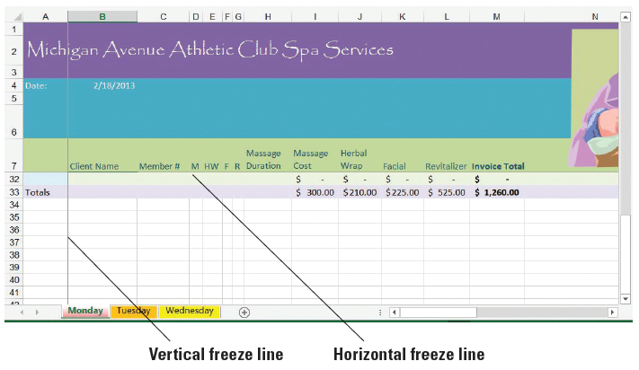
  - Press Ctrl + Home to scroll the worksheet to the top. In the Window group, click Freeze Panes, and then click Unfreeze Panes. The thin lines denoting the frozen borders of the worksheet disappear.
- PAUSE. LEAVE the workbook open to use in the next exercise.
Step by Step 11: Locate Data with the Find Command
- GET READY. USE the workbook from the previous exercise.
  - Select the Monday worksheet. Select cell B8.
  - On the HOME tab, in the Editing group, click Find & Select (the binoculars button). Click Find. The Find and Replace dialog box appears.
  - In the dialog box, click Options. The dialog box expands.
  - Click the Within down arrow, and in the drop-down list, click Workbook.
  - Click the Look in down arrow, and in the drop-down list, click Values.

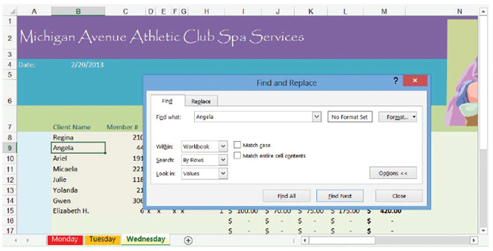
  - Click the Find what text box, delete any contents that might appear there, and type Angela. Click Find Next. The workbook window moves to Wednesday, and automatically selects Angela in cell B9. Meanwhile, the dialog box appears as shown below.
  - Double-click the Find what text box, press Delete, and then type Beth. Click Find Next. Excel highlights cell B15, whose contents include “beth,” in the middle of the cell and in a non-matching case.
  - Select cell B9.
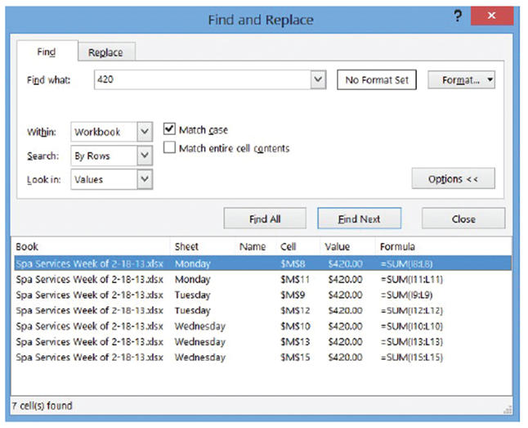
  - In the dialog box, click Match case, and then click Find Next. This time, Excel reports the text can’t be found, because it’s looking for a name that begins with a capital “B.” Click OK to dismiss the message.
  - Double-click the Find
what text box, press
Delete, and then type
420. Click Find All. The
dialog box shows a
detailed report listing
all the cells in the
workbook that contain
the value 420 (right). In
this case, it points to all
the locations where customers paid “the works” for all the services together.
  - Click the first item in the list whose Sheet entry is marked Tuesday. Excel brings up the Tuesday worksheet and selects cell M9, which contains an entry for $420.00.
  - Click Close to dismiss the dialog box.
  - Close the other two open workbook windows.
- PAUSE. LEAVE the workbook open to use in the next exercise
Step by Step 12: Replace Data with the Replace Command
- GET READY. USE the workbook from the previous exercise.
  - Select the Wednesday worksheet. Select cell B8.
  - On the HOME table, in the Editing group, click Find & Select. Click Replace in the menu. The Find and Replace dialog box appears (below). 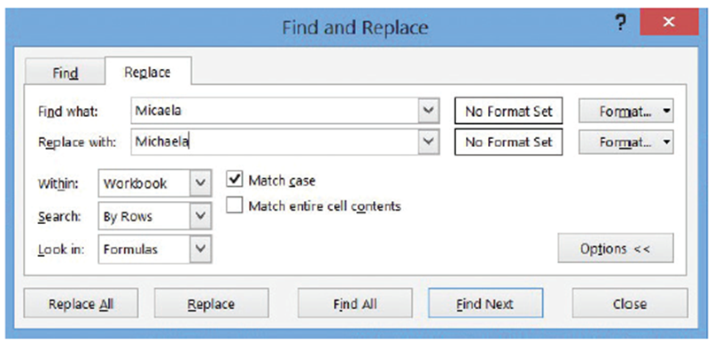
  - Make sure certain options are visible and that Workbook is the selected option for Within.
  - If the Find what text box shows the contents of the previous search, then double-click the text box and press Delete to erase its contents.
  - Click in the Find what text box and type Micaela.
  - Click in the Replace with text box and type Michaela. The dialog box should now appear.
  - Click Replace All. Excel searches for all instances of Micaela and adds an “h” to the middle (correcting this client’s spelling), and then will notify you when the job is done. Excel makes one replacement.
  - Click OK, and then click Close.
- SAVE the workbook, and LEAVE it open to use in the next exercise.

