Step by Step 1: Open a Non-Native File Directly in Excel
- GET READY. Before you begin these steps, LAUNCH Microsoft Excel.
  - If the active workbook is not a new, blank workbook, then click the FILE tab. In Backstage, click New, and then click the thumbnail marked Blank workbook.
  - On the DATA tab, click Get External Data. Then click From Text.
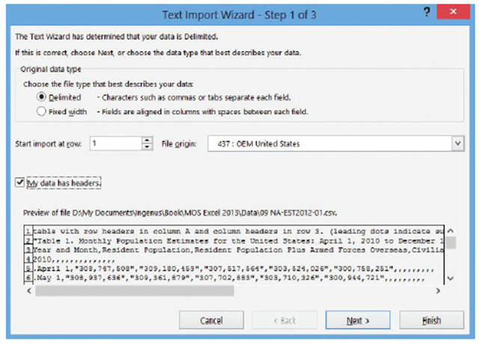
  - In the Import Text File dialog box, locate and click the 09 NA-EST2012-01.csv file in the Lesson 9 folder. Click Import.
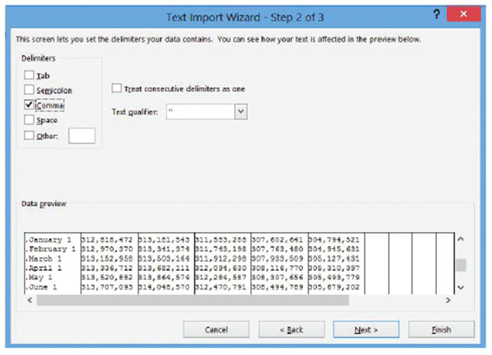
  - In Step 1 of the Text Import
Wizard, notice the preview
at the bottom (right). This is Excel’s best guess, for the moment, as to how the
data should be formatted.
There are population
figures rendered in
“quotation marks” with
commas between each
figure. Here, each comma acts as the delimiter, and it’s difficult to judge whether each figure between the commas will be the same length. Under Choose the file type that best describes your data, choose Delimited, and select My data has headers.
  - The preview shows the
headers starting on row 3.
Thus, for the Set import at
row option, choose 3.
Click Next.
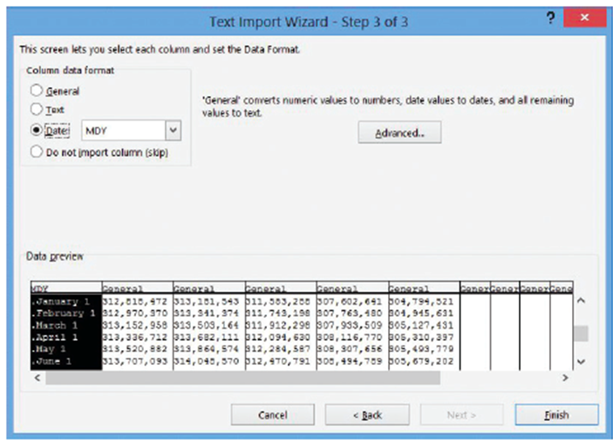
  - In Step 2 of the wizard,
shown at right, uncheck
Tab because the preview
does not indicate long spaces between the figures. Check Comma. Set Text qualifier to " (quotation mark). Scroll down the Data preview pane, and notice now that Excel has found the column separations between figures. Click Next.
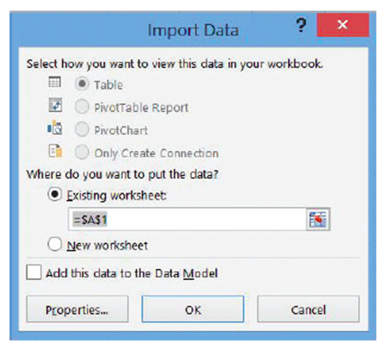
  - Step 3 of the wizard, right, lets you establish the data type for each discovered column. Click the first column in the Data preview pane. Then, under Column data format, click Date.
Click Finish.
  - In the Import Data dialog box that
appears next (above), leave where do you want to put the data? set to Existing worksheet. Click OK.
  - Shorten the width of column A
to 16 (see Lesson 7, “Formatting
Worksheets”).
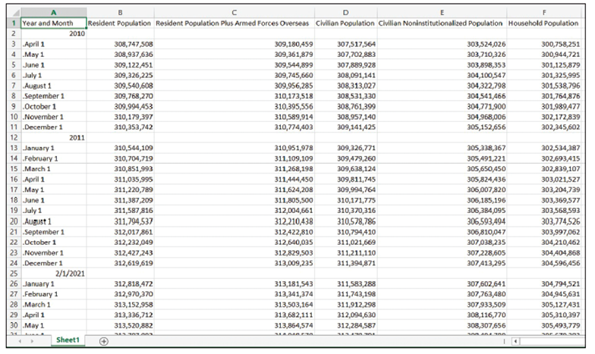
  - The worksheet that Excel has generated, shown at right,
shows United States population estimates for each month from
April 2010 to December 2012.
Excel could not make sense of the
dates in column A, so it left the data type set to General for most of the cells. However, it did make an error in attempting to convert the year in cell A25. To correct it, begin by deleting rows 2, 12, and 25.
  - Click cell A2, type April 2010, and press Enter.
  - Drag the fill handle from cell A2 down to cell A34 and release (see Lesson 2, “Working with Microsoft Excel 2013”). Excel changes the entries in column A to proper months.
  - Delete rows 35 through 40.
  - SAVE the workbook in the Lesson 9 folder as 09 Monthly Census Data Solution.
- CLOSE the workbook and leave Excel open for the next exercise.
Step by Step 2: Get External Data
- GET READY. Before you begin these steps, LAUNCH Microsoft Excel.
  - If the active workbook is not a new, blank workbook, then click the FILE tab. In Backstage, click New, and then click the thumbnail marked Blank workbook.
  - On the DATA tab, click Get External Data, and then click From Access.
  - In the Select Data Source dialog box, locate the 09 GMcC Customer contacts.accdb database file. Select it and click Open.
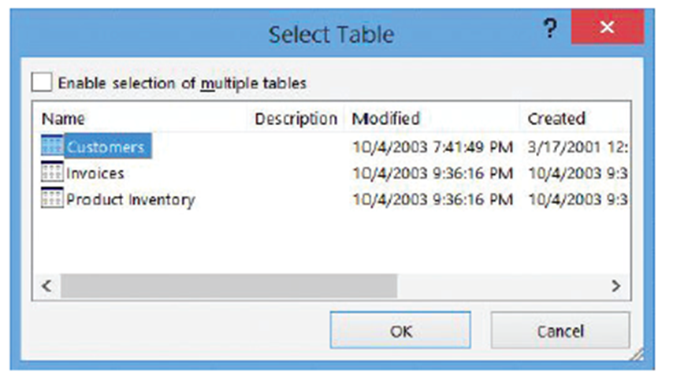
  - In the Select Table dialog box shown below, click Customers (the table we want to import), and then click OK.
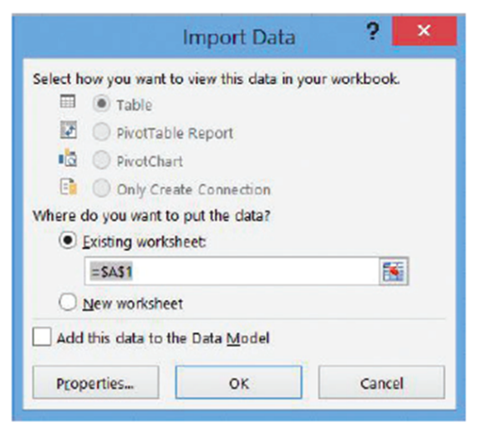
  - In the Import Data dialog box (right), click Table. Under Where do you want
to put the data, click Existing Worksheet and ensure the text box
reads =Sheet1!$A$1.

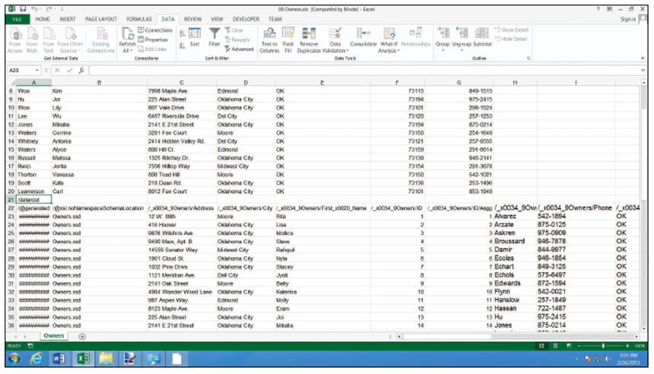
  - Click OK. Excel takes a moment to query the database. Soon, it displays a fully formatted table (right), complete with AutoFilter buttons in the headers, which you learn more about later in this lesson in “Using AutoFilter.”
  - SAVE the workbook in the Lesson 9 folder as 09 2005 Customers Solution.
- CLOSE the workbook and leave Excel open for the next exercise.
Step by Step 3: Append Data to a Worksheet
- GET READY. OPEN the 09 Owners.xls workbook for this lesson.
  - Click cell A21.
  - On the DATA tab, click Get External Data, then click From Other Sources, followed by From XML Data Import.
  - In the Select Data Source dialog box, locate and select the 09 2010_Owners.xml data file. Click Open.
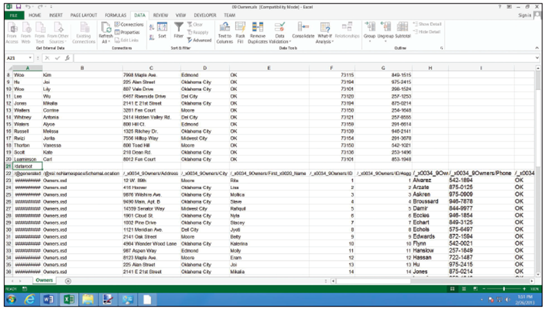
  - In the Import Data dialog box, click Existing worksheet, and then click OK. Although a list of customers is appended to the end of the worksheet, the columns don’t line up, as the figure below clearly indicates. This is typical of appended data.
  - To correct the problem, begin by moving the first names from cell range E23:E75 to B23:B75. Overwrite the existing contents in column B.
  - Move the last names from cell range H23:H75 to A23:A75. Overwrite the existing contents in column A.
  - Repeat the process for the states in column J that should be in column E, the ZIP codes in column K that should be in column F, and the phone numbers in column I that should be in column G.
  - Delete columns H through L.
  - Delete rows 21 and 22.
  - Replace all 11 instances of Dell City in column D with Del City.
- SAVE the workbook in the Lesson 9 folder as 09 Car Owners Solution.xlsx. CLOSE the workbook and leave Excel open for the next exercise.
Step by Step 4: Restrict Cell Entries to Certain Data Types
- GET READY. OPEN the 09 Vet Clinic Patients workbook for this lesson.
  - Click the FILE tab and select Save As. SAVE the workbook in the Lesson 9 folder as 09 Vet Clinic Patients (Active) Solution.
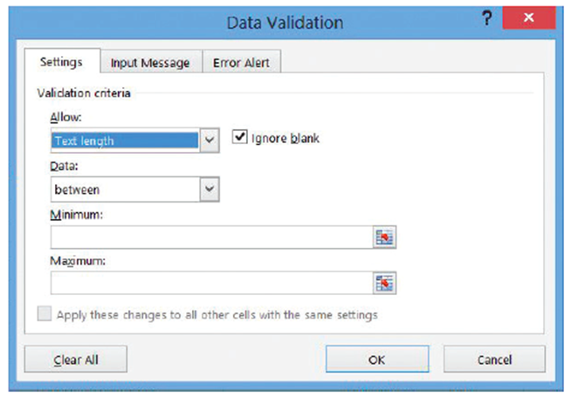
  - Freeze rows 1 through 5 in both worksheets in the workbook (see Lesson 8, “Managing Worksheets”).
  - In the Client list worksheet, select column L (Area Code).
  - On the DATA tab, in the
Data Tools group, click
Data Validation. The Data
Validation dialog box
opens.
  - Click the Settings tab.
  - In the Allow list box,
choose Text length.
This is the first step in the creation of a rule governing how many characters each new entry should contain. The dialog box should now appear as depicted above.
  - In the Data list box, choose equal to.
  - Click the Length box and type 3.
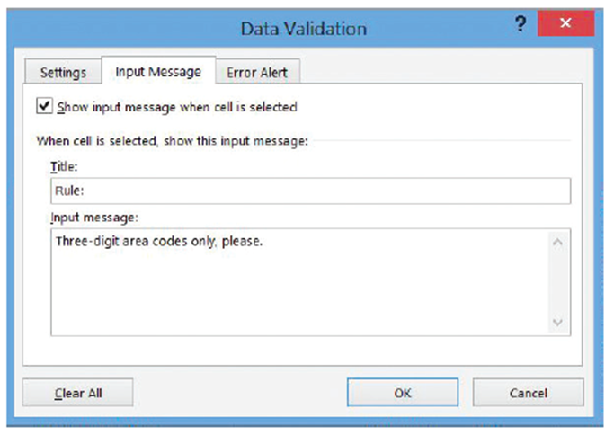
  - Click the Input Message tab. This tab displays a ScreenTip whenever you select a cell in this specially validated area.
  - Click the Title box and type Rule:
  - Click the Input
message box and type
Three-digit area codes
only, please. The Data
Validation dialog box
should now appear
as shown at right.
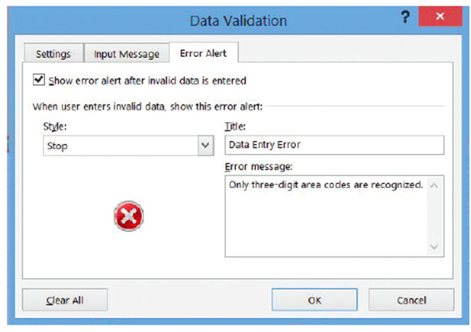
  - Click the Error Alert
tab. Excel notifies a
user who missed your ScreenTip that the data he has entered is invalid.
  - Click the Title box and
type Data entry error.
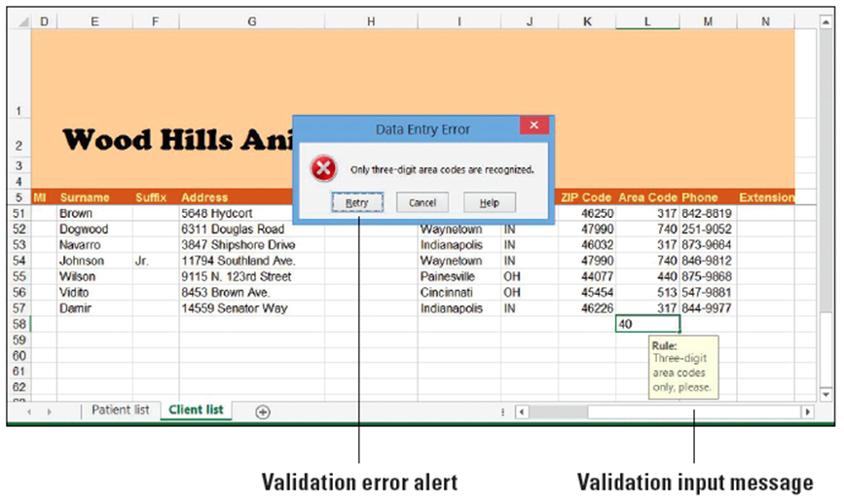
  - Click the Error message
box and type Only
three-digit area codes
are recognized. This
message is displayed in
a dialog box whenever
an invalid entry is made
in column L. The dialog box should now appear as shown above.
  - Click OK.
  - To test the new
validation rule,
click cell L58.
You should see
the notification
message you
typed into the
Input Message
tab.
  - Type 40 and press Enter. Excel displays an alert dialog box with the message you created (above).
  - Click Cancel. The partial entry in cell L58 is erased.
- PAUSE. SAVE the workbook and leave it open for the next exercise.
Step by Step 5: Allow Only Specific Values to Be Entered in Cells
- GET READY. USE the workbook from the previous exercise.
  - Click the FILE tab and select Save As. SAVE the workbook in the Lesson 9 folder as 09 Vet Clinic Patients (Active) Solution 2.
  - Click the Patient list tab.
  - Select column D.
  - On the DATA tab, in the Data Tools group, click Data Validation.
  - In the Data Validation dialog box, click the Settings tab.
  - In the Allow list box, choose List. The Source box appears at the bottom of the dialog box.
  - Click the Source box. Type M,F,N being careful to include the commas.
  - Uncheck the Ignore blank box.
  - Click the Input Message tab. Click the Input message box and type Male, Female, or Neutered.
  - Click OK. Now anyone entering a new patient into the database must specify the animal’s gender.
  - Select column E (Owner #).
  - In the Data Tools group, click Data Validation.
  - Click the Settings tab. In the Allow list box, click List.
  - On the right side of the Source box, click the Collapse Dialog button.
  - With the Data Validation dialog box collapsed, click the Client list worksheet tab.
  - Select column A (Client #).
  - At the end of the Source box, click the Expand Dialog button. The full dialog box returns, and the Source box should now read ='Client list'!$A:$A.
  - Unselect the Ignore blank and In-cell dropdown boxes.
  - Click the Error Alert tab. Choose Warning from the Style box.
  - In the Error message box, type Owner must be the number for a pre-existing client.
  - Click OK. Now the Owner # column may contain only numbers for clients who appear in the Client # column of the Client list worksheet.
  - To make sure your new validation rules are working, in the Patient list worksheet, at the bottom of the list, click cell A58 and attempt to type the following data:
Murdock Dog Rottweiler B 61
  - After you attempt to enter B into column D, respond to the error dialog by clicking Retry and by typing M.
  - After you attempt to enter 61 into column E, respond to the error dialog shown below by clicking No and typing 31.
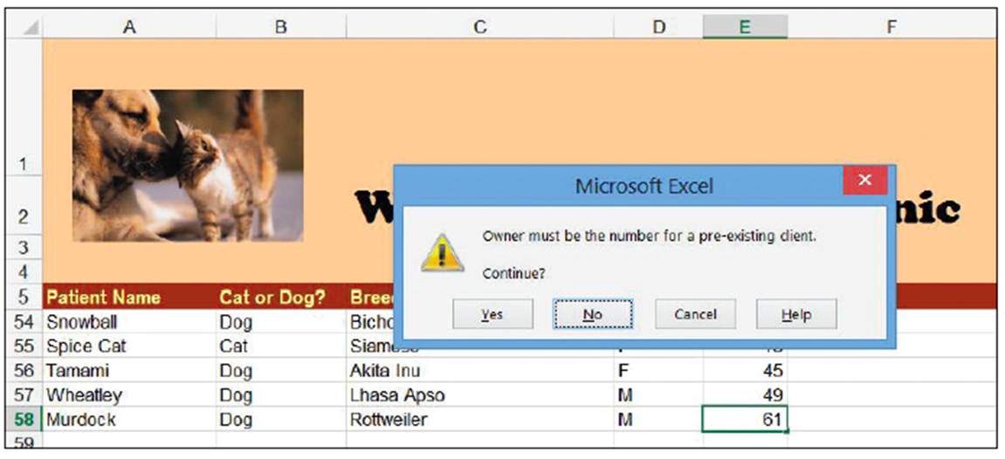
- PAUSE. SAVE the workbook and leave it open to use in the next exercise.
Step by Step 6: Remove Duplicate Rows from a Worksheet
- GET READY. USE the workbook from the previous exercise.
  - SAVE the current workbook as 09 Vet Clinic Patients (Active) Solution 3.
  - Click the Client list worksheet tab.
  - Click cell A58 and in row 58, type the following data:
0053 Mrs. Mary Jane Brink 704 Fairway Drive Cincinnati OH 45250 513 255-1655
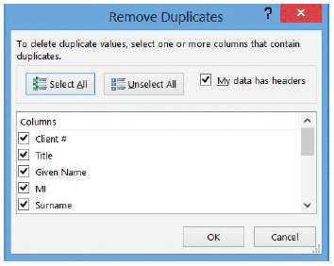
- Select the cell range A5:N58.
- On the DATA tab, in the
Data Tools group, click
Remove Duplicates. The
Remove Duplicates dialog
box appears (right).
- Remove the check beside Client # in the Columns list. If duplicate names and addresses appear in the list, it’s likely their client index numbers were not duplicated.
- Leave the My data has headers box checked. This way, Excel won’t treat row 5 as though it contained data.
- Click OK. Excel responds with a dialog box stating one duplicate value set (the one you just entered) was removed.
- Click OK to dismiss the dialog box. Note the second (lowermost) instance of the duplicate entry was removed, from row 58.
- PAUSE. SAVE the workbook and leave it open to use in the next exercise.
Step by Step 7: Sort Data on a Single Criterion
- GET READY. USE the workbook from the previous exercise.
  - SAVE the current workbook as 09 Vet Clinic Patients (Active) Solution 4.
  - In the Patient list worksheet, click cell E6. Note this is the top row of the Owner # column and its entries are all numerical.
  - Hold the Shift key down while clicking cell A58. This selects the entire range you wish to sort.
  - On the DATA tab, in the Sort & Filter group, click the Sort Smallest to Largest button (with A on top of Z, and an arrow pointing down). The list is now sorted in ascending numerical order (despite the presence of the alphabet on the button) by Order #, which was the first column you clicked in when selecting the range.
  - Click cell A6.
  - Hold the Shift key down while clicking cell E58.
  - Click the sorting button again, whose ScreenTip is now the Sort A to Z button (because you’re sorting alphanumeric text). This time, the list is sorted by Patient Name, and again, the first column you clicked in when selecting the range. Murdock the Rottweiler, which you previously added to row 58 and that now appears on row 45.
- PAUSE. SAVE the workbook and leave it open to use in the next exercise.
Step by Step 8: Sort Data on Multiple Criteria
- GET READY. USE the workbook from the previous exercise.
  - Click the Client list tab.
  - Select the range A5:N57.
  - Name the range Clients.
  - On the DATA tab, in the Sort & Filter group, click Sort. The Sort dialog box appears.
  - In the Sort by list box, under Column, choose Surname.
  - Click Add Level.
  - In the Then by list box that appears, choose Given Name.
  - Click Add Level.
  - In the next Then by list box, choose MI (middle initial).
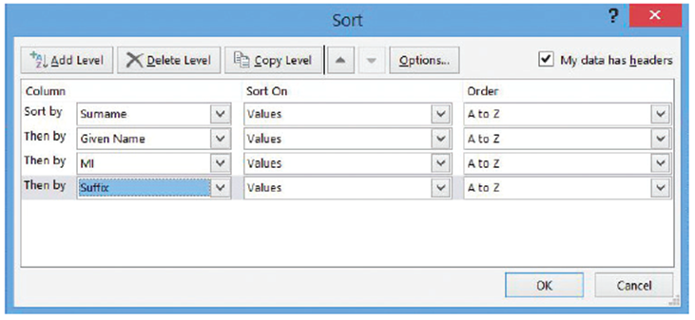
  - Click Add Level again.
  - In the next Then by list
box, choose Suffix.
The dialog box
should now appear as
down at right.
  - Leave My data has headers checked, so that Excel won’t treat the headers row as a data entry.
  - Click OK. The clients list is now sorted alphabetically, with people sharing the same surname sorted alphabetically by first name. Although the client numbers appear all out of sort, the data is unchanged and the database itself retains its full integrity.
- PAUSE. SAVE the workbook and leave it open for the next exercise.
Step by Step 9: Sort Data Using Cell Attributes
- GET READY. USE the workbook from the previous exercise.
  - On the Patient list worksheet, select column E.
  - Right-click the column, and then click Insert in the shortcut menu.
  - With column E selected, on the DATA tab, in the Data Tools group, click Data Validation.
  - In the Data Validation dialog box, click Clear All. Click OK.
  - Click cell E5 and type Spayed/Neutered.
  - Type S into column E for the following row numbers: 7, 22, 23, 26, 35, 38, 47, and 51.
  - Type N into column E for the following row numbers: 6, 8, 9, 10, 11, 13, 14, 16, 17, 18, 20, 21, 25, 28, 30, 31, 32, 33, 36, 37, 39, 42, 43, 44, 46, 48, 49, 50, 53, 55, 56, 57, and 58.
  - Select column E.
  - On the DATA tab, in the Data Tools group, click Data Validation.
  - In the Data Validation dialog box, click the Settings tab. Under Allow, choose List.
  - In the Source box, type N,S.
  - Click the Input Message tab. In the Input message box, type S = Spayed, N = Neutered. Click OK.
  - Select the range E6:E100. On the HOME tab, in the Styles group, click Conditional Formatting. Click New Rule.
  - In the New Formatting Rule dialog box, choose Format only cells that contain in the Select a Rule Type list.
  - In the list box, under Format only cells with, choose No Blanks.
  - Click Format.
  - In the Format Cells dialog box, click the Fill tab. Choose the sixth color swatch from the left in the third row. Click OK.
  - Click OK. Now both spayed and neutered animals should appear shaded.
  - Select the range A5:F58. Name the range Patients.
  - On the DATA tab, in the Sort & Filter group, click Sort.
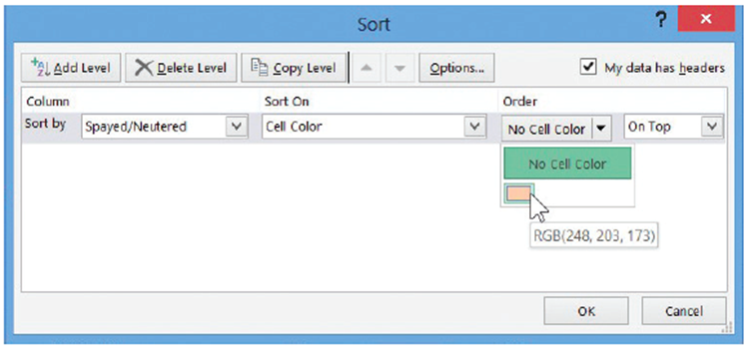
  - In the Sort dialog box, in the Sort by list, choose Spayed/Neutered.
  - In the Sort On list,
choose Cell Color.
  - Click the down
arrow next to
No Cell Color. As
the figure at right
shows, the list box that appears shows only those colors that are actually in use for conditional formatting—in this case, only one swatch.
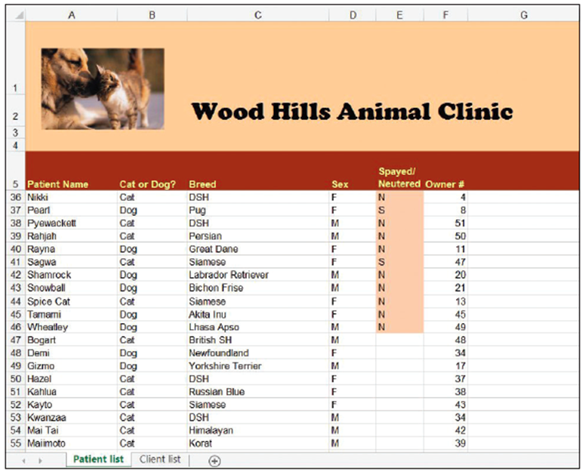
  - Click OK. The sorted
worksheet should
now appear as
shown at right. All
the “N” and “S”
animals are grouped
together at the top,
with the two types
mingling among
each other. All the
non-operated-on
animals are bunched toward the bottom.
- PAUSE. SAVE the workbook. Leave it open for the next exercise.

Step by Step 10: Use AutoFilter
- GET READY. USE the workbook from the previous exercise.
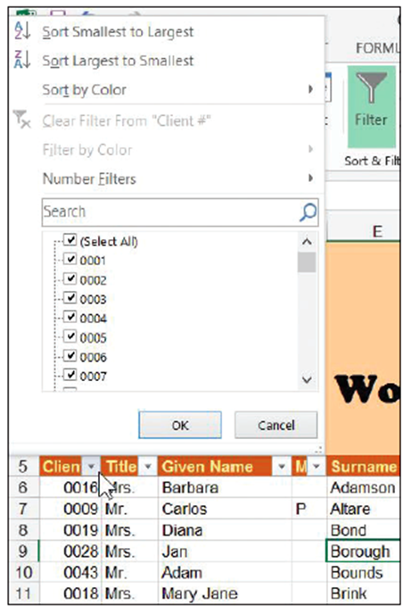
  - SAVE the current workbook as 09 Vet Clinic Patients (Active) Solution 5.
  - Click the Client list worksheet tab. In the Name box, type Clients and press Enter. Excel highlights the data range for the Clients table.
  - On the DATA tab, in the Sort & Filter group, click Filter. Excel adds down arrow buttons to the field names in all of the columns in the list.
  - Click the down arrow beside the
Client # heading in column A.
Excel displays the AutoFilter menu
shown at right.
  - To sort the table by client number,
click Sort Smallest to Largest.
This gives you a shortcut for
sorting that bypasses the menu.
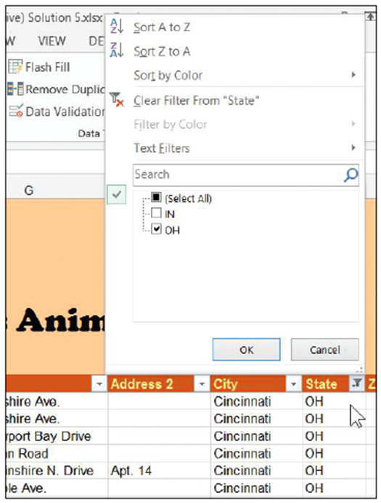
  - To show just the clients with
addresses in Ohio, click the
down arrow beside State. In the
AutoFilter menu that appears
(right), uncheck the (Select All)
box to clear all check boxes,
and then check OH and
click OK.
- PAUSE. SAVE the workbook and
leave it open to use in the next
exercise.
Step by Step 11: Create a Custom AutoFilter
- GET READY. USE the workbook from the previous exercise.
  - Insert a new column into the Patient list worksheet, between the existing columns D and E.
  - Clear the validation rules from the new column E.
  - Add the title Hepatitis inoculation to row 5. Increase the width of the column to make room for the label.
- Type the following dates into the cells shown:
E9 1/18/2012
E12 8/16/2011
E14 5/15/2012
E19 3/1/2009
E23 10/19/2010
E27 7/5/2012
E33 2/2/2011
E38 8/15/2012
E39 7/14/2011
E44 9/1/2012
  - Select the Patients data range. The range should have automatically stretched to include the new column.
  - On the DATA tab, in the Sort & Filter group, click Filter.
  - Click the down arrow beside Hepatitis inoculation. In the menu, click Date Filters, and then click Custom Filter. The Custom AutoFilter dialog box opens.
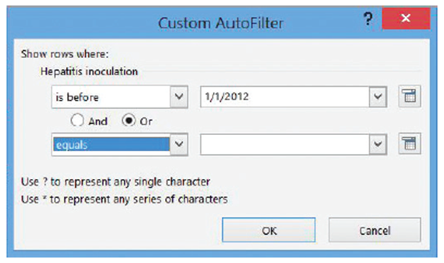
  - In the first list box just below Hepatitis inoculation, choose is before. In the box to the right, type 1/1/2012.
  - Click the Or button between the two rows of list boxes.
  - In the second list box
below Or, choose equals.
Leave the list box blank
(literally meaning “blank”
or “nothing”). The dialog
box should now appear
as shown at right.
  - Click OK. After the dialog box disappears, Excel filters out all entries in the patient list where the patient is known to have had a hepatitis inoculation in 2012 or later. What remains are both the animals known to have been inoculated in 2011 or earlier, or whose inoculation dates are not known.
  - Click the filter button beside Hepatitis inoculation again. In the menu, click Date Filters, and then click Custom Filter.
  - In the second list box that currently reads equals, choose the blank entry at the top of the list. The box should now be empty.
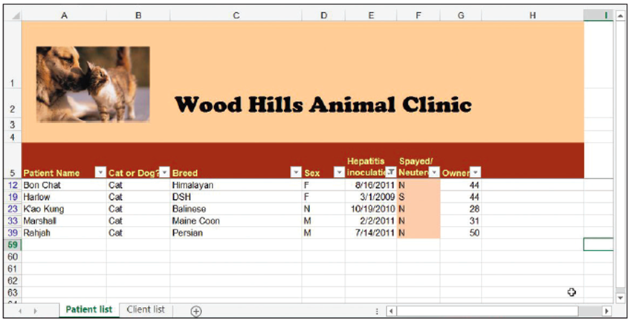
  - Click OK. The list should now show only the five animals known to have been inoculated in 2011 or earlier (below).
  - Click the filter
button beside
Hepatitis
inoculation
again. In the
menu, choose
Clear Filter
from
“Hepatitis inoculation”.
- PAUSE. SAVE the workbook and leave it open to use in the next exercise.
Step by Step 12: Filter Data Using Cell Attributes
- GET READY. USE the workbook from the previous exercise.
  - In the Patient list worksheet, click the Spayed/Neutered button down arrow.
  - In the menu, click Filter by Color.
  - In the popup menu, choose the pink swatch. Excel now shows only those animals that have been spayed or neutered.
- PAUSE. SAVE the workbook and leave it open for the next exercise.
Step by Step 13: Group and Ungroup Data
- GET READY. USE the workbook from the previous exercise.
  - SAVE the current workbook as 09 Vet Clinic Patients 130114 Solution. Grouping data is best reserved for final reports and not for active databases where new data might be entered later.
  - With the Patient list worksheet active, on the DATA tab, in the Sort & Filter group, click Clear.
  - Click the down arrow button beside Cat or Dog? In the menu, click Sort A to Z. Now, all the cats are clustered together at the top, and dogs at the bottom.
  - Right-click the heading for row 30, the row where the first dog appears. Click Insert in the shortcut menu.
  - Select cell H30. Type Number of cats.
  - Select cell G30. On the HOME tab, in the Font group, click the Bold button. This makes this particular number stand out.
  - On the HOME tab, in the Editing group, click the AutoSum down arrow. In the menu, click Count Numbers, and then press Enter. Excel inserts a function into the cell that counts the number of contiguous cells in the column just above it that contains numbers—in this case, the owner numbers for clients.
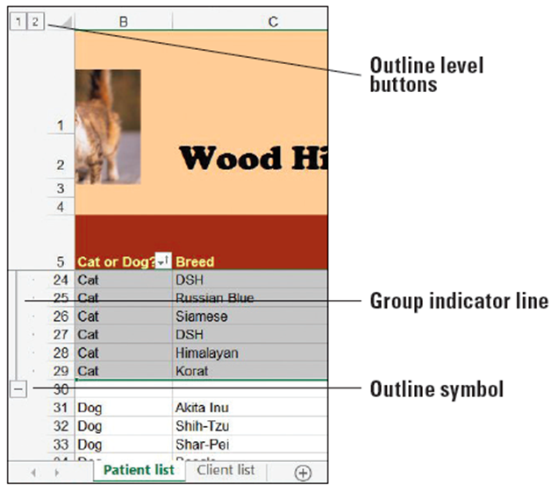
  - Add a similar function for counting the number of dogs to row 60. (Bypass the validation rule by clicking Yes in the dialog box.)
  - Select rows 6 through 29 (all the cats).
  - On the DATA tab, in the
Outline group, click the
Group button. A group
indicator line is added to
the left of the row markers
and an outline symbol on
the row just below the end
of the group (right).
  - Repeat the process in
Steps 8 and 9 for the dogs
in rows 31 through 59.
Format cell G60 as Bold.
In cell H60, type Number of dogs.
  - To collapse the cats group, click the minus box beside row 30, which contains the cats count. The control becomes a plus box, indicating that when you click on it, it will show hidden rows.
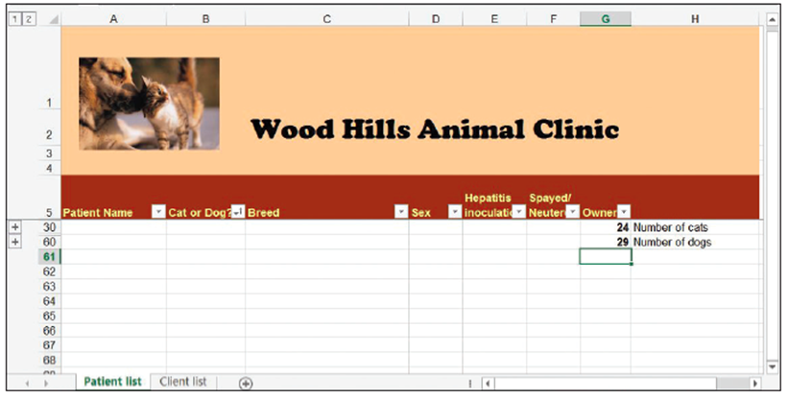
  - Collapse the dogs
group with the
minus box in row
60. The worksheet
now appears fully
collapsed (right).
  - Click the Select
All button. In the
Outline group, click Show Detail.
  - Select columns B through F.
  - In the Outline group, click the Group button. A new column group is created.
  - Click the minus box over column G to collapse the column group. Click the plus box that takes its place to expand it.
  - Select columns B through G.
  - In the Outline group, click the Ungroup button. The columnar group disappears.
- SAVE and CLOSE the workbook. Leave Excel open for use in the next exercise.
Step by Step 14: Auto-Outline Data
- GET READY. OPEN the 09 Critical Care Expenses workbook for this lesson.
  - SAVE the workbook in the Lesson 9 folder as 09 Critical Care Expenses 0315 Solution.
  - Select cell H18. On the HOME tab, in the Font group, click the Bold button. Then, in the Editing group, click the AutoSum button and press Enter. The grand total appears as bold in the cell.
  - Repeat the grand total process for cell H28.
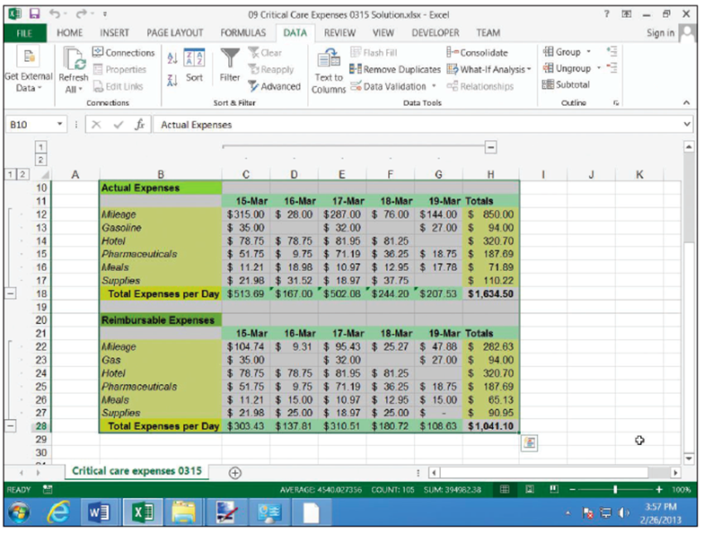
  - Select the cell range B10:H28, covering both groups of expenses in their entirety.
  - On the DATA tab, in
the Outline group,
click the down arrow
next to Group. In the
menu, click Auto
Outline. As the figure
shows, Excel auto-
matically groups
rows 12 through 17
and rows 22 through
27, having spotted
the Total Expenses
row along the bottom
of each cluster. Excel also groups together the columns for March 15 through 19, having spotted the weekly totals columns along the right.
- SAVE the workbook and LEAVE Excel open for the next exercise.

Step by Step 15: Collapse Groups of Data in an Outline
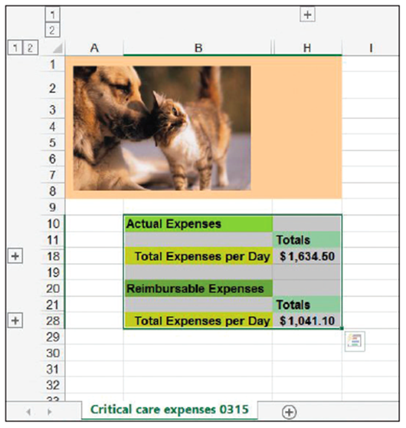
- GET READY. USE the workbook
from the previous exercise.
  - Click all three minus boxes
to collapse their respective
groups. The worksheet
should now appear
shrunken to just the grand
totals cells you created
with the appropriate labels
(right).
  - Click any of the plus boxes (which replaced the minus boxes) to expand the group to which it’s attached.
  - To remove the outline entirely, on the DATA tab, in the Outline group, click the Ungroup button arrow. In the menu, click Clear Outline.
- SAVE and CLOSE the workbook. Leave Excel open for the next exercise.
Step by Step 16: Subtotal Data in Outlines
- GET READY. OPEN the 09 Server Usage Stats workbook.
  - SAVE the workbook in the Lesson 9 folder as 09 Server Usage Stats 130831 Solution.
  - Select the range A5:G140.
  - On the DATA tab, in the Sort & Filter group, click Sort.
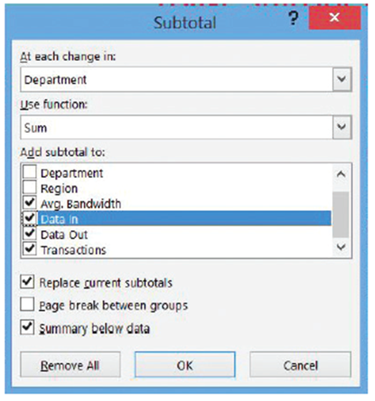
  - In the Sort dialog box, ensure that the initial sort is by Date, Oldest to Newest. The secondary sort should be by Department, from A to Z. The third should be by Region, from A to Z. Click OK.
  - On the DATA tab, in the Outline group, click Subtotal. The Subtotal dialog box appears.
  - In the At each change in list box, click Department.
  - If necessary, in the Use function list box, choose Sum.
  - In the list of columns marked
Add subtotal to, check the
boxes for Avg. Bandwidth,
Data In, Data Out, and
Transactions.
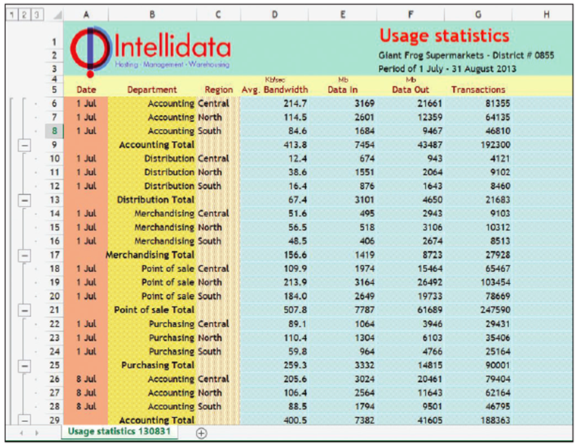
  - Check the Summary below data and Replace current subtotals check boxes, if necessary. The dialog box
should now appear as depicted at right.
  - Click OK. Excel inserts
subtotal rows for each
company division,
grouping together
data consumption
values for all three
corporate regions. It
places each of these
division row clusters
into groups. It then
creates a broader
group for the entire
range, and adds a grand total row at the bottom. The result is a subtotal-endowed worksheet with a three-tier outline (above).
- SAVE and CLOSE. Leave Excel open for the next exercise.

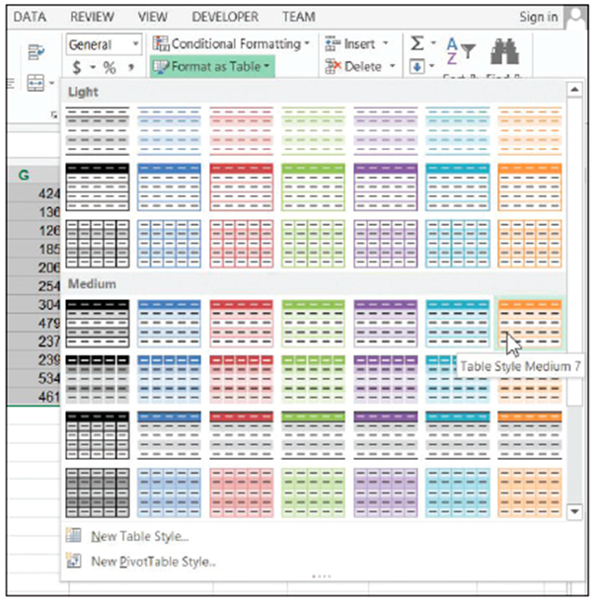
Step by Step 17: Format a Table with a Quick Style
- GET READY. OPEN the 09 Pet Pharma Sales workbook for this lesson.
  - SAVE the workbook in the
Lesson 9 folder as 09 Pet
Pharma Sales August
Solution.
  - In the August Sales worksheet,
select the data range A6:K93.
  - On the HOME tab, in the
Styles group, click Format
as Table. Excel brings up a
colorful menu full of sample
layouts right).
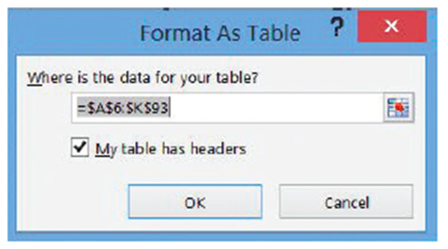
  - Click the sample in row 4,
column 7 (Table Style Medium
7). The Format As Table dialog
box appears (right).
  - Because the cell reference
under Where is the data for your table? is accurate, don't make any changes and click OK. Excel converts the data range into a formal table and applies the style you chose, which includes automatically banded rows that maintain their banding even when rows become sorted. AutoFilter controls are also added to the field names row.
  - To automatically boldface the rightmost column in the table (Total Sales), click any cell inside the table. On the DESIGN tab, in the Table Style Options group, click Last Column.
- SAVE the workbook and LEAVE it open for the next exercise.
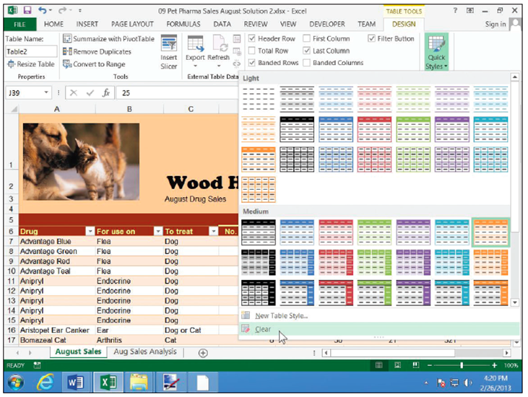
Step by Step 18: Remove Styles from a Table
- GET READY. USE the workbook from the previous exercise.
  - SAVE the workbook
in the Lesson 9 folder
as 09 Pet Pharma Sales
August Solution 2.
  - In the August Sales
worksheet, click any-
where inside the table.
  - On the DESIGN tab, in
the Table Styles group, click the More down arrow button. (Or if you see only the Quick Styles button, click that instead.)
  - In the menu, as indicated above, click Clear.
  - To change the table style to something that contrasts against the others in this series, bring up the Quick Styles menu again, and this time choose Table Style Light 6 (upper right corner).
  - To automatically apply boldface to the rightmost column, in the Table Style Options group, ensure Last Column is checked. To do the same for the leftmost column, check First Column.
- SAVE the workbook and LEAVE it open for the next exercise.
Step by Step 19: Define a Title for a Table
- GET READY. USE the workbook from the previous exercise.
  - SAVE the workbook in the Lesson 9 folder as 09 Pet Pharma Sales August Solution 3.
  - In the August Sales worksheet, click anywhere inside the table.
  - On the DESIGN tab, in the Properties group, click the text box under Table Name.
  - Type DrugSales (all one word) and press Enter. You have given a name to the table. Now you can replace the strange-looking formulas at the bottom of the August Sales worksheet with formulas that are easier to read, yet yield the same results.
  - Select cell D97 (Total Sales).
  - Type =sum(Dr
  - When DrugSales appears in the list, press Tab.
  - Type [ (left square bracket).
  - Use the arrow keys to select Total Sales from the list, and then press Tab.
  - Type ] (right square bracket), followed by ) (right parenthesis) and Enter. If you enter the formula properly, the result should be identical to what was there before.
  - Replace the formula in cell D98 with the following:
  - =SUMIF(DrugSales[To treat],"Dog",DrugSales[Total Sales])
  - Replace the formula in cell D99 with one based on the formula in D98, but searching for Cat instead of Dog.
- SAVE the workbook and leave it open for the next exercise.
Step by Step 20: Use the Total Row Command in a Table
- GET READY. USE the workbook from the previous exercise.
  - Select any cell in the table. Excel adds the DESIGN tab to the ribbon.
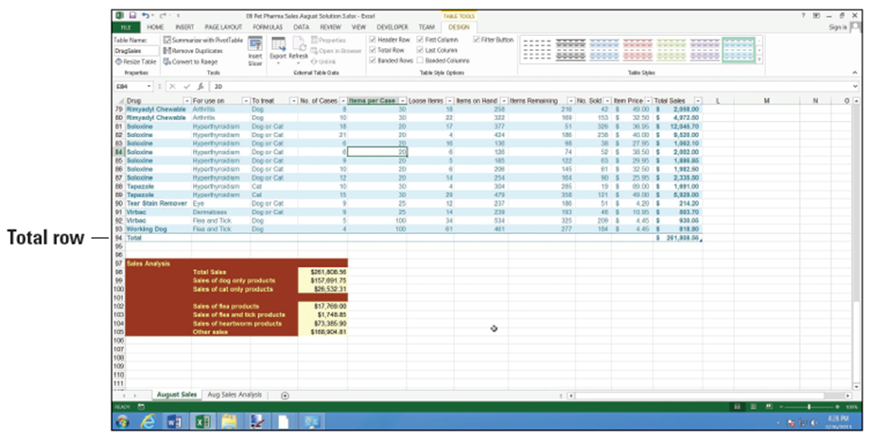
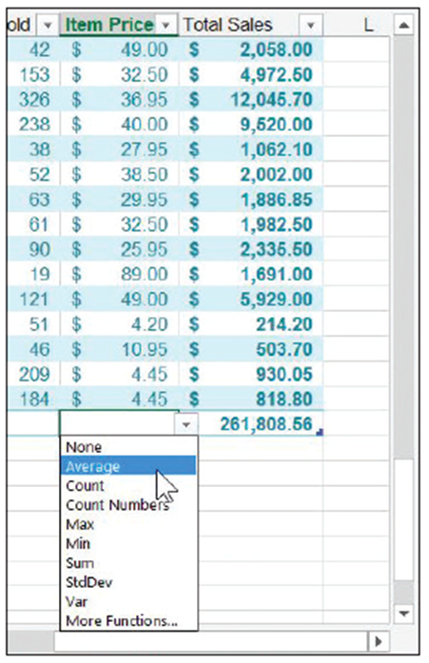
  - With the August Sales worksheet active, on the DESIGN tab, in the Table Style Options group, select the Total Row box. Excel adds a total row to the bottom, as shown above, with a label in the leftmost column and the grand total in the rightmost column.
  - To add other subtotals or formulas to
the Total Row, you can choose one
from a drop-down menu. Click the
cell in the total row at the bottom of
the Item Price column.
  - Click the down arrow that appears to
the right of the blank cell. In the
popup menu (right), click Average.
Excel calculates the average price per
sales item.
  - Repeat the process to find the
maximum number of items sold in
one order, by choosing the Max
function for the No. Sold column.
- SAVE the workbook and leave it open
for the next exercise.
Step by Step 21: Add and Remove Rows and Columns in a Table
- GET READY. USE the workbook from the previous exercise.
  - SAVE the workbook in the Lesson 9 folder as 09 Pet Pharma Sales August Solution 4.
  - In the August Sales worksheet, select cell A88 (in the Drug column).
  - On the HOME tab, in the Cells group, click the Insert down arrow. In the menu, click Insert Table Rows Above.
  - Type the following values into cells A88:F88:
Soloxine Hyperthyroidism Dog or Cat 7 20 2
- Note that the value in the Items on Hand column is automatically updated, because Excel copied the formula into the new row.
- Select cell H88 (in the Items Remaining column) and type the value 41. Cell I88 is updated.
- Select cell J88 (in the Item Price column) and type the value 25.95. Cell K88 is updated.
- Select any cell in row 32.
- On the HOME tab, in the Cells group, click the Delete down arrow. In the menu, click Delete Table Rows. Row 32 is deleted, and the table shrinks to fit.
- Select any cell in column I (No. Sold).
- On the HOME tab, in the Cells group, click the Delete down arrow, and then click Delete Table Columns. Column I is removed, and for the time being, #REF! errors are generated throughout the Total Sales column, which contain formulas that referred to No. Sold.
- With a cell in column I still selected, click the down arrow next to Insert in the Cells group, and in the menu, click Insert Table Columns to the Left.
- Change the header in cell I6 to read No. Sold.
- Click cell I7 and enter the formula =[Items on Hand]-[Items Remaining]. Use the “IntelliSense” menus when you type each left bracket [ to expedite your entry. Notice when you press Enter that Excel automatically copies the formula down the remainder of the column. You normally don’t have to do this manually for a table.
- Click cell K7 and enter the formula =[No. Sold]*[Item Price]. This time when you press Enter, Excel does not fill the formula down the column, because it will not auto-fill over non-blank cells.
- Fill the new Total Sales formula down to row 93, making sure to stop short of the total row. The grand total formula in cell K94 is now fixed.
- Click cell L7, outside the table.
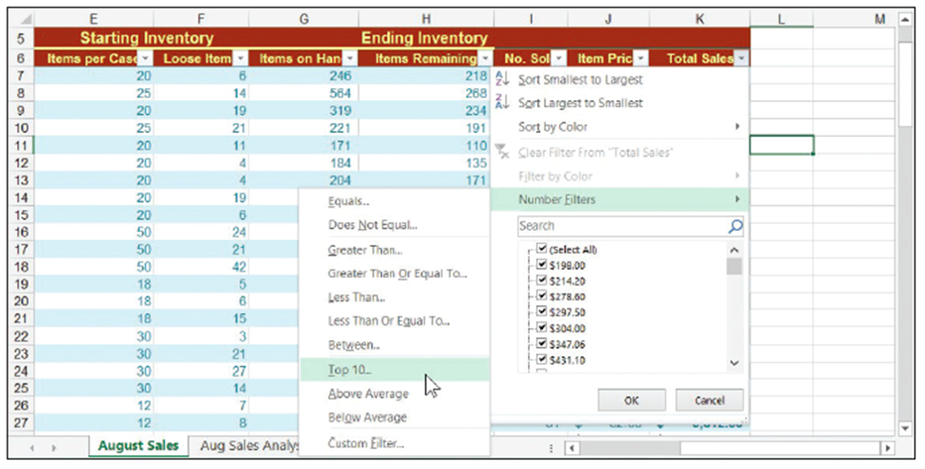
- Enter the formula =[Total Sales]/AVERAGE([Total Sales]). Notice you
don’t get the
“IntelliSense”
menus this
time, because
the cell
pointer is not
inside the
table. After
you press
Enter, Excel not only creates the formula but extends the table one column to the right, and copies the formula down the entire column L. For now, Excel gives the new column the temporary name Column1 (above).
- Rename the new column % of Avg.
- Select cell range L7:L93 and give the range a percent style. Excel does not automatically copy custom cell styles down a column, so you must select the range manually first. Note how Excel has moved the last column’s boldfaced format from Total Sales to % of Avg.
- Click any cell in % of Avg., and then click the down arrow next to Delete. Click Delete Table Columns. As the appended column disappears, the boldfacing is returned to Total Sales.
- SAVE the workbook and leave it open for the next exercise.
Step by Step 22: Filter Records in a Table
- GET READY. USE the workbook from the previous exercise.
  - In the August Sales worksheet, click the down arrow beside Total Sales.
  - In the menu (below), click Number Filters, and then click Top 10. The Top 10 AutoFilter dialog box appears.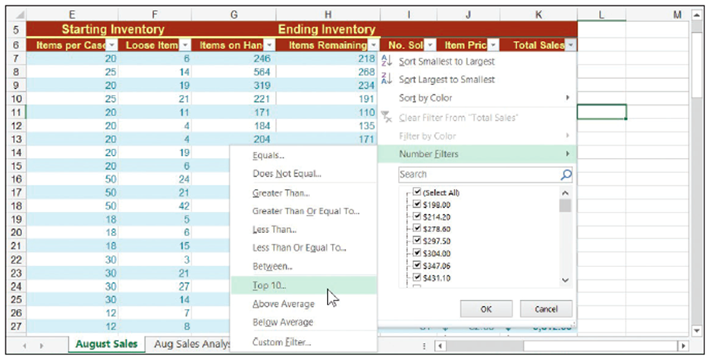
  - Leave the choices set at Top 10 items, and then click OK. The table is filtered down to the 10 items with the highest sales.
- SAVE and CLOSE the workbook and leave Excel open for the next exercise.
Step by Step 23: Sort Data on Multiple Columns in a Table
- GET READY. RE-OPEN the 09 Car Owners Solution workbook from earlier in this lesson.
  - SAVE the workbook in the Lesson 9 folder as 09 Car Owners Solution 2.
  - Select the range A1:G73.
  - On the HOME tab, in the Styles group, click Format as Table. In the menu, click Table Style Medium 14.
  - In the Format As Table dialog box, click OK.
  - Because this range contains data appended from an outside source (see the “Appending Data to a Worksheet” section earlier in this lesson), the query data related to that outside source is still attached to the range. Click Yes in the dialog box to have Excel remove those connections.
  - Click the Name box and rename the table Owners.
  - Resize columns B, E, and F to more appropriately fit their contents.
  - Change the font for the entire table to Cambria, 11 pt.
  - Left-justify column G.
  - With the Owners table selected, on the DATA tab, in the Sort & Filter group, click Sort. The Sort dialog box appears.
  - In the Sort by list box under Column, choose Last Name.
  - Click Add Level.
  - In the Then by list box that appears under Column, choose First Name. Click OK.
- SAVE the workbook and leave it open for the next exercise.
Step by Step 24: Change Sort Order in a Table
- GET READY. USE the workbook from the previous exercise.
  - With the cell pointer in the Owners table, on the DATA tab, in the Sort & Filter group, click Sort.
  - In the Sort dialog box, click Delete Level, and then click Delete Level again, to remove the existing sort order.
  - Click Add Level.
  - In the Sort by list box that appears, click ZIP. Click OK.
- SAVE the workbook and leave it open for the next exercise.
Step by Step 25: Remove Duplicates in a Table
- GET READY. USE the workbook from the previous exercise.
  - Click any cell inside the table.
  - On the DESIGN tab, in the Tools group, click Remove Duplicates.
  - The Remove Duplicates dialog box lets you determine how much of a record needs to be duplicated before it qualifies as a duplicate. For instance, two or more customers might have the same name, though they probably don’t share the same address or phone number. In the Columns list, uncheck City, State, and ZIP.
  - Click OK. Excel shows a dialog box reporting how many duplicate entries were removed. Click OK to dismiss.
- SAVE and CLOSE the workbook and leave Excel open for the next exercise.
Step by Step 26: Convert a Table to a Range
- GET READY. RE-OPEN the 09 2005 Customers Solution workbook for this lesson.
  - Near the top of the Excel window, respond to the security warning by clicking Enable Content.
  - SAVE the workbook in the Lesson 9 folder as 09 2005 Customers Solution 2.
  - Click any cell inside the table.
  - On the DESIGN tab, in the Tools group, click Convert to Range.
  - Excel opens a dialog box to verify this conversion is what you want. Click OK. The AutoFilter buttons are removed from the header row and entries are left sorted as they were. Subtotals and total rows remain, and formatting is left as it was.
- SAVE and CLOSE the workbook and leave Excel open.

